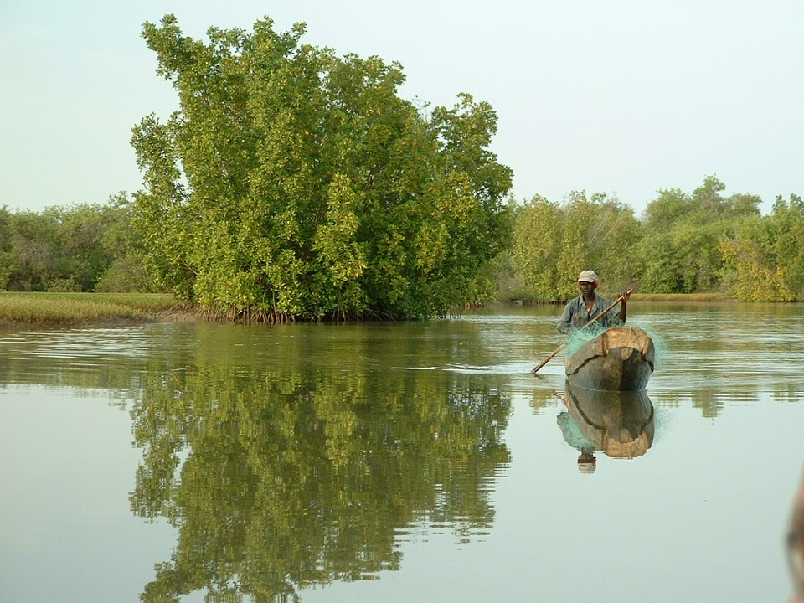

Mission to control, monitor, and supervise the construction of the OMVG Energy Project
Development of an adaptive environmental flow strategy for the Sambangalou Hydroelectric Development Project

Gambia River Basin Development Organization (OMVG)

Project number: 60518562

Final report – Provisional version
August 2021



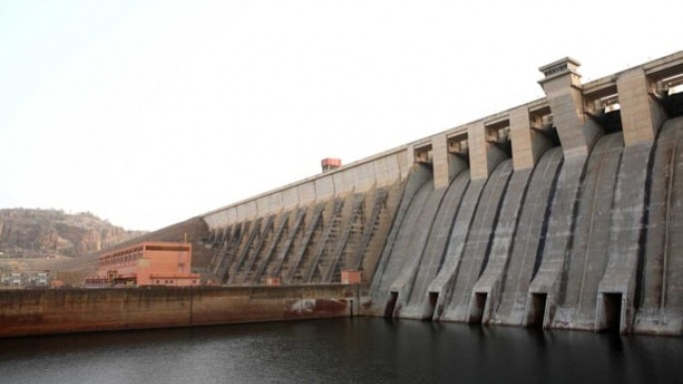

Reservations and limitations
The attached report (the “Report”) has been prepared by AECOM Consultants Inc. (“Consultant”) for the benefit of the client (“Client”) in accordance with the agreement between Consultant and Client, including the detailed scope of work (the “Agreement”).
The information, data, recommendations and conclusions contained in the Report (collectively, the “Information”):
- is subject to the scope, schedule and other constraints and limitations in the Agreement and the reservations and limitations contained in the Report (the “Limitations”);
- represents Consultant’s professional judgement in light of the Limitations and industry standards for the preparation of similar reports;
- may be based on information provided to Consultant which has not been independently verified;
- has not been updated since the date of issuance of the Report and its accuracy is limited to the time period and circumstances in which it was collected, processed, made, or issued;
- must be read as a whole and, consequently, sections of the Report should not be read out of such context;
- was prepared for the specific purposes described in the Report and the Agreement; and
- in the case of subsurface, environmental or geotechnical conditions, may be based on limited testing and on the assumption that such conditions are uniform and not variable either geographically or over time.
Consultant will be entitled to rely upon the accuracy and completeness of the information that was provided to it and has no obligation to update such information. Consultant accepts no responsibility for any events or circumstances that may have occurred since the date on which the Report was prepared and, in the case of subsurface, environmental, or geotechnical conditions, is not responsible for any variability in such conditions, whether geographically or over time.
Consultant agrees that the Report represents its professional judgement as described above and that the Information has been prepared for the specific purpose and use described in the Report and the Agreement, but Consultant makes no other representations, or any guarantees or warranties whatsoever, whether express or implied, with respect to the Report, the Information or any part thereof.
Without in any way limiting the generality of the foregoing, any estimates or opinions regarding the construction costs or construction schedule provided by Consultant represent Consultant’s professional judgement in light of its experience and the knowledge and information available to it at the time of preparation of the Report. Since it has no control over market or economic conditions, prices for construction labor, equipment or materials, or bidding procedures, Consultant, its directors, officers and employees are not able to, nor do they make any representations, warranties or guarantees whatsoever, whether express or implied, with respect to the accuracy of such estimates or opinions, or their variance from actual construction costs or schedules and accept no responsibility for any loss or damage arising therefrom or in any way related thereto. Persons relying on such estimates or opinions do so at their own risk.
Except (1) as agreed to otherwise in writing by Consultant and Client; (2) as required by-law; or (3) to the extent used by governmental reviewing agencies for the purpose of obtaining permits or approvals, the Report and the Information may be used and relied upon only by Client.
Consultant accepts no responsibility, and denies any liability whatsoever, to parties other than Client who may obtain access to the Report or the Information and use, rely upon, or make decisions based on the Report or any of the Information (“improper use”), except to the extent those parties have obtained the prior written consent of Consultant for such use. Any injury, loss, or damages arising from improper use of the Report or Information will be borne by the party making such use.
These Reservations and Limitations are attached to and form part of the Report and any use of the Report is subject to these Reservations and Limitations.
AECOM: 04-13-2015
© 2009-2015 AECOM Consultants Inc. All rights reserved.

Table of Contents

Glossary of acronyms vi
1. Introduction 7
2. Adaptive Environmental Flow Strategy 8
3. Drafting of the environmental flow 10
3.1. Expected effects on natural dynamics 10
3.2. Issues related to the management of water at the Sambangalou dam 12
3.3. Socio-environmental criteria to be met downstream of the dam 24
3.4. Sambangalou hydropower plant operations simulation approach 27
4. Socio-environmental operating procedures for the Sambangalou dam 34
4.1 Predefined operating rules during reservoir filling 34
4.2 Daily operating procedures 35
4.3 Annual operating procedures 40
4.4 Triennial operating procedures 43
5. Assessment of residual impacts of the AEFS 45
5.1 Hydraulic conditions of the fluvial section 45
5.2 Flood peaks and backswamp flooding 54
5.3 Saltwater front displacement 55
5.4 Potential impacts on tidal range 55
5.5 Output optimization 57
6. AEFS implementation procedures 58
6.1 Technical instruments required 58
6.2 Tasks specific to monitoring and reassessment of the AEFS 58
6.3 AEFS management procedures 58
7. Estimated investments required to implement the AEFS 74
8. Findings 77
8.1 Key components of the environmental flow 77
8.2 Implementation challenges 77
9. References 79

APPENDICES

Appendix 1: Methodological process used to reassess water needs for irrigation 81
Appendix 2: Structure of the model used to simulate operation of the Sambangalou dam 102
Appendix 3: Methodological description of the SIMULGAM model 107
Appendix 4: Methodological description of the SALNSTAT model 112
Appendix 5: Hydrological series used 116
Appendix 6: Diagram of synchronization levels at the hydrometric stations 119
Appendix 7: Annual statistics on backswamp filling 126
Appendix 8: Turbine shut-down and fulfillment of water needs for irrigation 129

Figures
Figure 1. Diagram of the components of the Adaptive Environmental Flow Strategy (AEFS) 9
Figure 2. Environmental flow drafting process 11
Figure 3. Comparison between the average daily flow under a natural (1970–2019) and regulated (according to SAMVA’s 1990–2017 simulation) regime and main positive and negative impacts. 12
Figure 4. Map of the general context and environmental issues downstream of the Sambangalou dam 13
Figure 5. Level and flow released at the Sambangalou dam during the filling period, according to three scenarios with different natural reservoir inflows. 18
Figure 6. Context of the probable flows at the hydrometric stations downstream of the Gambia River during the filling period 19
Figure 7. Average monthly tidal range values at the Kaur, Kuntaur, and Bansang stations 23
Figure 8. Context of the section of the river subject to permanent desalination further to water regulation at the SHDP 28
Figure 9. Diagram of the simulation tools used to draft the environmental flow 29
Figure 10. Trend and average rupture analyses of the maximum annual flow series for the 1954–2019 period in Gouloumbou 33
Figure 11. Structure for applying operating rules or AEFS monitoring and reassessment processes 35
Figure 12. Daily optimization rules according to the environmental flow strategy with presentation of additional turbine flows. 37
Figure 13. Comparison of the average daily flows under a natural regime and a regulated regime according to the environmental flow operating criteria at the Kédougou, Mako, Simenti, and Gouloumbou stations, respectively. 52
Figure 14. Comparison of the average monthly levels under a natural regime and a regulated regime according to the environmental flow operating criteria at the Kédougou, Mako, Simenti, and Gouloumbou stations, respectively. 53
Figure 15. Impact of water regulation at the SHDP on tidal range in the estuary of the Gambia River 56
Figure 16. Technical tasks of AEFS monitoring and reassessment components 63
Figure 17. Key stakeholders collaborating on AEFS implementation 67

Tables
Table 1. Socioenvironmental issues resulting from the change in natural physical processes caused by the Sambangalou dam. 14
Table 2. Statistics on the amplitude of flows associated with the backswamp flooding threshold, the backswamp flooding frequencies, and the average river-backswamp connection times 24
Table 3. Simulated average monthly saltwater front positions for the 1970–2019 period 26
Table 4. Comparison of monthly average daily turbine flow values 36
Table 5. Monthly values of the minimum and maximum daily turbine flows. 38
Table 6. Synchronization criteria for discharge released to maintain flooding 40
Table 7. Water needs for irrigation of riverside land along the Gambia River 41
Table 8. Spatial summary of the impacts on natural physical dynamics related to the environmental flow 46
Table 9. Impacts of the water management environmental flow scenario on flood peaks and backswamp filling 54
Table 10. Impacts of operating rules for compliance with the environmental flow on saltwater front displacements 55
Table 11. Instruments required to implement the AEFS 59
Table 12. Details of the technical tasks required to implement the AEFS 64
Table 13. Details of the management tasks required to implement the AEFS 65
Table 14. AEFS management responsibilities and coordination matrix 68
Table 15. Estimated costs for implementation of the AEFS 74

Glossary of acronyms
AEFS Adaptive environmental flow strategy
DGPRE Directorate of Water Resource Management and Planning
EF Equipment factor
EF Environmental flow
EFA Environmental flow assessment
ESAP Environmental and Social Action Plan
ESIA Environmental and Social Impact Assessment
g/l grams per liter
GWh Gigawatt hours (energy measurement unit)
hm³ cubic hectometer (1,000,000 m³)
hm³/year cubic hectometer per year
IFC International Finance Corporation
IRD Development Research Institute
km kilometer
km² square kilometer
KP Kilometer point
LRP Livelihood Restoration Plan
m meter
m³/s cubic meter per second
MW Megawatt (electric power unit equivalent to 10⁶ W)
NOL Normal operating level (same as NO, normal operations)
OMVG Gambia River Basin Development Organization
PAP Person affected by the project
PNNK Niokolo-Koba National Park
PS5 Performance standard: Land acquisition and involuntary resettlement
PS6 Performance standard: Biodiversity conservation and sustainable management of living natural resources
RAP Resettlement Action Plan
SAMVA VINCI Construction Grands Projets, VINCI Terrassements and ANDRITZ Hydro group
SHDP Sambangalou Hydroelectric Development Project
SHDP Sambangalou Hydroelectric Development Project
TU-AEFS Technical Unit of the Adaptive Environmental Flow Strategy
UF Use factor
WCD World Commission of Dams
WWF World Wildlife Fund

Introduction
This document constitutes the main report for Study 3 on the development of an adaptive environmental flow strategy (AEFS) for the Sambangalou Hydroelectric Development Project (SHDP) in Senegal, as requested by the OMVG from AECOM as part of its mission to control, supervise and monitor the construction of the OMVG Energy Project.
Pursuant to the Environmental and Social Action Plan (ESAP) drafted upon completion of the SHDP E&S due diligence (ERM 2019), this study is a component of the final phase of the environmental, social, and technical studies that precede the construction and start-up of the Sambangalou Hydroelectric Development Project (SHDP). These studies primarily aim to make sure that the project meets the International Finance Corporation’s (IFC) performance standards and that it upholds the project’s commitments to its international lenders.

The study on the development of an adaptive environmental flow strategy plays a key role, particularly by enabling the SHDP to consistently manage waters, in compliance with the environmental and social needs both upstream and downstream of the dam. Though the SHDP’s main objective is to produce power, such power production must not result in unmanageable impacts or impacts associated with management costs that exceed the expected benefits of the plant.
This adaptive environmental flow strategy (AEFS) for the SHDP puts forth operating criteria intended to limit negative impacts on populations and biodiversity while minimizing the decrease in hydroelectric output. This so-called adaptive strategy, insofar as it operates in a cyclical manner, was developed further to dam operation and physical process simulation tools. These tools are important for future dam management.
The specific objectives of this report are to present:
- the AEFS’ general operating principles;
- the environmental flow development process;
- the plant operating procedures required to comply with the environmental flow;
- the residual impacts of the environmental flow as detailed in this report;
- the actions and resources to plan in order to implement the adaptive environmental flow strategy.

Though it presents the final adaptive environmental flow strategy developed by AECOM’s team, this report is provisional and remains to be validated by the main stakeholders. This provisional version will be presented to OMVG member countries and to the stakeholders identified as playing a key role in the future management of SHDP waters. Once the report has been distributed and its main items understood, a workshop will be organized in order to add all necessary clarifications to this strategy and to discuss its main components. The comments recorded during this workshop will be used to validate and improve certain aspects of the strategy, and then to produce a final version of the report that includes the general conclusions of the workshop.

Adaptive Environmental Flow Strategy (AEFS)
In its good practice guide for environmental flows specific to hydro power plants, the World Bank Group (WBG, 2018) clearly describes the foundation of an effective and consistent water management strategy. The following key points from this guide were retained in this study in order to develop the strategy. They are summarized as follows:
- First, an environmental flow provides information on the natural physical dynamics of river systems that will come to be affected by water regulation at a dam-reservoir. It further describes how biodiversity, ecosystem services, and populations will be affected by the changes in dynamics.
- Based on these impacts, a study is carried out with various stakeholders (social, economic, environmental, and technical) in order to identify released discharge (environmental flow) criteria that will reduce potential impacts.
- A procedure for hierarchizing impact mitigation in the development of an environmental flow is also proposed. Dam water management rules must be developed according to this prioritization of dam-reservoir impact mitigation measures;
- Avoid: establish a water management system that avoids the expected impact on the river regime, ecosystem, or population.
- Reduce: implement water management measures that limit the extent of the effect on the river regime. Reducing may also consist of the implementation of measures outside water management, which limit the extent of the local impacts on the ecosystem or population.
- Compensate: where some impacts cannot be avoided or reduced, compensation measures, such as the creation of new habitats, the protection of other habitats, or even financial compensation may be put forth.
For example, for many large hydroelectric dam-reservoir projects, the negative impacts of regulation were not sufficiently studied prior to the implantation and start-up of the structure. Even though environmental flow criteria were established at a later date, in line with new international environmental standards, there are many examples of negative impacts that could not have been avoided or reduced. For the SHDP, both the project’s negative and positive impacts could be significantly more efficiently managed if the guidance and recommendations of this study are actually implemented.
To understand this report, it is crucial to differentiate between the (1) Adaptive Environmental Flow Strategy and (2) Environmental Flow, the latter being a component of the former. As explained above, an environmental flow is defined by the initial characterization of physical dynamics and their impacts on the use of dam waters. By implementing specific dam water management measures, these impacts can generally be managed.
Because of the physical and social context of the Gambia River, the project’s progress thus far, the lack of information regarding current and future uses of the river waters, and the types of changes to be considered (climate, use, and need-related), no environmental flow can guarantee the perpetual and efficient management of negative impacts. The environmental flow strategy is therefore “adaptive”, and first requires the mandatory drafting of the environmental flow (EF). It will then evolve according to the data obtained in the EF’s monitoring and reassessment phases; these phases must be carried out at the SHDP.
The diagram in Figure 1 illustrates the main components of the AEFS developed for the SHDP. Four main components were identified:
- Drafting of the environmental flow, which consists of identifying impacts, simulating natural dynamics, and identifying environmental criteria used to avoid or reduce negative impacts.
- Implementation of SHDP operating rules, which allow for compliance with the EF’s environmental criteria.
- Monitoring of certain environmental and social criteria during dam operation, which is key to ensuring compliance with the rules and performance laid out in the EF.
- The final phase consists of analyzing monitoring data regarding environmental criteria and changes in the primary uses of water from the Gambia River, which may lead to changes in the EF or the redrafting thereof.
The AEFS should therefore be viewed as an operational cycle. This report will first describe the drafting of the environmental flow, after which the operations, monitoring, and reassessment phases will be presented in a chronological analysis framework.

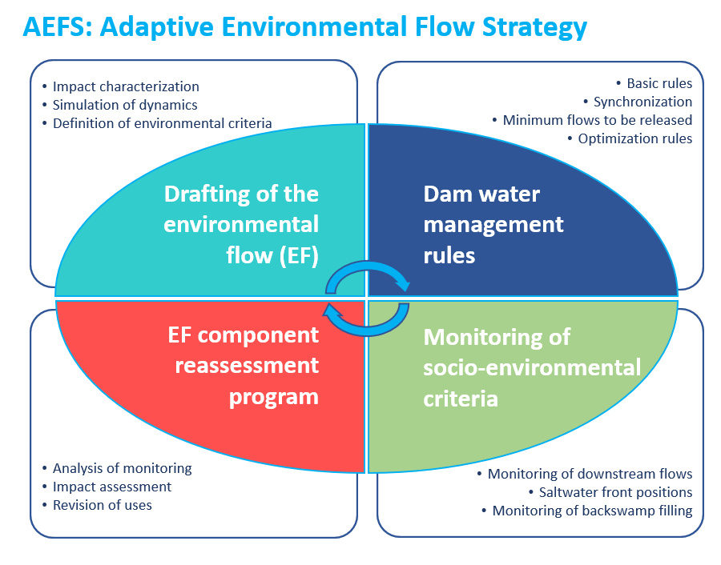
Figure 1. Diagram of the components of the Adaptive Environmental Flow Strategy (AEFS)

Drafting of the environmental flow
Though this report presents an adaptive strategy based on four major study or management components, at its core, AECOM’s study consisted of drafting the environmental flow and the water management rules associated with the dam. Figure 2 presents the environmental flow drafting process used to implement dam water management rules that avoid or reduce the negative impacts of river regulation.

3.1. Expected effects on natural dynamics
The natural dynamic of alternating high flows (rainy or high-water periods) and low flows (dry or low-water periods) causes significant changes to the conditions of the natural and human riparian environments (e.g., high sediment transport versus sedimentation, flooding versus drying up of certain areas, etc.). Changes related to the alternating periods of high and low flows are especially significant for the Gambia River because of the maritime influence felt up to 500 km upstream of its mouth in the Atlantic Ocean. As a result, the effect of the tides, the intrusion of the saltwater front upstream of the river, and the changes in the environmental conditions they create are closely related to variations in river flows.
The analysis of the daily flows released at the dam for the 1990–2017 period, determined according to the current water management scenario described in SAMVA’s output estimate reports, identified several potential impacts on the ecosystem services and natural dynamics downstream. Figure 3 illustrates the regulation of the Gambia River flows as planned by SAMVA’s proposed simulations to date regarding water and output management at the Sambangalou dam. This figure also identifies the main expected impacts, both negative and positive, for the low and high-water periods, if this regulation moves forward.
Though water regulation can have certain positive impacts, these new benefits are only possible at the expense of certain natural habitats and dynamics that support several ecosystem services. This being said, regulation of river waters offers an interesting opportunity for downstream irrigation development, from a perspective of more consistent water availability, of the future maintenance of freshwater in a section of the river that naturally experiences seasonal salinization, and that of stabilization of the daily tides, which could help plan tidal irrigation 250 to 300 km from the mouth:
Here, it is also important to introduce the concept of discharge released to maintain natural flooding. High-water maintenance discharge was planned by the dam output studies; this happens every second year, in the month of October, and consists of discharging water through the sluices to supplement the turbine flow of water at the dam (see Figure 3 - discharged released to maintain flooding). This discharge aims to simulate physical conditions that more closely resemble the natural dynamics of the high-water period. This report will define the characteristics of high-water maintenance discharge, which will result in an actual reduction of the impact on natural dynamics.
To date, the main negative impacts of water regulation have been summarized in several studies, including three recent studies entrusted to AECOM:
- Study of flood backswamps of the Gambia River;
- Updated assessment of the impact on biodiversity and natural environments of the Sambangalou Hydroelectric Development Project (SHDP);

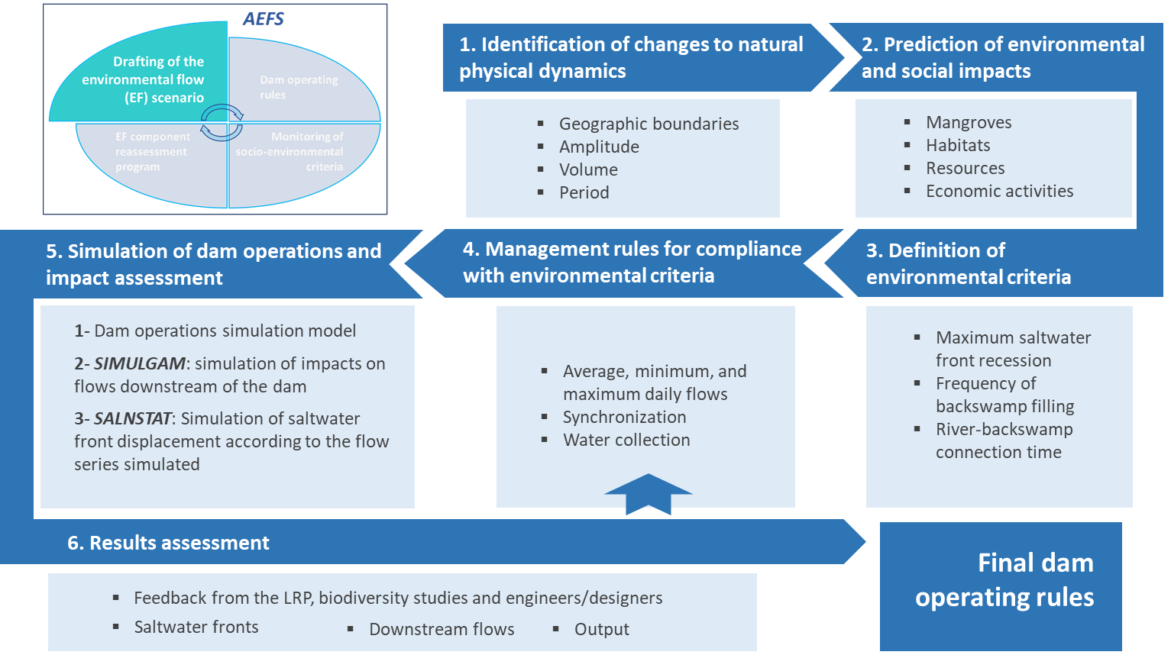
Figure 2. Environmental flow drafting process
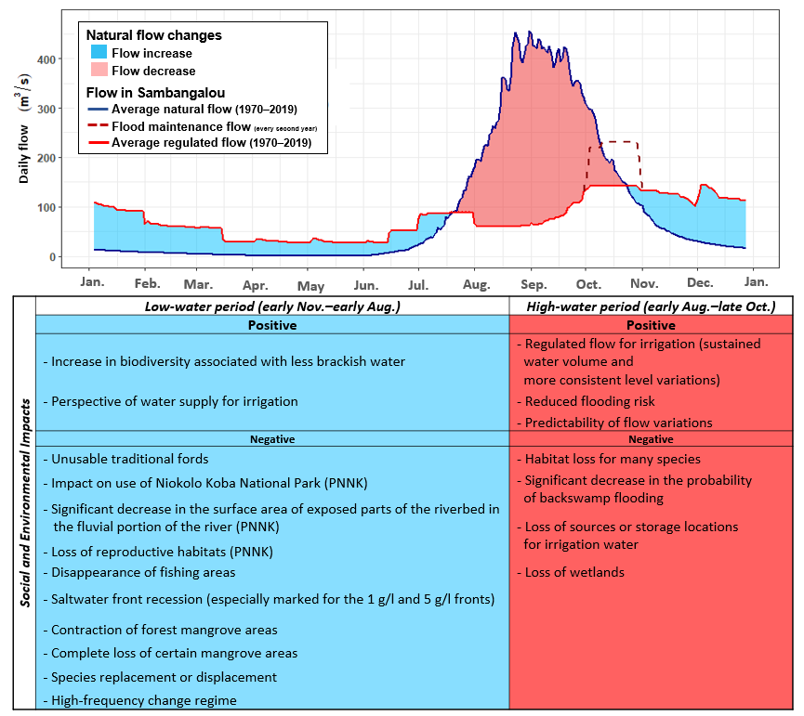
Figure 3. Comparison between the average daily flow under a natural (1970–2019) and regulated (according to SAMVA’s 1990–2017 simulation) regime and main positive and negative impacts.

- Update to the Resettlement Action Plan and preparation of a Livelihood Restoration Plan for the Sambangalou Hydroelectric Development Project (SHDP).
The map presented in Figure 4 illustrates the location of the main environmental and socioeconomic issues considered in the drafting of the environmental flow.

3.2. Issues related to the management of water at the Sambangalou dam
The study team responsible for developing an adaptive environmental flow strategy played a key role in connecting SAMVA, the consortium in charge of engineering and construction of the installation, and the teams in charge of the biodiversity management plan and the Livelihood Restoration Plan (LRP) for populations affected by the project (PAP). To do so, the technical issues pertaining to designing and managing the planned Sambangalou dam were translated into potential impacts on natural physical dynamics. And, based on the expected changes in natural dynamics, experts from biodiversity and social impact studies were able to define the extent and possibility of reduction and compensation of the impacts.

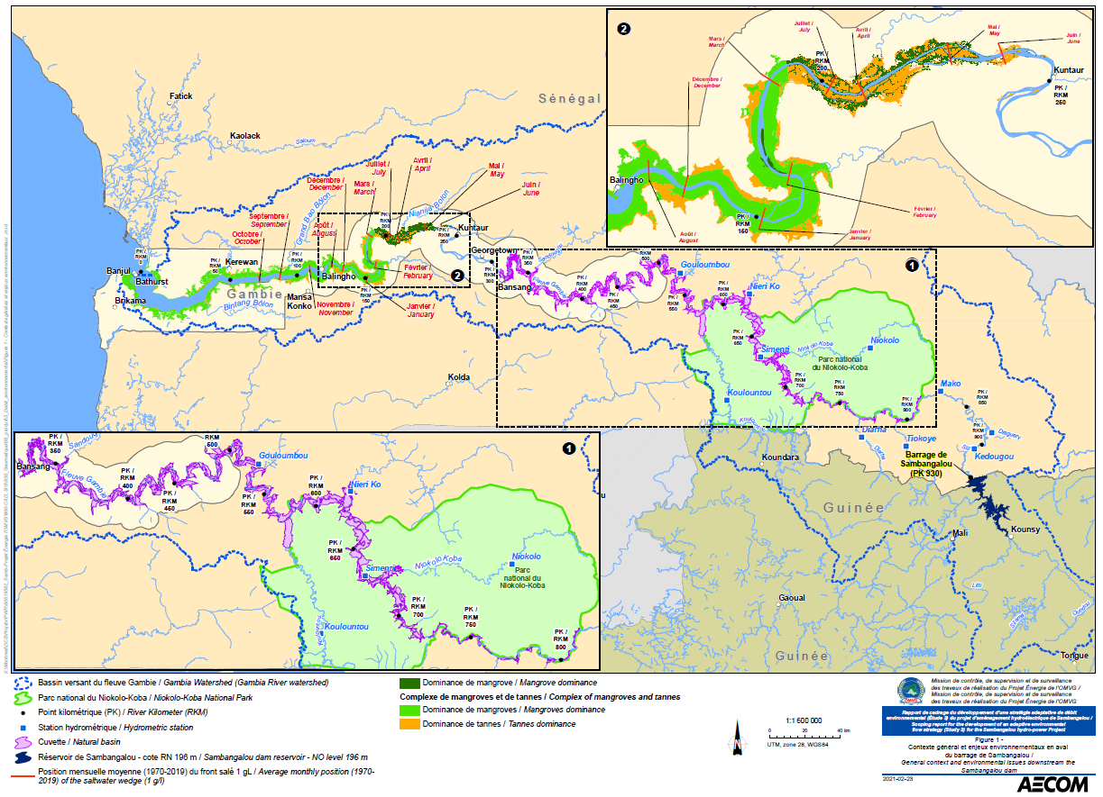

Figure 4. Map of the general context and environmental issues downstream of the Sambangalou dam

3.2.1 Environmental and social issues
The environmental flow was drafted within a global perspective of minimizing the negative impacts of the construction and management of the Sambangalou hydroelectric plant, all the while limiting potential output losses. Table 1 below details the negative impacts identified by the biodiversity and social teams for each major natural dynamic change connected with the water regulation at the Sambangalou dam. It should be noted, here, that the environmental flow presented in this report was drafted according to criteria associated with the environmental and social issues resulting from the changes in natural physical dynamics presented above. Communication with the biodiversity and social study teams regarding the extent of the impacts, assessed using the models developed in this study, was ongoing to enable the teams to assess reduction and compensation issues.
For each expected impact of water regulation at the Sambangalou dam, a qualitative assessment of (1) the extent of the impact and (2) the possibility of reduction measures to limit the extent of the impact was conducted retroactively with the biodiversity and social studies. These assessments guided the drafting of the environmental flow. Details of the reduction and compensation measures will be provided in the biodiversity study reports and LRP. Worthy of note among the main reduction and compensation measures to be implemented are:
- The creation of artificial fords to make up for the loss of natural fords, which will stop being usable following the increased river water level during the low-water period.
- The creation of reproductive environments to compensate for the loss of the exposed sand bar.
- The construction of certain irrigation infrastructure that could be affected by the change in natural river water level variation.
- The displacement of certain economic activities to make up for the inability to carry out certain practices on certain specific sections of the river.
- The development of alternative economic activities to make up for the inability to use the river for certain operations.

Table 1. Socioenvironmental issues resulting from the change in natural physical processes caused by the Sambangalou dam.
Impact ranking |  |  | Possibility of reduction
Limited: there are few repercussions on the environment, and no reduction measures need be applied. |  |  | Very easy: there are several reduction measures, they are easy to implement, and require the mobilization of very few resources.
Significant: there are significant but fewer repercussions on the environment, and reduction measures may or may not need be applied. |  |  | Easy: reduction measures are accessible and easy to implement but require the mobilization of a significant number of resources.
High: repercussions on the environment are sizeable but may be reduced by specific measures. |  |  | Difficult: there are few reduction measures, they are difficult to implement, and require the mobilization of a large number of resources.
Major: repercussions on the environment are very significant and are difficult to reduce. |  |  | Impossible: reduction measures do not exist or are extremely difficult to implement.

Expected negative impacts of the installation as a function of the change in certain physical processes
Impact areas | Expected social and environmental impacts | Dynamics or criteria incorporated into the environmental flow (EF) strategy | Impact extent |  |  |  |  | Possibility of reduction
Decrease in the frequency of backswamp filling by river overflow
Fluvial portion (upstream of Bansang) | Decrease in natural fishing productivity. | Backswamp filling every 2.3 years in Simenti and 1.8 years in Gouloumbou.
Fluvial portion (upstream of Bansang) | Loss of irrigation water storage.
Fluvial portion (upstream of Bansang) | Effect on resting and feeding grounds and watering sites for many species.
Fluvial portion (upstream of Bansang) | Loss of reproductive, raising, and feeding grounds for many species of fish.
Fluvial portion (upstream of Bansang) | Change in plant composition around the backswamps.
Fluvial portion (upstream of Bansang) | Decrease or loss of fishing-generated income.
Shortening of river-backswamp connection times
Fluvial portion (upstream of Bansang) | Loss of reproductive habitats for many species of fish and manatee. | Average river-backswamp connection time of 9 days in Simenti and 17 days in Gouloumbou.
Fluvial portion (upstream of Bansang) | Decrease in the volumes of stored water available for irrigation.
Decrease in the water level during the high-water period
Estuarine portion | The agricultural areas irrigated by the tides might not be irrigated if the flood level is not high enough. | Maintenance of an average tidal difference of 0.5 m (low tide) and 0.3 m (high tide) between the low and high-water periods.
Significant increase in water levels in the fluvial portion of the river during the low-water period
Fluvial portion (upstream of Gouloumbou) | Disappearance of exposed sandbanks, resulting in a loss of habitats and reproductive and feeding grounds for many species. | A maximum daily flow of 40 m³/s has been determined to limit the increase in low-water levels. Consideration of possible agricultural development and the estimated increase in irrigation water needs.
Fluvial portion (upstream of Gouloumbou) | Loss of several fords and ecological corridors between the river banks.
Fluvial portion (upstream of Gouloumbou) | Loss or restriction of access to river crossings for populations.
Fluvial portion (upstream of Gouloumbou) | Displacement or loss of gold-panning sites due to the increased water level of the riverbed during the low-water period.
Fluvial portion (upstream of Gouloumbou) | Displacement or loss of material extraction sites (sand, gravel, etc.) due to the increased water level of the riverbed.
Downstream saltwater front recession during the low-water period
Estuarine portion (downstream of Kuntaur) | Significant degradation of the mangroves upstream of the river estuary and loss of related ecosystem services | Development of agriculture in the area that naturally experiences seasonal salinization, but limit of the downstream recession of the 1 g/L saltwater front at KP 190 (upstream limit of the densest mangrove).
Estuarine portion (downstream of Kuntaur) | Contraction of the habitats of brackish water species
Estuarine portion (downstream of Kuntaur) | Loss or displacement of fishing areas
Estuarine portion (downstream of Kuntaur) | Loss of natural resources collected by populations in the mangroves.
Likelihood of zero flow
Fluvial portion (upstream of Gouloumbou) | Lack of water resources for irrigation | Applied during periods of extreme drought, the EF will minimize the frequency and duration of flows of zero.
Fluvial portion (upstream of Gouloumbou) | Change in certain environments created because of the constant increase in water flows and levels during the low-water period
Possible high-frequency changes caused by turbine flow variations within a day
Fluvial portion (impacts decreasing downstream) | Significant daily variations in the flooded and exposed portions of the riverbed and, consequently, significant and rapid changes in habitat conditions. The most territorial species will be most affected. | The maximum and minimum flow criteria established according to the daily dam management model must be respected; otherwise, the EF will need to be reassessed.
Fluvial portion (impacts decreasing downstream) | Possibility of habitat losses for aquatic wildlife during the low-water period, if the changes in released flows are too significant (ex.: certain spawning or raising habitats might become unusable)
Fluvial portion (impacts decreasing downstream) | Periods of restricted access to water for irrigation (and other uses of the river water on a smaller scale) and adjustment of pumping infrastructure to more complex systems.
Fluvial portion (impacts decreasing downstream) | Changes in certain economic activities carried out or possibly developed during the low-water period (ex.: gold panning, resource extraction, fishing)
Fluvial portion (impacts decreasing downstream) | Compromise of certain uses of the river water (washing, bathing, children playing, water supply, livestock watering, transportation, etc.).
Lack of flow during the reservoir filling period
Fluvial portion (downstream of the dam until Diaguéri) | Loss of access to water for domestic activities related to the river. | Conformity with the average monthly level thresholds at the Mako, Simenti, and Gouloumbou hydrometric stations. Implementation of compensation measures to reduce the negative impacts upstream of Kédougou and plan to develop compensation measures during this low-water period.
Fluvial portion (downstream of the dam until Diaguéri) | Loss of water access for irrigated agricultural activity and livestock watering using the river water.
Fluvial portion (downstream of the dam until Diaguéri) | Potential decrease in water supply sources for riverside villages (impact on the phreatic zone, river water extraction, etc.).
Fluvial portion (downstream of the dam until Diaguéri) | Loss of fishing activities in the river.
Fluvial portion (downstream of the dam until Diaguéri) | Loss of possible transportation along the river.

3.2.2 Reservoir filling phase
To date, several strategies have been put forth to manage water during the Sambangalou reservoir filling period. In its most recent report, SAMVA recommends the following management phases for filling:
- Works construction phase (month M1 to M39), during which no influence on the river flow is expected.
- Filling phase (M39), capturing the entire river flow (except for the environmental flow, specify in the management rules), until the minimum operating level (176.5 m) is reached, after which a turbine flow 40 m³/s will be implemented throughout the first year if the reservoir level is above the minimum operating level.
- Start of normal operations (M52, or 1 year after the start of the filling phase), after which normal management rules should be applied.
Based on the average flow in Sambangalou for the period simulated in the report (1980–2017), the minimum level of 176.5 m after the start of reservoir filling is expected to be reached towards the end of the first week of September, or slightly over two months after the start of filling. However, no information is provided on the possible impacts of such management on flows further downstream in the river. Figures 5 and 6 illustrate, respectively, water management at the Sambangalou dam during the filling period based on low inflows (daily flows, 20th percentile), average inflows (average daily flows), and high inflows (daily flows, 80th percentile) determined according to the available historical data (1980–2019). The impact on flows downstream of the Gambia River, based on average inflows in Sambangalou and average tributary contribution, is subsequently illustrated.

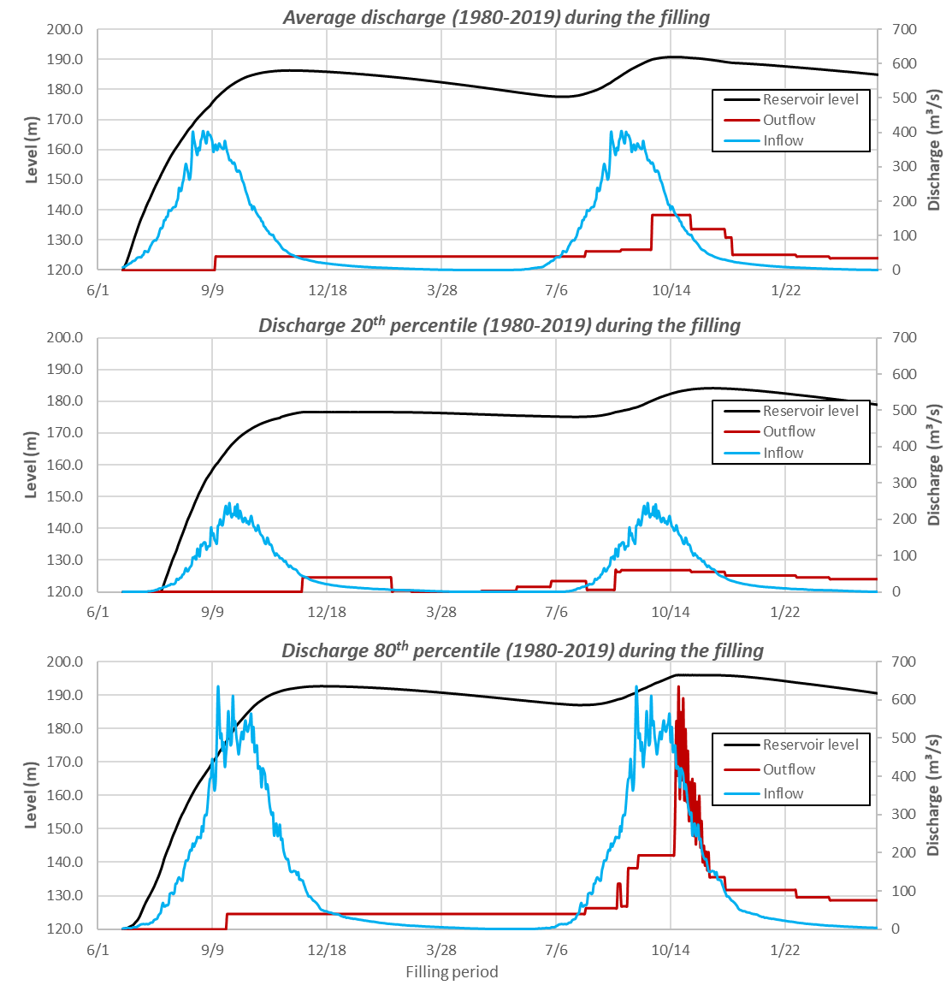
Figure 5. Level and flow released at the Sambangalou dam during the filling period, according to three scenarios with different natural reservoir inflows.
Filling simulations carried out by the environmental flow study team suggest that, if conditions of substantial water inflows (80th percentile) occur during the second year of the filling period, flooding maintenance could already be in place. This flooding maintenance would greatly reduce the impacts of the low flow released downstream during the previous year. Analysis of flows downstream of the Gambia River using average reservoir inflows and average tributary contribution during the filling period shows that the impacts would be especially marked until the confluence with the Diaguéri (to the right of the town of Kédougou) and, because of tributary contribution, would rapidly decrease downstream until Gouloumbou. Indeed, from the Mako hydrometric station, in the event of average tributary contribution, river flows during filling would be similar or higher to the minimum daily flows observed for the 1980–2019 period.
For the section between Sambangalou and the confluence with the Diaguéri, it could be worth taking advantage of the very low flows in the filling period, at this part of the river, to plan works to build fords. For their part, the other fords further downstream of the river could be built in that same low flow (and controlled flow) year, but during the low water period or even the works construction phase.

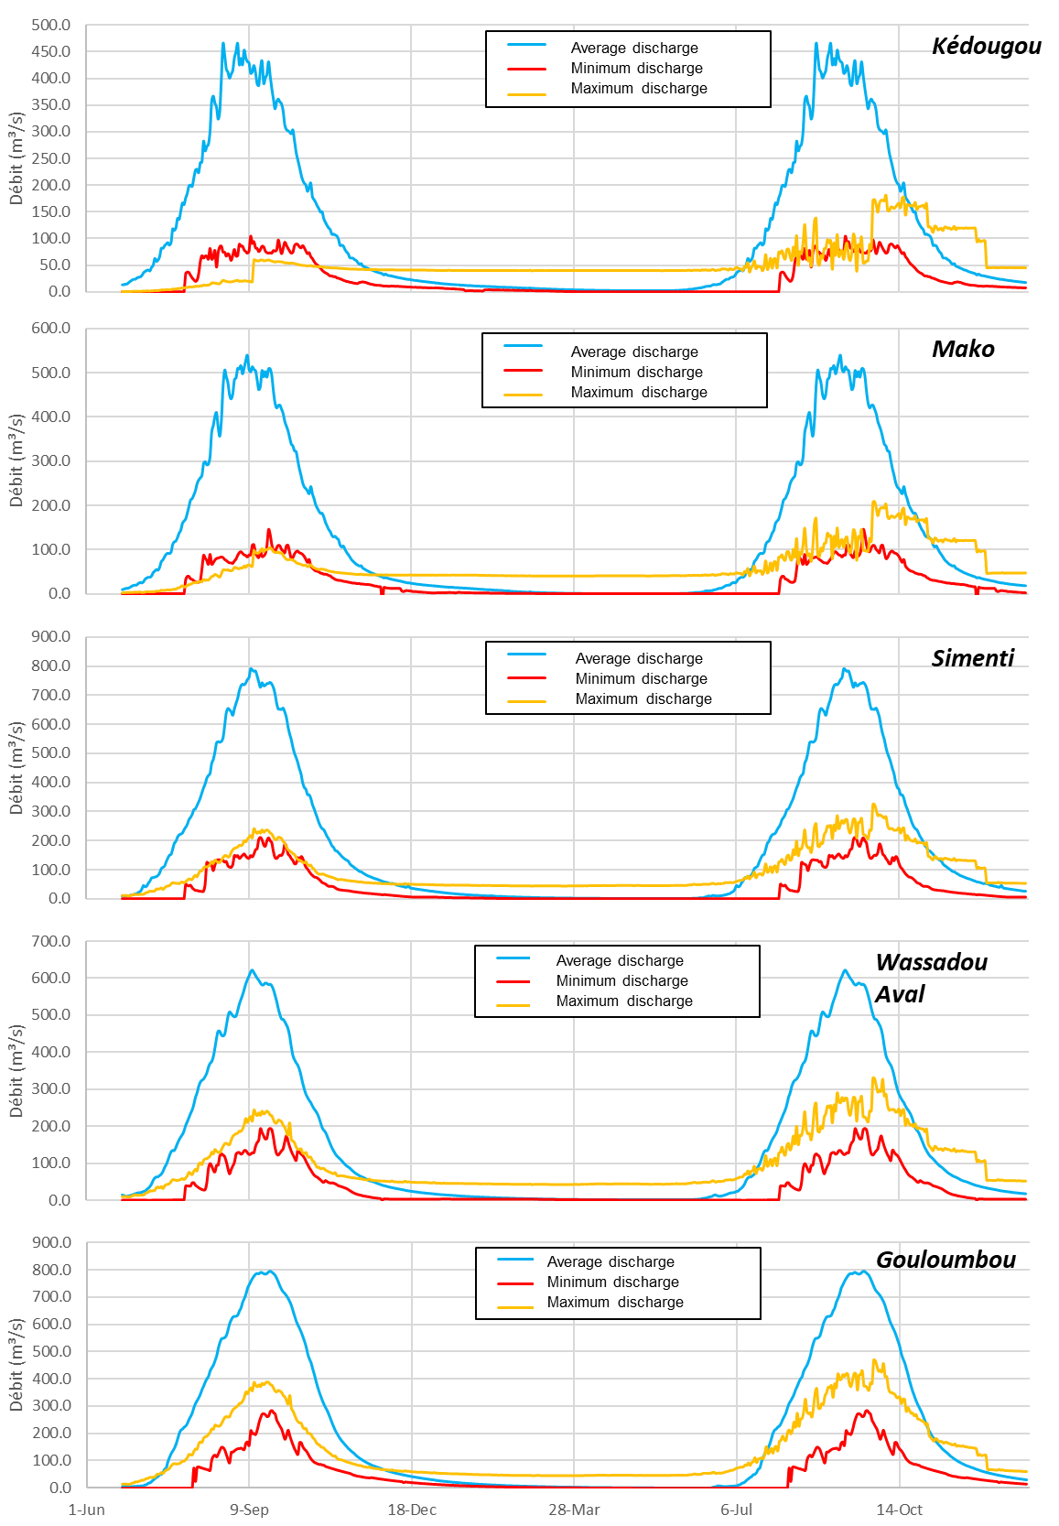
Figure 6. Context of the probable flows at the hydrometric stations downstream of the Gambia River during the filling period

3.2.3 Particularities of the seasonal flooding of riparian backswamps of the Gambia River
The flood backswamps located along the Gambia River represent a total surface area of 656 km², of which an average of slightly over 200 km² is filled every 2 years. An overview of all 108 backswamps identified was carried out for a study entrusted by the OMVG to AECOM. Five (5) of them were studied in detail in an effort to understand their filling dynamics. This study also identified several social and ecosystem functions of the backswamps. Of the most important functions identified, special note is paid to the storage capacity for water used for the reproduction of several species of fish, animal watering, and irrigation. Furthermore, the lusher vegetation in the backswamp areas, associated with conditions of greater humidity, creates a wetland that is well suited to several species of bird and terrestrial mammal. Studies of the ichthyological fauna of the Gambia River also identified several species that reproduce in environments similar to backswamps, thus highlighting the importance of the relationship between river and backswamp for the reproduction of species in the river. The preliminary conclusions of the aforementioned studies are also consistent with the main findings of the Environmental and Social Impact Assessments (ESIAs) carried out in previous years (COTECO, 2006 and Oréade Brèche, 2014).
The main environmental flow issue related to the filling of backswamps located downstream of the dam is to make sure that the flows released during the high-water period at the SHDP reach an amplitude (m³/s) that meets the filling thresholds for backswamps. Backswamps will also need to be flooded at a filling frequency that mimics natural dynamics. This also applies to the hydraulic river and backswamp connection time.

In the most recent report of the Study of flood backswamps of the Gambia River (AECOM, 2020), the backswamp filling process is divided into four consecutive steps:
- Period 1 – Pre-flooding: slow and gradual filling of the backswamp by rain and drainage of its own sub-drainage basin.
- Period 2 – Overflow: rise in the river level until an overflow threshold is reached. The overflow of the river to the backswamp leads to much faster filling and rising of the backswamp water level. During this period, an offset is observed between the variation in river and backswamp levels, which is associated with the gradual but rapid filling (6 to 15 days) of the backswamp.
- Period 3 – Hydraulic balancing: Once the storage capacity of the backswamp is reached, a hydraulic balance forms between the two environments—river and backswamp—with similar water levels that fluctuate synchronously during the rest of the high-water period.
- Period 4 – River-backswamp disconnection: during flood recession, when the river level lowers and approaches the overflow threshold level, a disconnection between the river and backswamp is observed. In that case, the backswamp tides retain their water and start the slow process of emptying by evapotranspiration and infiltration.
In previous phases of this study, it was determined that, during backswamp filling years, the flow of the river to the right of Sambangalou reaches flood peaks of approximately 700 m³/s, which is significantly high than the amplitude of the flooding maintenance discharge currently considered in SAMVA’s output reports. Indeed, as proposed by SAMVA, additional flooding maintenance discharge of 20 m³/s, added to the 200 m³/s turbine flow, would not succeed in filling the backswamps through river overflow. Even discharge of an amplitude of 700 m³/s for a period set every 2 or 3 years would only allow for river overflow and backswamp filling during years for which natural tributary contribution is also highly significant.

3.2.4 Impacts specific to low waters
The socio-environmental impacts related to the considerable increase in flows during the low-water period, projected according to the water management scenarios issued in the scoping reports of social and biodiversity studies, are related to either (1) the rise in water levels downstream of the dam until Gouloumbou, which will deprive the shores of large areas that are usually exposed during the low-water period, or (2) the recession of the saltwater front until around KP 160, resulting in significant impacts on mangrove areas upstream of that KP. The increased water volumes released at the dam during the low-water period will have several negative impacts, the management costs of which could outweigh the outcome of the increase in expected benefits of irrigation.
Increase in water levels and ecosystem service losses
Along the mountainous reach downstream of the dam and in the upstream part of the reach of the river backswamps, the low contribution of tributaries and the lack of influence of the tides mean that during natural low-water periods, or periods of low inflows in Sambangalou, the river water levels drop considerably, below 0.5 m at some hydrometric stations. In fact, at this time of the year, the river is characterized by alternating flooded and exposed sections.
When this happens, the exposed portions of the riverbed are used, both by the populations and wildlife, as fords between the riverbanks. The use of models to simulate the impacts of water regulation at the SHDP on the amplitude of flows downstream of the river (SIMULGAM model) and the rating equations at the hydrometric stations showed that greater discharge released in typically dry periods, as planned, will have the effect of significantly increasing water levels (1 to 2 m) as compared to natural low water levels. This increase in water levels will obstruct the multiple traditional fords along these reaches of the river and cover up the riparian habitats that typically appear in the dry season.
According to the terms of the definition of “use” of PS5, the loss of functionality or ease of crossing, like the natural ford of the Gambia River, is considered a loss of ecosystem service provided to river-dwelling communities by the low water period. It should also be highlighted that several economic activities, such as gold panning and resource collection, are related to the drop in water levels and the exposure of several portions of the Gambia River during the low-water period.
The main components of biodiversity conservation and sustainable management of natural living resources of PS6 could also be significantly affected by increased river water levels. Since the Gambia River divides the entire length of Niokolo Koba National Park (PNNK) in two, if species cannot travel between the riverbanks, they may become geographically isolated, and the types and evolution of the species present in PNNK may change. As many species found in or near the river use the exposed sandbanks as reproductive environments in the low water period, the impacts of the increased water levels are all the more significant for these species.
Saltwater front recession and habitat changes
Several studies have demonstrated the dynamics of saltwater tide intrusion in the Gambia River. Like for many major rivers, the salinity of the water in the river estuary is characterized by an annual cycle of gradual salinization in the low water period and relatively rapid desalinization during the first floods. This cycle is directly regulated by the annual continental freshwater inflow cycle. The update to the simulation tool for saltwater front displacements developed for the Gambia River (SALNSTAT model) allowed for the calculation of the average monthly positions of the saltwater fronts under a natural regime for the 1970–2019 period, thus accounting for the previous 20 years, which were characterized by highly significant flows. The average monthly positions of the 1 g/l saltwater front are illustrated in Figure 4.
From the end of flood recession (December) to the lowest water period (June), saltwater (1 g/l saltwater front) gradually penetrates the river from kilometer point (KP) 144 to KP 247. During the high-water period, the increased river flow pushes the saltwater back to KP 87, the average position of the 1 g/l saltwater front in October, or the month after the flood peak of the river. In a natural regime, an average of 160 km of the river therefore experiences seasonal salinization and desalinization. The water management suggested in SAMVA’s reports on SHDP outputs presents significant impacts on front displacement with maximum saltwater recession to KP 84 and intrusion to KP 166. This means that 81 km of the river (KP 166 instead of KP 247) would no longer be salinized and therefore remain filled with freshwater year-round.
On the lower coasts of tropical regions, the development of mangroves in the mouth of certain calm and shallow rivers, which are subject to the oscillation of the tides, is undeniable proof of the richness of the estuarine ecosystems. These environments provide riverside communities with many forest and fishing resources. Mangroves are known to be one of the most productive ecosystems in terms of biomass. They make up one of 14 major terrestrial biomes defined by the WWF. Mangroves, which are perfectly adapted to the cycle of the tides and the poorly oxygenated soil, are able to resist salt up to concentrations beyond that of saltwater (33 g/l). However, their survival is associated with a lower limit of salinity of approximately 1 g/l, which is needed to preserve the mangrove trees in particular.
Between the mouth of the river and KP 100, the mangrove density varies between the north and south riverbanks. The highest density of mangrove forests on both the north and south riverbanks is observed between KPs 100 and 200. Upstream of KP 190, the mangroves are much less significant and especially located on the shores of the river and its tributaries. The mangrove located furthest upstream of the river is mapped at KP 250, where the freshwater reaches and tidal irrigation areas begin.
Significant recession of the maximum intrusion of saltwater into the river is therefore associated with a significant loss of mangrove areas and the ecosystem services that they provide (e.g., extraction of timber, habitats, stabilization of banks, etc.). In the 1 g/l saltwater front recession area, the disappearance of certain economic activities such as fishing for species adapted to brackish water should also be considered. The types of fishing carried out today on some sections of the river could also be displaced as a result of the general recession of saltwater (at various concentrations) towards the estuary during the low-water period.

3.2.5 Issues related to irrigation on the shores of the Gambia River
The increased flow of the Gambia River during the low-water period is often associated with the positive impact that is the increase in water resources available, particularly for irrigation. This benefit is primarily observed during the low-water period with a minimum guaranteed flow, while in the rainy period, the regulated flow provides more consistent levels while limiting the negative effects of flooding on agriculture. A regular water supply of a few cubic meters during the low-water period provides river-dwelling populations with interesting economic development potential thanks to irrigated agricultural crops, since the guarantee of a regulated river flow is an essential requirement for subsequent irrigation investments.
However, it must be reiterated that several areas in the Gambia use hybrid irrigation, that is, halfway between pump irrigation and tidal irrigation, while other areas rely entirely on tidal irrigation as their pumping stations become obsolete. In the literature, these areas are estimated to cover between 1,500 and 2,000 ha.
Tidal irrigation in the plains bordering the river, particularly between kilometers 250 and 300 from the mouth of the river, is a type of irrigation that utilizes the variations in the height of the tides to channel, in times of high tide, freshwater from the river to the plots. This type of irrigation is especially useful during puddling for rice transplanting, since large volumes of water can be directed towards the plots with no need for pumping.
This type of semi-traditional irrigation, in large part the effect of fluctuating river flows and the cycle of the tides, nevertheless represents a viable alternative for agricultural production on the shores of the upper portion of the estuary (KP 200–400) of the Gambia River.
A study of the data available regarding the variation in water levels at Gambian hydrometric stations in Kaur, Kuntaur, and Bansang, located between KP 200 and 320, was carried out in order to assess the potential impact of water regulation on the estuarine tidal range and, by association, on tidal irrigation practices. Figure 7 depicts the average monthly tidal range at these stations. Note that the years used to calculate averages are different at each station because of periods of missing data.
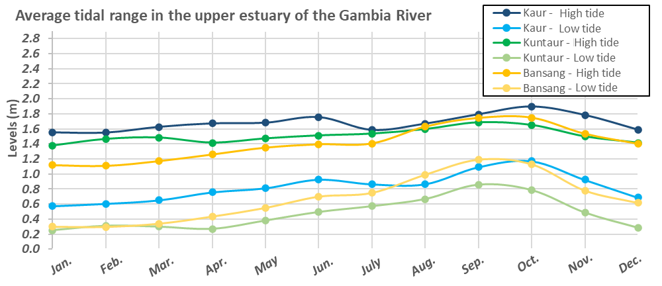
Figure 7. Average monthly tidal range values at the Kaur, Kuntaur, and Bansang stations

The maximum tidal range amplitude is observed during the low-water period, with values of 0.8, 1.2, and 1.1 m at Bansang, Kuntaur, and Kaur hydrometric stations respectively. The tidal range amplitude is lowest during the high-water period and is 0.6, 0.8, and 0.7 m, respectively. Under a regulated regime, the water levels reached at the low tide and high tide stations should be slightly below the levels reached under a natural regime during high-water periods; however, during low-water periods, the river water levels should increase slightly. Therefore, there will be fewer seasonal differences between monthly tidal range values. The negative impacts of regulation on tidal range dynamics are considered to be limited because of the low difference in levels assessed (<20–30 cm). The slight decrease in levels reached during the high-water period could even be positive for certain agricultural operations, because of the improved flooding control in some areas. The adaptation of other tidal irrigation infrastructure, for which the decrease in levels would be a constraint, would a priori seem to easily reduced by minor changes to the structures given the mild decrease in amplitude expected. More consistent tidal ranges should also simplify tidal irrigation planning.
The expected benefits of the dam for irrigation in both the dry season and the flooding season, with a better regulated river regime, will therefore need to account for the impact of this new system on the areas concerned by hybrid and tidal irrigation. The development of irrigated agriculture as a result of more consistent water inflows will, however, remain highly sensitive to the periods during which the turbines might not be used as outlined in SAMVA’s various output estimates to date.

3.2.6 Power production issues
Since the economic component cannot be removed from any sustainable development project, issues pertaining to power production—one of, if not the main function of the Sambangalou dam—must be considered. However, it seems clear already that the ideal environmental flow scenario will require compromise between the impacts on natural environments, ecosystem services and downstream human activity and on hydroelectric production.
The energy production optimization issues considered to develop this initial environmental flow scenario are related to two basic energy production concepts for hydroelectric dams with a reservoir:
(1) Limit losses of water or discharge released without being passed through the turbines;
(2) Provide an uninterrupted power source.
Limiting water losses during the high-water period, in order to reconcile environmental flows and energy production, consists of evacuating the least possible flooding maintenance water not passed through the turbines in order to help reach environmental targets while limiting negative impacts. Uninterrupted energy production during the high-water period does not pose a problem.
During low-water periods, the issues pertaining to water losses are related to the maximum flow required in Gouloumbou, in order to limit downstream saltwater front recession, which is much lower than the minimum flow of the SHDP’s equipment (≥ 30 m³/s). Turbine flow stoppage must also account for the minimum water requirements for irrigation downstream of the dam and losses by evapotranspiration by storing water in the reservoir. It is clear that the best solution to limit the saltwater front recession during drought and output losses would be to develop off-season irrigated farming in order to capture most of the turbine flow.

3.3. Socio-environmental criteria to be met downstream of the dam

3.3.1 Frequency and duration of backswamp filling
SHDP water management criteria allowing for the flows released during the high-water period to reach the flooding thresholds of the backswamps located downstream are developed according to the amplitude of flows (m³/s) connected with the backswamp flooding threshold and on the frequency and duration of river-backswamp connections observed to date. The flooding frequency and river-backswamp connection time values differ slightly according to the methods or data used in the various studies. Table 2 summarizes these various values. It is reiterated that the natural flow series estimated by AECOM are used to evaluate the Simenti and Gouloumbou backswamp filling criteria according to measured or simulated values. The flow series in Simenti and Gouloumbou are not reconstructed for SAMVA’s output studies and cannot therefore be used to estimate backswamp flooding criteria.
Table 2. Statistics on the amplitude of flows associated with the backswamp flooding threshold, the backswamp flooding frequencies, and the average river-backswamp connection times
Statistics on backswamp flooding
Studies/statistics |  | Flow amplitude (m³/s) for backswamp flooding | Overage frequency (years) | Number of days over (average)
Simenti - Natural regime | Backswamp study (Frequency analyses) | 1,025 | 1.9 years | -
Simenti - Natural regime | Analyses using reconstituted flows | 1,025 | 27/49 years or 1.8 years | 17
Simenti - Natural regime | Analyses using simulated flows (SIMULGAM) | 1,025 | 28/49 years or 1.75 years | 9
Gouloumbou - Natural regime | Backswamp study (Frequency analyses) | 1,050 | Average: 2.3 years | -
Gouloumbou - Natural regime | Analyses using reconstituted flows | 1,050 | 28/49 years or 1.75 years | 24
Gouloumbou - Natural regime | Analyses using simulated flows (SIMULGAM) | 1,050 | 30/49 years or 1.6 years | 17

The flow amplitude associated with river overflow and backswamp filling thresholds was determined during the hydraulic backswamp operations monitoring study (AECOM, 2020). During this study, a frequency analysis showed that these threshold flows were exceeded every 2.3 years on average. The frequency analyses also associated a 700 m³/s flow with a return period of 2.3 years in Sambangalou. These values guided AECOM’s preliminary recommendations for flooding maintenance discharge for backswamp filling.
Clarification of these values is provided in more detailed studies of the reconstructed flow series under a natural regime in Simenti and Gouloumbou. Of the 49 years of hydrological series, the threshold was exceeded for 27 and 28 years in Simenti and Gouloumbou, respectively. For the years in which the thresholds are exceeded, the average overage time is 17 days in Simenti and 24 days in Gouloumbou.
As slight differences are observed between the series of flows measured at the Simenti and Gouloumbou stations and the series of flows simulated by the SIMULGAM model according to the natural inflows in Sambangalou and in the tributaries, the same exercise is carried out with series of natural flows simulated by the SIMULGAM model. This exercise is necessary because the impact assessment of water management at the SHDP on the downstream flows of the river is based on flows simulated by the SIMULGAM software, which, though very accurate from a hydrological perspective, does not perfectly reflect reality. The assessment of the series of flows simulated in Simenti and Gouloumbou according to the natural inflows in Sambangalou shows a slight difference between overage frequencies (28 and 30 years). However, the river-backswamp connection times are shortened to 9 days in Simenti and 17 days in Gouloumbou.

3.3.2 Water needs to be met downstream
Avoid the negative impacts of saltwater front recession by suggesting turbine shut-down periods that contradict irrigation water supply, one of the main benefits of regulating dam water during the low-water period. The water needs currently estimated for irrigation near the Gambia River are currently much lower than the dam turbine flows during the low-water period. Two relatively recent studies (Verkerk and van Rens, 2005, Bader, 2003) attempted to assess current and future water requirements for irrigation according to short-term, medium-term and long-term agricultural development scenarios.
For this study, the first technical note raised concerns regarding the values estimated in these previous studies (see technical note 1, p. 21–22). Consequently, more detailed work was carried out to determine irrigation water volumes that are better suited to Senegal’s and the Gambia’s agricultural schedules and to the succession planting usually carried out. These newly estimated extraction flows are used in this environmental flow scenario as they reflect current and future water needs much more accurately.
The approach put forth to reassess current and future water needs for irrigation primarily relies on the hierarchization of the following tasks: (1) very high-resolution delimitation of the borders of the types of land use using satellite imaging, (2) classification of the types of land use according to their current and future agricultural potential, (3) study of agricultural trends of the Senegalese and Gambian regions bordering the Gambia River, (4) calculation by the CropWat model of water needs for irrigation relating to the different types of crop and the regional climate and, finally, (5) calculation of the total water needs for irrigation based on irrigated or potentially irrigable areas and the types of crop prioritized in the region. These main methodological steps of the reassessment of water needs are presented in detail in Appendix 1.

3.3.3 Saltwater front recession limit
The average monthly positions of the saltwater front under a natural regime in the Gambia River were determined according to the flows observed and reconstructed in Gouloumbou for the 1970–2019 period and according to the average monthly water needs for irrigation, updated according to AECOM’s latest studies as presented in this report. Compared to the values simulated by the IRD (2003), the monthly position has receded approximately 10 km downstream, which may be attributed to the period of much higher hydraulicity observed from the early 2000s to present.
Table 3. Simulated average monthly saltwater front positions for the 1970–2019 period
Average monthly position under a natural regime (KP) | 1 g/l | Jan. | Feb. | Mar. | Apr. | May | June | July | Aug. | Sep. | Oct. | Nov. | Dec.
Average monthly position under a natural regime (KP) | 1 g/l | 162 | 178 | 198 | 218 | 236 | 247 | 214 | 139 | 100 | 87 | 118 | 144
Average monthly position under a natural regime (KP) | 5 g/l | 136 | 150 | 166 | 181 | 196 | 203 | 177 | 125 | 90 | 78 | 100 | 122
Average monthly position under a natural regime (KP) | 15 g/l | 96 | 109 | 122 | 136 | 149 | 154 | 137 | 99 | 70 | 60 | 72 | 84
Water requirements for irrigation (m³/s) |  | 1.7 | 0.9 | 0.4 | 0.46 | 0.6 | 2.6 | 5.6 | 1.1 | 0.9 | 3.3 | 1.4 | 1.8
Average monthly flows in Gouloumbou (m³/s) |  | 25 | 12 | 6 | 3 | 2 | 6 | 93 | 473 | 819 | 494 | 132 | 53

Based on initial studies of the dam water management scenarios and the impacts on saltwater front displacement (Bader, 2003, Verkerk and van Rens, 2005), a 1 g/l saltwater front recession to KP 160 was considered at the time. Agricultural development opportunities were heavily promoted, but the impacts on the mangroves were poorly understood. High-resolution mapping of the land use carried out for social, biodiversity studies and this study helped clarify the potential impacts on the mangrove associated with different amplitudes of the 1 g/l saltwater front recession. Land use mapping also helps draw clearer a spatial portrait of irrigated agriculture along the section of the river that experiences permanent desalinization during operation of the SHDP (see Figure 8). This mapping also helps estimate the surface area of plots representing short-term potential (abandoned formerly irrigated plots or fallow land) and medium-term potential (crop already being used) for the development of irrigated agriculture. Here, special attention is paid to section KP 160 to 250 because of the emphasis on the saltwater influence and impacts associated with the 1 g/l saltwater front recession.
Though some isolated mangrove trees are found upstream of KP 250, the first mangroves whose density was visible on satellite images (WorldView-2) are located at this point of the river. Only 7% of the total surface area (685 km²) of mangroves is located upstream of KP 160, or a rate of 0.5 km² of mangroves per linear kilometer of river. However, the land use map clearly shows (see Figure 8) that the actual dense mangrove limit is located between KP 170 and 190, where the mangrove density significantly decreases. 1.3% of the total mangrove area is located upstream of KP 190, or a rate of 0.15 km² of mangroves per kilometer.
Upstream of KP 190 until KP 247, the average limit of the annual maximum 1 g/l saltwater front intrusion, there is slightly over 1,000 ha of irrigated land, whether by the tides or by river water pumping. A surface area nearly three times greater (2,758 ha) contains former irrigated crops, now abandoned or consisting of fallow land. Lastly, 3,686 ha of non-irrigated agricultural land, with potential for the development of irrigation because of its proximity to the river and low difference in elevation with respect to the river, is scattered along this section of the river.
After discussions with the biodiversity and social study teams and consultations with Gambian experts on the subject (Gambia Department of Forestry and National Environment Agency), a KP limit of the 1 g/l front, which finds a compromise between agricultural development mangrove impact limitation, was identified. This limit was set to KP 190 and constitutes the environmental criterion regarding the impact of water regulation on saltwater front recession.

3.4. Sambangalou hydropower plant operations simulation approach
An SHDP water management scenario that meets the environmental flow environmental criteria was drafted further to a process to simulate the operation of the future dam and the resulting impacts on physical processes. Discussions with the biodiversity study and ESAP teams and the SAMVA group team responsible for assessing output helped ensure the consistency and efficacy of the environmental criteria and management methods to be added to the dam operation simulation model (see Figure 9).
The simulation tools developed to draft the final environmental flow scenario and field measurement instruments validated and added to the AEFS will be used to monitoring the environmental criteria identified to draft the environmental flow. Three simulation tools were used to draft the environmental flow scenario. First (1), a dam water management model was developed to simulate various environmental flow scenarios using the same SHDP water management bases as those put forth to date to assess output. Next (2) the SIMULGAM model was used to determine the impact of water management at the SHDP on downstream flows of the Gambia River; finally (3), the SALNSTAT model was used to determine the impact of water regulation on saltwater front displacement in the estuarine portion of the river. Figure 9 is a diagram of the simulation tools used to develop management and qualification rules for the impacts associated with environmental flow.

3.4.1 Simulation tools
Dam water management simulation model
The simulation model for water management at the dam was developed according to i) the dam characteristics and ii) the water management rules initially proposed. These data come from reports produced by SAMVA: Estimated output during operation and filling (2019), Review of the hydrology of inflows and estimation of output (2019), Floodwater evacuation devices (2020), Estimation of output during operation and filling (revised in November 2020), and from direct transmission of the missing data by the engineers responsible for output evaluation.

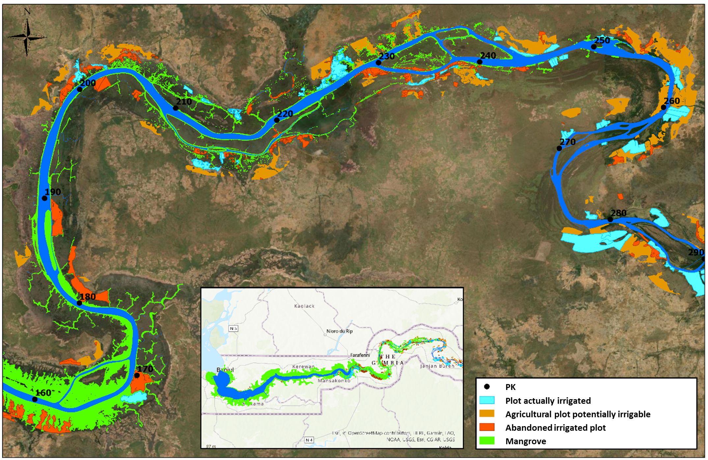
Figure 8. Context of the section of the river subject to permanent desalination further to water regulation at the SHDP
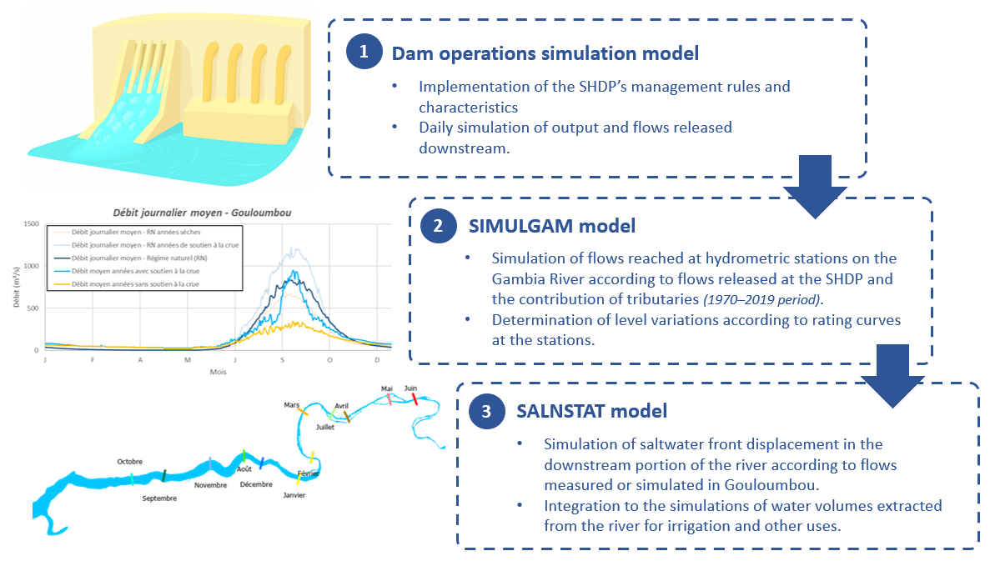
Figure 9. Diagram of the simulation tools used to draft the environmental flow

The model developed by AECOM was validated by comparison across the series of data sent by SAMVA for various water management scenarios at the dam and by simulation of the operation using AECOM’s model for the 1990–2017 period. The differences between average annual output determined by SAMVA’s model and AECOM’s model were, for the three scenarios studied (1: flooding maintenance discharge of 220 m³/s for 1 month; 2: flooding maintenance discharge of 500 m³/s for 7 days, and 3: flooding maintenance discharge of 700 m³/s for 14 days), of 6, 4, and 1 GWh, respectively, or a maximum difference of 1.5%.
An essential aspect to ensure was that the model developed by AECOM used the same bases as the model used until now to estimate output, in order to quantify the impact of modifying or adding new water management rules connected with the environmental flow on the output estimated until now by SAMVA.
The basic management rules and characteristics used for the SHDP operations simulation model were described in the first technical note issued by this study and are also presented in Appendix 2.
SIMULGAM model
The SIMULGAM model was developed by Mr. Jean-Claude Bader of the Development Research Institute (IRD). The model is based on the contribution of tributaries to the Gambia River, as well as the water travel time, in order to determine the amplitude of flows of the Gambia River at the Kédougou, Mako, Simenti, downstream Wassadou, and Gouloumbou hydrometric stations, based on flows in Sambangalou. The SIMULGAM model was formerly used on a platform that is difficult to use today. For the purposes of this project, the model was converted to Excel format. Consequently, it was added to the dam operations simulation model and will be easier to use by future managers of the AEFS.
The SIMULGAM model was previously updated and validated in 2003 (IRD, 2003), while the simulation of dam operations was conducted for the 1970–2001 period. To be able to use the model for the entire period targeted by SAMVA to estimate output and even for more recent years, the model first needed to be updated. The following was required to update the SIMULGAM model for this study:
- reconstruction of missing flow data for the main tributaries of the Gambia River (Diaguéri, Tiokoye, Diarha, Niokolo Koba and for the Koulountou) in order to provide complete flow series for the entire 1970–2019 period;
- reconstruction of certain missing periods of data for hydrometric stations along the Gambia River;
- correction of level data in Gouloumbou during the low-water period, caused by the influence of the tides when the river flow is below 200 m³/s;
- validation of the model results for the 1970–2019 period by comparison of the flows simulated at the station according to a natural flow in Sambangalou and the flows actually measured at the stations over the same period.
All the technical details of these methodological steps are provided in Appendix 3.
SALNSTAT model
The SALNSTAT model simulates saltwater front displacements in the estuarine part of the river. The one-dimensional model was developed by M. Savenije (Savenije, 1986) and subsequently adjusted to the physical, hydrological and climate characteristics of the Gambia River (Savenije, 1988). The model was developed in Fortran programming language and uses the following processes: river flow, precipitation, evaporation, tide, water requirements for irrigation, and the morphology of cross-sections of the river. The SALNSTAT model was last updated in 2003 (IRD, 2003). The saltwater front displacement had been simulated for the 1970–2001 period and validated according to salinity measurements collected between 1974 and 1996.
Here, saltwater front displacements are simulated according to the reconstructed flows in Gouloumbou for the 1970–2019 period and for average monthly water needs for irrigation, updated according to AECOM’s latest studies on water needs for irrigation presented later in this report. Compared to the values simulated by the IRD (2003), the monthly position has receded approximately 10 km downstream, which may be attributed to the period of much higher hydraulicity observed from the early 2000s to present.
Based on the flows simulated in Gouloumbou associated with flow regulation in Sambangalou and the revised estimates of current and future flows extracted from the river based on short and medium-term irrigated agriculture development scenarios, the SALNSTAT model was used in order to assess the impact of the environmental flow on saltwater front displacement. To do so, the following updates to the SALNSTAT model were required:
- new simulations in light of the flows recorded to date (June 2021) at the station, as well as;
- spatial and chronological validation of simulated saltwater front displacements, thanks to longitudinal measurements of river salinity carried out in mid-December 2020 and mid-June 2021, respectively, and river water salinity data continuously recorded in Tendaba, at the Senegambia bridge, and in Kaur.
All the technical details of these methodological steps are provided in Appendix 4.

3.4.2 Hydrological series and simulated period
In its report titled Review of the hydrology of inflows and estimation of output (SAMVA, 2019), SAMVA recommends, though very few data are provided on the analyses performed, that, according to a series of flows reconstructed using data from the Gourbassi station in Mali, the 1990–2017 period be used to avoid generating incorrect outputs as a result of the drought observed between the 1970s and 1990s.
Studying variations in flow series is currently a key aspect of hydrology. Viewing or analyzing a hydrological series solely through a restricted lens while abstracting other data can result in incorrect results.. Consequently, output assessment, like the assessment of the impacts on physical dynamics, varies considerably according to the period used for the simulations.
The standard in hydrology is that in the presence of a stationary series, the longest period of data available will be preferred in order to better reflect the natural variability in the flow series. The hydrological analyses carried out to date (Review of the hydrology of inflows and estimation of output or other prior studies) were insufficient for the needs of this study. Further analysis was therefore carried out.
In this section of the report, the environmental flow analyses carried out by AECOM are slightly more detailed from a technical perspective and could be difficult to understand for some non-specialist readers. However, here, this information should be presented in order to clearly justify the period chosen for the simulations used to draft the environmental flow.
Characteristics and processing of hydrological data
The data used to reconstitute the flow series at hydrometric stations along the Gambia River and its tributaries were retrieved from the Hydraccess database updated in spring 2020. The Hydraccess database is the archiving tool used for hydrometric data (water levels measured at the stations, types of measurements, flows rated according to the gauging data and levels collected at the stations) sampled from the Gambia River and its tributaries. This database (version here updated in summer 2021) includes information on the water levels measured at the hydrometric stations, the flows estimated from these levels, as well as the gauging carried out at the hydrometric stations. Note that hydrometric stations in Senegal are sometimes equipped with automatic recorders, but that water levels are often recorded visually or by stream gauge. This is done 1 to 3 times per day, whether visually or by automatic data recording systems. The database contains information on the sensors and the type of measurement, but this information is inconsistent in many ways. It should also be noted that the rating equations at the stations are not provided in the Hydraccess database or in the hydrological monograph of the Gambia River (Lamagat, 1987).
Given the inconsistencies observed in the Hydraccess database and one of the goals of the environmental flow study, which is to determine the impact of an increase in flows released during the low-water period on river water levels, the rating curves were recalculated for all stations.
Daily flows were also recalculated according to the maximum daily levels recorded at the stations and purged (elimination of deviations). Since the level data are not recorded automatically at intervals of one hour or less, and since the Gambia River has a relatively significant capacity to limit the effects of a sudden flood occurring within a day, AECOM recommends that the maximum daily levels (or flows) recorded at the stations be used in order to better represent the actual amplitude of floods along the river. Use of the maximum instead of the average flows is subject to debate; however, comparisons between flow series calculated by AECOM and the average and maximum daily flow series provided in the Hydraccess database showed the following trends:
- The rating curves produced by AECOM conform with the curves used to estimate the flows provided in the Hydraccess database.
- There are few differences between the series of flows calculated according to average or maximum daily levels at the stations.
- The periods for which significant differences are observed between the hydrological series calculated by AECOM and those provided by ISL or available via the Hydraccess database actually correspond to periods of missing data. Furthermore, these periods of missing data almost always correspond to the peak of certain flooding events. The approach used by ISL to fill these periods of missing data was to use linear interpolation across the missing data, while AECOM preferred to develop statistical relationships between the data observed for certain tributaries and other stations on the river to complete the missing data.
Feedback was provided by the OMVG and supervisors of the SAMVA group. The conclusion was to use the hydrological series reconstructed by ISL in Sambangalou as reservoir inflows. For the needs of the SIMULGAM model, the missing data during periods of flood peaks at the other hydrometric stations were replaced with statistical relationship models, which, according to AECOM, provide a much more accurate estimate of the river’s natural dynamics than linear interpolation. All the details and data resulting from hydrological series reconstructions are presented in Appendix 5.
Simulated period
AECOM analyzed the maximum annual flows measured and reconstructed in Gouloumbou for the 1954–2019 period. A Mann-Kenndall test reveals that the maximum flow series in Gouloumbou is stationary and, consequently, that there is no significant stand-out to suggest dividing the hydrological series into two separate series. For its part, Figure 10 illustrates a trend analysis and an average rupture analysis for this same series. The statistical trend in the flow series shows a decrease followed by an increase in flows. The available time window suggests that the flows of the Gambia River are influenced by periods of high and low hydraulicity. The report on the Third National Communication of Senegal at the United Nations Framework Convention on Climate Change (2015) concluded that one of the effects of climate change in Senegal is an increase in the amplitude of the alternating high and low hydraulicity periods, which is consistent with the patterns observed in the Gouloumbou series. A series rupture analysis used to form groups in order to minimize intra-group variance suggests that the low hydraulicity period spans 1966–2000.
Based on these analyses, AECOM recommends that the 1980–2019 period be used for the simulations and the evaluation of both potential output and regulation impacts. This period, characterized by 20 years of lower hydraulicity and 19 years of higher hydraulicity, is a more reliable representation of the future dam regime. Though the use of a 1970–2019 series would give more weight to the low hydraulicity period, the 1990–2019 period gives more weight to the high hydraulicity period. Based on historical analyses of the Gouloumbou series and climate forecasts, it is not recommended to give more weight to the high hydraulicity period. However, the 1990–2017 period will be used for comparisons with the annual output estimated to date by SAMVA in various reports on hydroelectric dam output.

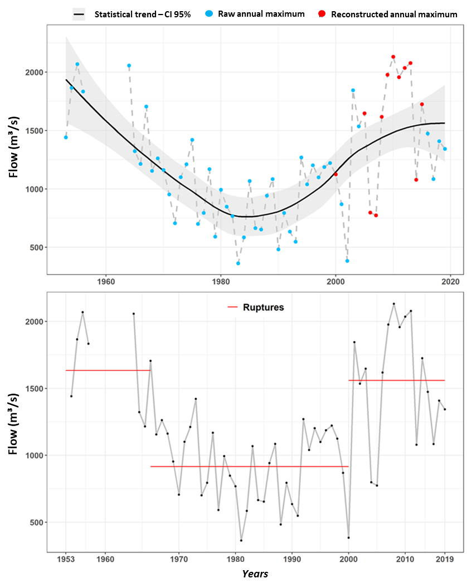
Figure 10. Trend and average rupture analyses of the maximum annual flow series for the 1954–2019 period in Gouloumbou

Socio-environmental operating procedures for the Sambangalou dam
In the first technical note produced by AECOM for this study, two environmental flow scenarios were presented. The first favored power production and imposed no limit on turbine flows in the low-water period, and the second favored a turbine shut-down period in order to limit impacts on socioeconomic activity and biodiversity. As a reminder, these impacts are related to the significant rise in water levels upstream of Gouloumbou and to the saltwater front recession downstream of the river.
These two preliminary scenarios aimed to present possible management alternatives and to encourage feedback from the client, the biodiversity study and LRP teams, and from the SAMVA group responsible for the construction of the installation, in order to determine which impacts cannot be compensated or avoided, for each major aspect (social, environmental, and economic) affected by the project. Based on the feedback received regarding the possible negative and positive impacts of the structure and regarding the potential turbine water management scenarios likely to be put forth in the future, one single environmental flow scenario was drafted.
Also note that the environmental flow drafted falls within an adaptive strategy, the AEFS, which requires (1) water management rules at the dam associated with the environmental flow, (2) monitoring procedures required to apply certain rules that are also used to validate their applications and effectiveness, and (3) periodic environmental flow reassessment phases.
The rules for water management at the dam, monitoring, and reassessment tasks are integrated into the various AEFS steps, as a result of which application periods for socio-environmental operational procedures for the Sambangalou dam are established. Figure 11 below illustrates the process for applying the operating rules or monitoring and reassessment process put forth by the AEFS.

4.1 Predefined operating rules during reservoir filling
Because of the i) short period expected for reservoir filling if the inflows observed are at least average, ii) contributions of tributaries that minimize the impacts downstream of Kédougou, and iii) condition of applying the environmental flow management rules as of the second year of filling, no changes were made to the latest filling procedures proposed by the SAMVA group. These procedures are as follows:
Rule 1. Construction phase: During this phase, no significant influence on the river flow should be observed. If short-term work was to require the drying up of the riverbed, this work can be completed during drought (or using stoplogs) and take into account the requirements of off-season irrigation.
Rule 2. First year of filling: The reservoir may be filled by capturing all incoming water volumes, except the volumes required for off-season irrigation, until the level of 176.5 m is reached (approximately 2 months in the average to significant flooding period and approximately 5 months during dry years). Once the minimum operating level (176.5 m) has been reached following initial months of filling, a constant average daily turbine flow of 40 m³/s is expected for the rest of the year by only one of the structure groups. All of the other environmental flow scenario criteria, except for flooding maintenance discharge for backswamp filling, must also be met.
Rule 3. Second year of filling: Start of management according to the environmental flow criteria.

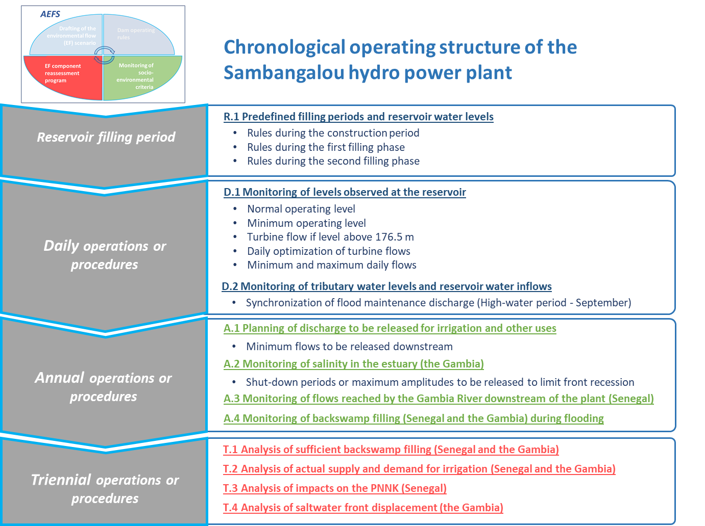
Figure 11. Structure for applying operating rules or AEFS monitoring and reassessment processes

4.2 Daily operating procedures
Though based on fixed or monthly criteria, the monitoring rules or procedures described below should be applied daily by the future SHDP operator and/or another stakeholder involved in the socio-environmental dam operation procedures, such as SOGESART. It should also be clarified that the rules apply as a whole and not independently from one other. However, some rules supersede the application of others; this will be clarified in the rule application as necessary.

4.2.1 Basic rules or rules resulting from the monitoring of levels observed at the reservoir
The basic management rules were developed according to the water management scenarios presented in the SAMVA group’s various reports on output. The scenarios currently presented by the SAMVA group are based on average daily flows. The basic rules for water management at the dam are thus presented here in terms of daily values or amplitudes.
Rule 4. Normal operating level (NOL) of 196 m: the sluices and spillway, as needed, are used to avoid exceeding this level. In 50 years of simulation of reservoir inflows, only 2 years (2015–2016) are associated with sluice opening to maintain the level of 196 m during flooding.
Rule 5. Minimum operating level of 176.5 m: below this level, there is no turbine flow. When the turbines are shut down, a reserve flow must be provided by the sluices. The amplitude of the flow reserve to be provided corresponds to new monthly estimates of current or short-term water needs for irrigation. It is clear that the release of a flow reserve will delay reservoir reloading for energy production; however, this will limit the negative impacts related to river water uses. Since the amplitude of the flow reserve to provide in case of turbine shut-down in March, April, and May is negligible, the reserve at the dam will suffice. From a perspective of medium-term agricultural development, the turbine shut-down periods will need to be limited in June, since the storage capacity of the reservoir at 176.5 m will have reached its limit for providing the flow reserve volumes at the start of the month.
Rule 6. Turbine flow if level above 176.5 m: Because of flooding maintenance flows, the monthly average daily turbine flow values (or minimum turbine flow if level > 176.5 m) initially proposed in the reports on output estimation are associated with frequent and prolonged periods of turbine shut-down because of a decrease in reservoir level below the minimum operating level. The preferred approach in the environmental flow scenario is to target monthly daily average turbine flow values that limit turbine shut-downs to a typically acceptable threshold for the development of irrigated agriculture (approximately 1 in 10 years). Table 4 below details the monthly average daily turbine flow values required to meet environment flow criteria.

Table 4. Comparison of monthly average daily turbine flow values
 | Jan. | Feb. | Mar. | Apr. | May | June | July | Aug. | Sep. | Oct. | Nov. | Dec.
Flow (m³/s) initially proposed by VINCI | 90 | 60 | 45 | 30 | 30 | 45 | 90 | 60 | 60 | 200 (220) | 60 | 90
Flow (m³/s) defined by AECOM | 50 | 45 | 40 | 35 | 35 | 35 | 45 | 55 | 60 | 60 | 55 | 50

Rule 7. Daily optimization of turbine flows: As proposed by the management strategy to assess output presented by the SAMVA group, turbine flows are optimized according to the reservoir’s monthly level limits. This means that an additional flow to that presented in Rule 6 passes through the turbines to supplement the average daily flow passed through the turbines, if the reservoir level exceeds certain monthly reference levels. Equally to reduce the turbine shut-down periods, the environmental flow scenario contributes minor changes to the monthly reference levels and to the amplitude of turbine flows (optimization flows) to supplement the existing average turbine flow.. Figure 12 shows the optimization rules defined for the environmental flow scenario and clarifies the additional turbine flows permitted.

* For years in which flood maintenance is not activated, a flow of 200 m³/s, which corresponds to maximum equipment capacity, is passed through the turbines during flood maintenance periods.
Figure 12. Daily optimization rules according to the environmental flow strategy with presentation of additional turbine flows.
Modification of initial reference values for daily optimization
The flooding maintenance criteria for backswamp filling under this EF scenario result in less water storage in the reservoir during the rainy season. The initial minimum drought maintenance flows resulted in a frequency and duration of turbine shut-down periods that was too high (nearly 1 every 3 years). In a context of possible irrigated agriculture development on the shores of the Gambia River, associated with more consistent water inflows, a shortage of water inflows when the reservoir level falls below the level of 176.5 m could have major consequences for agricultural producers. A flow reserve of an amplitude corresponding to irrigation water needs, guaranteed during turbine shut-down periods by discharge released at the sluices, is far from ideal from a power production perspective. In this light, it would be better to minimize turbine shut-down periods in order to limit the flow reserve released by the sluices and consequently potential power losses. The monthly amplitude of turbine optimization flows also aims to limit the amplitude of flow variations in the natural low-water period and the resulting negative impacts (i.e., unusable natural and artificial fords, destruction of habitats or reproductive sites, impact on river-related economic activities).

Rule 8. Daily minimum and maximum flows: Population safety issues related to possible variations in turbine flows within a day should be assessed primarily using the dam’s safety plans. Some environmental and social aspects are also non-negligible and should be considered if this management mode moves forward. To limit the extent of these impacts, the environmental flow scenario incorporates minimum and maximum daily turbine flow criteria, regardless of the hourly management method, which can be selected at a later date.
Minimum daily turbine flows should always at least allow for a constant irrigation water supply. If discharge is released below the minimum equipment flow, discharge to support downstream needs will be provided by the sluices.
The minimum turbine flows from March to June correspond to the minimum equipment flow, i.e., 30 m³/s per recent communication with SAMVA. During the low-water period, a maximum daily flow of 45 m³/s should limit the impacts on fords, economic activity, and on the dynamics of the river and riverside ecosystems. Consequently, a maximum variation margin within a day of 15 m³/s during the natural low-water period is considered acceptable in order to reduce socio-environmental impacts.
To simulate natural dynamics in the high-water period, total turbine shut-down periods cannot be considered. This means that, during flood maintenance periods, the average daily flows issued from the backswamp filling criteria should be used as the minimum daily flows, so as to not affect the minimum river-backswamp connection periods. However, outside of the flood maintenance periods, higher minimum daily turbine flows to pass through the turbines are also imposed in August, September, and October.
Table 5 below describes the monthly minimum and maximum daily turbine flows.
According to the data and information currently available, the minimum daily flows for January, February, July, October, November, and December were set to the values of irrigation water needs, while no maximum limit was set. Therefore, these limits give output study supervisors more flexibility for daily optimization. However, the safety studies required to establish possible daily variation limits will need to be conducted. Once these values have been determined, certain aspects of the environmental flow might need to be reviewed.
Note that the application of Rule 7 supersedes that of Rules 6 and 7.

Table 5. Monthly values of the minimum and maximum daily turbine flows.
 | Jan. | Feb. | Mar. | Apr. | May | June | July | Aug. | Sep. | Oct. | Nov. | Dec.
Minimum daily turbine flow (m³/s) | IWN | IWN | MEF  30 m³/s | MEF  30 m³/s | MEF  30 m³/s | MEF  30 m³/s | IWN | 55 | 60  Or FM | 60 | IWN | IWN
Maximum daily turbine flow (m³/s) | none | none | 45 | 45 | 45 | 45 | none | none | none | none | none | none
* IWN: Irrigation water needs, MEF: Minimum equipment flow (30 m³/s), FM Flood maintenance for backswamp filling.
Framework of potential optimization within a day
Additional turbine flow management rules were established in case future dam management is based on (1) the total volume of water to be passed through the turbines, corresponding to the reference and optimization average daily flows, and on (2) hourly optimization of turbine flows taking into account peak power demand periods and potentially involving total turbine shut-down periods in order to maximize power production at peak periods. Based on the management system proposed for the low-water period, river water flows and levels would be considerably higher than under natural conditions. These increases are sure to have significant positive effects on access to water as a resource, but they will also significantly impact some habitats, reproductive grounds, gold panning, and the river crossings provided by several natural fords. Reduction measures must be put forth to limit the negative impacts of these higher water levels. However, it will be very difficult, if not impossible, to put such measures in place if flow variations within a day are too significant. Furthermore, these significant variations could also prevent populations from reclaiming the river and these new conditions in the low-water period in order and developing new activities or uses (i.e., fishing, crossing, bathing). Since periods of very low flow, even zero flow, already exist for the Gambia River; the minimum daily turbine flows do not aim specifically to limit environmental impacts but rather to limit excessive flow deviations within a day, which do not allow ecosystems to adjust to the new dynamics. Furthermore, statistic propagation models for flows downstream of the plant suggest a one-day delay between the flows released in Sambangalou and the flows measured at Mako hydrometric station, which should limit the socio-environmental impacts of flow variations within a day in the Sambangalou-Mako reach of the river. However, additional hydraulic simulations, requiring, among others, relatively accurate bathymetry of the river until Gouloumbou, a more accurate elevation model of the banks, along with safety studies for riverside populations are required in order to opine on the possible amplitudes of flow variations within a day. Only further to these studies can final minimum and maximum daily turbine flows be determined. This being said, the rules presented below guide the minimum conditions to be met under the environmental flow.

4.2.2 Synchronization or rules resulting from the monitoring of tributary water levels
The SHDP operator must release flooding maintenance discharge in order to fill backswamps at a frequency and a duration defined in the environmental flow’s environmental criteria. However, given the importance of the proportion of inflows in Sambangalou to the flow observed to the right of the backswamps, and the amplitude of the flow required for the river to fill backswamps, only rigorous management of flooding maintenance discharge based on synchronization will succeed in meeting environmental criteria. Synchronization will require Level monitoring at some tributaries and frequent communication of such levels to the dam operator. Tributary level monitoring and the resulting dam water management rules are daily procedures, but they will only begin to apply in September.
Rule 9. Flooding maintenance discharge: In the high-water period, and, more specifically, in September, the dam managers will need to adopt a management method based on the synchronization of discharge released at the dam with the amplitude of the flows or levels observed on certain tributaries of the river (i.e., Koulountou, Diaguéri, and Niokolo Koba), and the incoming reservoir flows.
Synchronization criteria for flooding maintenance discharge were determined to allow for (1) a minimum backswamp filling frequency of 2.3 years and (2) a minimum river-backswamp connection time of 9 days in Simenti and 17 days in Gouloumbou (note that these periods correspond to the results of simulations of the SIMULGAM model rather than the natural connection times observed at the backswamps).
Table 6 presents the synchronization criteria in terms of flows and levels observed. Note that the criteria for triggering flood maintenance and for determining amplitude categories for the flows to be released must be observed jointly at the (3) tributaries and at the reservoir. The water levels (m) and flows (m³/s) are presented for each tributary thanks to a rating update for each station. The levels are presented in terms of relative elevation of the water level measured by ruler, since this is the easiest way for the readers assigned to each ruler to communicate the readings.
Note that Rule 9 supersedes all other rules, except for Rule 4 which, if applicable, is applied jointly.
Table 6. Synchronization criteria for discharge released to maintain flooding
Synchronization criteria for water management during the high-water period
Criteria for triggering flooding maintenance |  | Koulountou |  | Diaguéri |  | Niokolo Koba |  | Sambangalou
 |  | Flow (m³/s) | Level (m) | Flow (m³/s) | Level (m) | Flow (m³/s) | Level (m) | Flow (m³/s) | Level (m)
 |  | Value (on Day D-2) |  |  |  |  |  | Average  (of Days D-1 to D-3)
 |  | ≥ 140 | ≥ 4.9 | ≥ 70 | ≥ 6 | ≥ 60 | ≥ 4 | ≥ 385 | Rating of reservoir levels
Duration of released discharge |  | Once the triggering criteria have been met, the flooding maintenance discharge must be released over a specific duration of 20 days.
Amplitude of released discharge (evacuated by the sluices in addition to the 200 m³/s turbine discharge) | 500 m³/s | If < the threshold criteria 400 |  |  |  |  |  | -
 | 400 m³/s | 160 | 5.5 | 80 | 6.0 | 50 | 4.4
 | 300 m³/s | 185 | 6.2 | 90 | 6.5 | 60 | 4.7
 | 200 m³/s | 200 | 6.6 | 100 | 6.8 | 72 | 5.0

Validation of the hydrometric stations last December showed that, at present, only the hydrometric stations on the Diaguéri and Niokolo Koba are currently in a condition suitable for use for water management at the dam based on synchronization with the tributaries. The diagrams illustrating the levels to use for synchronization in accordance with these rules are presented in Appendix 6.
Synchronization basis
By releasing flooding maintenance discharge only during years in which tributary contribution is significant, synchronization avoids wasting flooding maintenance discharge that would not allow for backswamp filling. By regulating the amplitude of flooding maintenance discharge according to the tributary flows observed, synchronization also minimizes potential output losses while preserving the minimum the amplitude and duration of flooding required to fill the backswamps. By limiting the amplitude of discharge released in Sambangalou according to the amplitude of the tributary flows, such management also limits the risks relating to flooding through flood amplitude control.

4.3 Annual operating procedures
The dam operating rules applied annually are a product of monitoring of the water needs downstream of the dam and monitoring of the upstream rise of the 1 g/l saltwater front, two monitoring procedures to be conducted annually. Two other follow-up procedures should be conducted annually in order to collect the data required for triennial AEFS reassessment tasks.

4.3.1 Planning of the discharge to be released for irrigation and other uses
Rule 10. Minimum downstream flows to be ensured: Based on AECOM’s updated estimate of water needs for current and future irrigation, a minimum flow must be released downstream to ensure that current uses of the river water can be maintained year-round. Since the turbines can only operate from a minimum flow of 30 m³/s, in order to reduce negative impacts on output, planning of turbine flows that limit the turbine shut-down period will suffice to meet irrigation water needs. This will also cover other water-related needs (i.e., drinking water, industrial use) while minimizing output losses associated with flows released but not passed through the turbines. Table 7 summarizes the new estimates of current water needs, in addition to short and medium-term predictions related to the development of irrigated agriculture.
Annually, actual water needs for irrigation or other uses must be assessed in order to ensure consistency with the current and future estimates carried out for this study. Monthly values will need to be adjusted as needed.
Note that Rule 10 operates jointly with Rules 5 and 7.

Table 7. Water needs for irrigation of riverside land along the Gambia River
Estimated water needs | Minimum monthly flows (m³/s) to meet irrigation water needs
Estimated water needs | Jan. | Feb. | Mar. | Apr. | May | June | July | Aug. | Sep. | Oct. | Nov. | Dec.
1. Current | 1.7 | 0.9 | 0.4 | 0.5 | 0.6 | 2.6 | 5.6 | 1.1 | 0.9 | 3.3 | 1.4 | 1.8
2. Short-term development  (≈ 5 years) | 3.0 | 1.4 | 0.4 | 0.5 | 0.9 | 5.2 | 11.9 | 2.3 | 1.8 | 6.1 | 2.3 | 3.0
3. Medium-term development  (≈ 10 years) | 8.4 | 3.6 | 0.4 | 0.5 | 2.5 | 14.1 | 29.6 | 5.5 | 4.1 | 18.0 | 6.1 | 8.5

Consider needs for irrigation and other uses of the river water
One of the positive impacts of increased flows and levels of the Gambia River during the low-water period with operation of the Sambangalou dam is the guarantee of more regular access to a more abundant water resource. This new reality will simplify irrigation of current crops and encourage the development of irrigated agriculture along the river. To promote agricultural development and reduce negative impacts on farmers who come to invest in irrigated crops, a realistic and conservative estimate must be available for dam water management.
The water needs currently estimated for irrigation near the Gambia River are much lower than the dam turbine flows during the low-water period. Two relatively recent studies (Verkerk and van Rens, 2005, Bader, 2003), attempted to assess current and future irrigation water needs according to short, medium, and long-term agricultural development scenarios.
However, AECOM’s team raised concerns in its first technical note regarding the estimated agricultural potential values in these studies (See Technical Note 1, p. 21–22). Consequently, AECOM studied the situation much more closely, in order to determine irrigation water supply volumes that are better suited to Senegal’s and the Gambia’s farming schedules and to the succession planting regularly performed. These new flow estimates presented in this new technical note have been added to the final environmental flow scenario. They present a much more accurate estimate of current and future water needs. The detailed methodology put forth to generate these new estimates will be presented in the final Adaptive Environmental Flow Strategy (AEFS) report.

Salinity monitoring in the estuary
Annual salinity monitoring in Kaur (KP 205), involving the use of continued measurement probes and data retrieval to ensure the correct operation thereof, must be ensured. Afterwards, once the management method has been properly implemented and verified, and once no significant changes have been made to the environmental flow or the related management rules, salinity can be measured less frequently in Kaur (2–3 years). These data will be required for the AEFS’ triennial reassessment procedures.

Rule 11. Turbine shut-down period: Upstream of the confluence between the 1 g/l saltwater front and the freshwater inflows, it should be highlighted that the extraction of river water, to fulfill irrigation needs and other uses, plays a role in significantly reducing the river flow and limits the effect of the saltwater front recession. The maximum average 1 g/l saltwater front displacement limit (June) is set to KP 190, or 60 km from its natural average position. In order to limit the saltwater front recession to this location, no flow should pass through the turbines for the entire month of May, and as long as the water volumes actually used for irrigation do not correspond to the volumes required for irrigation, based on the medium-term projection (≈10 years) of irrigated agriculture development (see the monthly volumes required in Table 7). During the turbine shut-down periods (first 10 years), the flows required to meet irrigation water needs must at least be ensured by the dam sluices.

Saltwater front recession and impacts on the mangrove
Even though riverside populations would like a more sustained river flow during the low-water period, and even though this would represent very significant potential for irrigated agriculture development, the impacts on mangroves caused by an increased flow and saltwater front recession must also be reduced. In the context of the proposed environmental flow scenario, the recession of approximately 60 km of saltwater front is nonetheless quite significant. The limit of 190 km was selected according to mangrove density, which is much lower upstream of this limit. Note that the management method involving turbine shut-down in May for the first 10 years of operation was retained for the simulations.

Monitoring of flows reached by the Gambia River downstream of the plant (Senegal)
Monitoring of levels and, consequently, of the flows reached downstream of the SHDP is currently coordinated by Senegal and covers four hydrometric stations that are still operational (Kédougou, Mako, Simenti, Gouloumbou). In the context of the SHDP, continued monitoring will be especially important. Flow and level data at the station will be used to make sure the rules are properly ensuring compliance with environmental criteria. Such data will also be essential for the strategy reassessment and modification steps, since these data will be used to validate the models. Monitoring of water levels at the stations is normally done continuously, thanks to an automatic water level recorder or a reader assigned to a station, but it is considered an annual procedure insofar as the data must be retrieved, corrected, and validated at least annually.

Monitoring of backswamp filling (Senegal and the Gambia) during flooding
Though non-essential, monitoring of water levels during the high-water period (September–early October) should ideally take place at key backswamps in Simenti, Faraba, and Djunda Bolon, continued and incorporated to the environmental flow’s environmental and social criteria monitoring program, especially since the required infrastructure already exists. Monitoring of the levels reached at these backswamps only during the high-water period will be used to more accurately verify the efficacy of flooding maintenance discharge in filling the backswamps.
If continued monitoring of water levels at the backswamps is deemed too complex and consequently not planned, reinforced qualitative monitoring of the water levels reached at the backswamps during flooding maintenance years compared to past levels may also be considered. However, adding qualitative and evaluation criteria to a monitoring program based first and foremost on quantitative criteria is difficult. In this case, extensive understanding of backswamp hydrology is crucial.

Triennial operating procedures
All triennial operating procedures consist of meeting the AEFS’ socio-environmental criteria in order to determine whether the environmental flow scenario needs to be corrected or redrafted. Other criteria, such as a change to the uses of the river water or a change in political, social, or environmental conditions that compromises the application of one or several dam operation rules, may require reassessment of the environmental flow scenario and the related management rules. However, the first criterion requiring correction of the environmental flow or the drafting of new management rules is non-compliance with the environmental flow’s socio-environmental criteria, determined by analysis of the results of annual monitoring procedures.

4.4.1 Analysis of sufficient backswamp filling (Senegal and the Gambia)
To confirm that the maintenance discharge released indeed succeeded in reaching the river overflow and filling thresholds for the backswamps to the right of Simenti and Gouloumbou, the levels/flows recorded at these stations must be analyzed. The relative water levels of 9.6 and 8 m on the water level recorders of the Simenti and Gouloumbou stations, respectively, corresponding to the threshold flows (1,025 and 1,050 m³/s) for backswamp filling, must be reached within the days following the activation of flooding maintenance discharge.
For the drafting of the environmental flow, the environmental time overage criteria are based on the results of SIMULGAM model simulations. However, on the field, flooding maintenance discharge should allow the threshold levels to be exceeded for 17 and 24 days, respectively, at the Simenti and Gouloumbou stations. Durations corresponding approximately to these numbers of days (± a few days) must also be observed in the series of levels recorded at the stations in the weeks following flooding maintenance discharge.
If monitoring of the levels reached at the Simenti, Faraba, and Djunda Bolon backswamps during the high-water period is carried out, the data collected must be analyzed according to the fluvial backswamp filling threshold identified in AECOM’s backswamp dynamics studies.
If relative levels of 0.5, 2.8, and 2.6 m, corresponding to absolute elevations of 20.4, 8.4, and 4.7 m, are observed, respectively, at the Simenti, Faraba, and Djunda Bolon backswamps and exceeded for over ± 20 days, it can be confirmed with even greater certainty that the amplitude of flooding maintenance discharge is sufficient for backswamp filling.

4.4.2 Analysis of actual water supply and demand (Senegal and the Gambia)
A study of the actual developments in water needs for irrigation and other uses of the river water will need to be conducted every three years in order to make sure that the minimum flow values to be ensured downstream are consistent with the estimates produced in this study or those from previous years by the institutions responsible for the environmental and social operation of the SHDP.
Several methods may be put forth to analyze actual water supply and demand, whether by (1) keeping a register for the development of irrigated agriculture compared to baseline and other methodological tools developed for this study or, ideally, (2) coordinating large-scale field monitoring of water volumes extracted from the river.

4.4.3 Analysis of impacts on the PNNK (Senegal)
Impacts related to the rise in drought water levels to the right of the section of the river crossing the PNNK cannot be avoided through water management at the dam, as it contradicts other important functions of the dam, which are to improve the availability and reliability of water as a resource, and to optimize power production. The AEFS puts forth management rules intended to limit the amplitude of drought levels, but it should also come with impact reduction measures, like the creation of new fords and new breeding grounds or habitats.
The procedures to be put forth for the triennial analysis of impacts on the PNNK are the performance of occasional studies on the efficacy of the reduction measures implemented and on the extent of the actual impacts on species vulnerable to the rising river water levels during the low-water period. The criteria regarding impacts on species and measure efficacy analyzed by these studies must first be clarified by these studies conducted by AECOM on biodiversity and social impacts. The inefficacy of a measure, the serious and unexpected impact on a species of which could result in a reassessment of AEFS-related management rules.

4.4.4 Analysis of saltwater front displacements (the Gambia)
Hydrometric stations overseen by the Department of Water Resources of the Gambia are used to monitor salinity of the Gambia River in the area that experiences permanent desalination of the water according to the proposed environmental flow. This being said, these stations are known to have regular problems predominantly caused by long-term saltwater monitoring difficulties and the costs of purchasing appropriate measurement equipment and maintenance of existing equipment.
As part of its validation of the SALNSTAT model, AECOM’s environmental flow team used four continuous salinity measurement probes that will be used to monitor salinity in the estuary of the Gambia River during the first years of operation of the structure. Monitoring of probe operation to validate compliance with and efficacy of the management rules should take place annually. The triennial procedure to analyze the salinity data collected will aim to verified that the 1 g/l saltwater front does not recede further downstream than KP 190. To do so, the analyses will need to identify a minimum annual salinity between 0.1 and 0.5 g/l (reached in May or June) at KP 205 (Kaur), which corresponds to a salinity of 1–1.5 g/l at KP 190.
The monitoring results must be kept in order to make sure that, at each triennial salinity analysis period, that the 1 g/l saltwater front recedes on average no further downstream than KP 190. If years are missing because of instrument failure, the SALNSTAT model may be used to simulate the recession based on flows recorded in Gouloumbou. Note that the effect of the tides on levels in Gouloumbou and, consequently, the flows derived from ratings, will be limited because of (1) the increase in flows in the low-water period and (2) the use of the average flow as inflow over monthly or bimonthly periods in the SALNSTAT model.

Assessment of residual impacts of the AEFS
This section describes the quantitative assessment of impacts on physical dynamics and on the output estimate resulting from the dam operation rules related to the environmental flow added to the AEFS.
Use of water at the SHDP, according to the environmental flow rules presented in the previous section, was simulated using developed tools (daily dam use model, SIMULGAM model, SALNSTAT model). Note that the scenario was simulated for the 1970–2019 period, assuming an initial level of 186.5 m. However, the statistics are calculated for the 1980–2019 period, considered most representative of the natural inter-annual variations in the flow of the Gambia River. Output statistics for the 1990–2017 period are also presented in order to allow for comparisons with the output estimated to date by SAMVA.

To help AECOM’s team responsible for the environmental and social studies understand the impacts, such impacts were spatially analyzed. This will help the team target the best reduction and compensation measures and properly communicate the impacts to the local populations concerned during field work. Table 8 summarizes the changes considered to natural physical processes according to water regulation at the SHDP and taking into account the environmental flow operating rules. Impacts are summarized according to the various sections of the Gambia River associated with similar physical dynamics. The sub-sections below provide further details of the impacts related to certain specific dynamics or issues.

5.1 Hydraulic conditions of the fluvial section
This section describes the impacts specific to the flows and levels observed at hydrometric stations located along the fluvial section of the Gambia River (Senegal). Impacts are presented according to the daily averages for years with or without flooding maintenance and compared to daily statistics under a natural regime. Figures 13 and 14 illustrate the impacts on flows and levels, respectively, at Kédougou, Mako, Simenti, and Gouloumbou hydrometric stations.

Table 8. Spatial summary of the impacts on natural physical dynamics related to the environmental flow
Period |  | Reservoir filling | Drought | Flooding | Flooding  (year of significant water  inflows)
Period duration | No project | n/a | December to July | August to November | late August–early October
Period duration | With project | 1 year | December to July | August to November | late August–early October
Area Dam–  Diaguéri  (Fluvial section, until the confluence with the Diaguéri, 95% of the river is supplied by water inflows upstream of Sambangalou, with the remaining water inflows coming from direct streams or small tributaries) | No project (natural regime) | - Rapid increase in flow from June through September, increasing from a flow of nearly zero to flooding of an average amplitude of 400 m³/s in Sambangalou and 450 m³/s in Kédougou, respectively.  - Gradual decrease in river flow from September through January, then a flow of nearly zero from January through June.  - The average annual amplitude of the variation in water levels recorded at Kédougou station is 0.5 to 4.5 m.  - From June through September, the water height on the water level recorder in Kédougou varies between 1 and 4.5 m.  - From October through May, the water height on the water level recorder in Kédougou varies between 0.5 and 3 m. | - Average flow amplitude of 0 to 25 m³/s in Kédougou.  - Average level variation of 0.5 to 1.5 m in Kédougou. | - Average flow amplitude of 200 to 380 m³/s in Kédougou.  - The variation in daily flow amplitude reached may be significant.  - Average level change of 2.5 to 4.0 m in Kédougou. | - Average flow amplitude of 200 to 620 m³/s in Kédougou.  - The variation in daily flow amplitude reached may be significant.  - Average level change of 3.5 to  5.2 m in Kédougou.
 | With project (environmental flow – EF) | - Period of 2 to 6 months (June to September–December)  –December) of very low flow (<5 m³/s), or even no flow, depending of the amplitude of water inflows during the filling year.  - Period of 6 to 10 months for which a constant flow of 40 m³/s will be observed.  - After this 12-month filling period, the EF rules will be applied.  - During the first months of filling, the water levels in Kédougou will be much lower than the usual levels observed (0.5–1 m versus 2.5–4.5  m).  - After the filling phase—in other words, during the constant turbine activation period, the water height observed on the water level recorder in Kédougou should vary between 1.5 and 2 m. | - Average flow amplitude of 20 to 60 m³/s, respectively, in Kédougou.  - Average level variation of 1.3 to 2.1 m in Kédougou.  - Maximum variation within a day of 10 m³/s for March through July inclusive. | - Average flow amplitude of 60 to 115 m³/s in Kédougou.  - Average level variation of 2.1 to 2.5 m in Kédougou.  - Variation within a day could reach a maximum of 75 m³/s. | - Average flow amplitude of 95 to 620 m³/s in Kédougou.  - Average level change of 2.4 to  4.9 m in Kédougou.  - Variation within a day could reach a maximum of 75 m³/s, except during flooding maintenance periods, during which a constant flow will be released.
 | With project (environmental flow – EF) |  | Charts of the average daily flows and average monthly levels in Sambangalou and Kédougou;
 | With project (environmental flow – EF) |  | - Sambangalou flows: https://fichiers.omvg.net/core/preview?fileId=45470&x=1920&y=1080&a=true
 | With project (environmental flow – EF) |  | - Kédougou flows: https://fichiers.omvg.net/core/preview?fileId=45471&x=1920&y=1080&a=true
 | With project (environmental flow – EF) |  | - Kédougou levels: https://fichiers.omvg.net/core/preview?fileId=45473&x=1920&y=1080&a=true

Period |  | Reservoir filling | Drought | Flooding | Flooding (year of significant water  inflows)
Period duration | No project | n/a | December to July | August to November | late August–early October
Period duration | With project | 1 year | December to July | August to November | late August–early October
Area Diaguéri–Koulountou (PNNK area) (Fluvial section, along which the river flow gradually increases as a result of the contribution of several tributaries, the main ones of which are, from upstream to downstream, Diaguéri, Tiokoye, Diarha, Niokolo Koba, and Niériko. These tributaries contribute, on average, approximately just over 30% of the river inflows upstream of Sambangalou) | No project (natural regime) | - Rapid flow increase from June through September, increasing from a flow of nearly zero to flooding of an amplitude of 500 m³/s in Mako and 800 m³/s in Simenti, respectively.  - The gradual increase in flows along this section is the result of the contribution of several tributaries.  - The amplitude of the water contribution of each tributary is similar, and, during the low-water period, the contribution of each tributary is nearly nonexistent.  - The average annual amplitude of the variation in water levels recorded at Mako station is 0.25 to 4 m and 0.1 to 8 m at Simenti station.  - From June through September, the water height in Mako varies on average between 0.8–4 m and 0.8–8 m in Simenti.  - From October through May, the water height varies on average between 0.25–3 m in Mako and 0.5–5 m in Simenti. | - Average flow amplitude of 0 to 40 m³/s in Mako and 0 to 50 m³/s in Simenti, respectively.  - Average level variation of 0.25 to 1.5 m in Mako and 0.1 to 2 m in Simenti. | - Average flow amplitude of 200 to 400 m³/s in Mako and 250 to 600 m³/s in Simenti, respectively.  - The amplitude of daily flow variations decreases further downstream.  - Average level variation of 3.25 to 3.75 m in Mako and 5 to 6.2 m in Simenti. | - Average flow amplitude of 350 to 750 m³/s in Mako and 450 to 1,100 m³/s in Simenti, respectively.  - The amplitude of daily flow variations decreases further downstream.  - Average level variation of 4 to 4.7 m in Mako and 7.5 to 11.8 m in Simenti.
 | With project (environmental flow – EF) | - Period of 2 to 6 months (June to September–December)  for which, taking into account the average natural input, the flow in Mako will be comparable to the driest year in the last 40 years. Meanwhile, the flow in Simenti will be slightly above historical lows.  - Period of 6 to 10 months during which a constant flow slightly above 40 m³/s will be observed at Mako and Simenti station.  - After this 12-month filling period, the EF rules will be applied.  - From June through September, the water height in Mako should vary between 0.25–1 m and 0.1–1.5 m in Simenti.  - From October through May, the water height should be approximately 0.5–1 m, both in Mako and in Simenti. | - Average flow amplitude of 20 to 60 m³/s in Mako and 20 to 80 m³/s in Simenti, respectively.  - Average level variation of 1.8 to 2.1 m in Mako and 1.7 to 2.1 m in Simenti. | - Average flow amplitude of 100 to 200 m³/s in Mako and 200 to 330 m³/s in Simenti, respectively.  - The amplitude of daily flow variations decreases further downstream.  - Average level change of 2.4 to 2.7 m in Mako and 3.3 to 4.1 m in Simenti. | - Average flow amplitude of 240 to 750 m³/s in Mako and 350 to 950 m³/s in Simenti, respectively.  - The amplitude of daily flow variations decreases further downstream.  - Average level change of 2.8 to  4.6 m in Mako and 4.2 to 8.6 m in Simenti.
 | With project (environmental flow – EF) |  | Charts of the average daily flows and average monthly levels in Mako and Simenti;
 | With project (environmental flow – EF) |  | - Mako flows: https://fichiers.omvg.net/core/preview?fileId=45472&x=1920&y=1080&a=true
 | With project (environmental flow – EF) |  | - Mako levels: https://fichiers.omvg.net/core/preview?fileId=45476&x=1920&y=1080&a=true
 | With project (environmental flow – EF) |  | - Simenti flows: https://fichiers.omvg.net/core/preview?fileId=45547&x=1920&y=1080&a=true
 | With project (environmental flow – EF) |  | - Simenti levels: https://fichiers.omvg.net/core/preview?fileId=45477&x=1920&y=1080&a=true

Period |  | Reservoir filling | Drought | Flooding | Flooding (year of significant water  inflows)
Period duration | No project | n/a | December to July | August to November | late August–early October
Period duration | With project | 1 year | December to July | August to November
Area Koulountou–  Gouloumbou  (Fluvial section, after which the river flow considerably increases with respect to the upstream inflows, particularly thanks to the contribution of the Koulountou, the largest tributary in the Senegalese part of the Gambia River) | No project (natural regime) | - Gradual flow increase from June through September, increasing from a flow of approximately 50 m³/s to flooding of an average amplitude of 800 m³/s in Gouloumbou.  - Gradual decrease in river flow from October through February, then flow of nearly zero until June.  - The average annual amplitude of the variation in water height recorded at Gouloumbou station is 0.8 to 6.5 m.  - From June through September, the water height on the water level recorder in Gouloumbou varies on average between 0.8 and 6.5 m.  - From October through May, the levels vary on average from 0.8 to 4.5 m. | - The average flow amplitude in Gouloumbou varies from 0 to 50 m³/s.  - Average level variation of 0.6 to 1 m. | - The flows reached in Gouloumbou vary on average from 400 to 650 m³/s.  - Meanwhile, the levels vary from 3.5 to 5 m. |  | - The flows reached in Gouloumbou vary between 600 and 1,200 m³/s on average.  - Meanwhile, the levels vary from 5.1 to 8.8 m.
 | With project (environmental flow – EF) | - Period of 2 to 6 months (June to September–December)  during which average water inflows allow for flooding of an amplitude approximately 50% lower than average flooding.  - Period of 6 to 10 months for which a constant flow of 45–50 m³/s will be observed.  - After this 12-month filling period, the EF rules will be applied.  - During the initial months of filling (2 to 6 months), the water height on the water level recorder in Gouloumbou should vary between 0.6–4 m.  - During the constant turbine operation period, the level in Gouloumbou should be slightly below 1 m. | - The average flow amplitude in Gouloumbou varies between 20 and 70 m³/s.  - Average level variation between 0.8 and 1.1 m. | - The average flow amplitude in Gouloumbou varies from 350 to 650 m³/s.  - Slight variation in daily flow amplitude.  - Average level variation of 3.9 to 5.3 m in Gouloumbou. | - The average flow amplitude in Gouloumbou varies between 400 and 950 m³/s.  - Slight variation in daily flow amplitude.  - Average level variation between 3.0 and  7.7 m in Gouloumbou.
 | With project (environmental flow – EF) |  | Charts of the average daily flows and average monthly levels in Gouloumbou;
 | With project (environmental flow – EF) |  | - Gouloumbou flows: https://fichiers.omvg.net/core/preview?fileId=45474&x=1920&y=1080&a=true
 | With project (environmental flow – EF) |  | - Gouloumbou levels: https://fichiers.omvg.net/core/preview?fileId=45478&x=1920&y=1080&a=true

Period |  | Reservoir filling | Drought | Flooding | Flooding (year of significant water  inflows)
Period duration | No project | n/a | December to July | August to November | late August–early October
Period duration | With project | 1 year | December to July | August to November | late August–early October
Area Gouloumbou–KP245 (Start of the estuarine area, with no saltwater influence, but with observable influence of the tides when the flow in Gouloumbou is below 200 m³/s) | No project (natural regime) | - Little variation in water inflows along this section as compared to the upstream section.  - The average annual tidal range in Basse, Bansang, and Kuntaur is 0.3, 0.7, and 1 cm, respectively.  - The maximum tidal range amplitude is observed during the low-water period and is 0.5, 0.8, and 1.2 m, respectively, at Basse, Bansang, and Kuntaur hydrometric stations. The tidal range amplitude is lowest during the high-water period and is 0.3, 0.6, and 0.8 m, respectively, at the stations located on this section.  - The influence of the tides in Gouloumbou is observable only when the river flow is below 200 m³/s (low-water period only) and below the tidal range observed during the low-water period in Basse.
 | With project (environmental flow – EF) | - Effects on hydrological dynamics similar to the Koulountou-Gouloumbou area during the filling period.  - During the first 2 to 6 months of filling, slight increase in the daily and seasonal tidal range amplitude. The tidal range amplitudes are found to be within the average amplitudes observed, respectively, during the high and low water periods.  - During the last 6 to 10 months of filling, the daily and seasonal tidal range amplitudes are slightly lower than those observed during the low-water period.  * Note that no model was developed to simulate the impact of operation on tidal range. The possible variations in tidal range are determined according to the historical data available on levels and flows. | - Slight increase in minimum and maximum daily height (<10–20 cm).  - Slight decrease in daily tidal range amplitude. | - Slight decrease in minimum and maximum daily water height (<20–30 cm).  - Slight increase in daily tidal range amplitude. | - Very slight decrease (<5–10 cm) in minimum and maximum daily levels.  - Very slight increase in daily tidal range amplitude.

Period |  | Reservoir filling | Drought | Flooding | Flooding (year of significant water  inflows)
Period duration | No project | n/a | December to July | August to November | late August–early October
Period duration | With project | 1 year | December to July | August to November | late August–early October
Area KP 245–KP 87  (Estuarine area that experiences seasonal salination/desalination and daily level fluctuation according to the tides. The tidal range amplitude varies slightly between the low and high-water periods.) | No project (natural regime) | - Because of the tidal influence, the monitoring of flows downstream of Gouloumbou is complex, and the flow at Gouloumbou hydrological station is typically used for downstream hydrological analyses.  - The average tidal range in Kaur is 0.9 m.  - The maximum tidal range amplitude in Kaur is observed during the low-water period, at 1.1 m. The minimum tidal range amplitude (0.7 m) is observed during the high-water period.
 | No project (natural regime) | - In October, or the time at which the flood peak is typically observed in Gouloumbou, this entire section consists of freshwater.  - In June, or at the end of the low-water period, the maximum upstream rise of the 1 g/l saltwater front is reached and this entire section consists of saltwater at varying concentrations.  - From June to September, the 1 g/l, 5 g/l, and 15 g/l saltwater fronts vary between KP 100–247, 90–203, and 70–154, respectively.  - From October to June, the 1 g/l, 5 g/l, and 15 g/l saltwater fronts vary between KP 87–236, 78–196, and 60–149, respectively. | - Depending on position along the section and the period, the salinity observed in this section will vary between 1 g/l and 30 g/l.  - Gradual displacement of the 1 g/l, 5 g/l, 15 g/l, and 20 g/l saltwater fronts between KP 144–247, 122–203, 84–149, and 66–126, respectively. | - Depending on position along the section and the period, the salinity observed in this section will vary between 1 g/l and 30 g/l.  - Faster recession of the 1 g/l, 5 g/l, and 15 g/l saltwater fronts between KP 139–87,  125–78, and 99–60. | - Initial positions and recessions of the saltwater fronts slightly further downstream  - Depending on position along the section and the period, the salinity observed in this section will vary between 1 g/l and 15 g/l.  - Faster recession of the 1 g/l, 5 g/l, and 15 g/l saltwater fronts, respectively, between KP 139–87, 125–78, and 99–60.
 | With project (environmental flow – EF) | - Slightly lesser impact on tidal range slightly than on the upstream section and decreasing downstream.
 | With project (environmental flow – EF) | - During the first 2–6 months of filling (June–October), position slightly further upstream than under the natural regime of the 1 g/l, 5 g/l, and 15 g/l saltwater fronts, i.e., varying between KP 120–247, 113–203, and 80–154, respectively.  - Stagnation of the position of the 1 g/l, 5 g/l, and 15 g/l saltwater fronts around KP 160, 145, and 115, respectively, during the second phase of filling (approximately from October to June). | - Depending on position along the section and the period, the salinity observed in this section will vary between 1 g/l and slightly below 20 g/l.  - Gradual displacement then stagnation of the 1 g/l, 5 g/l, 15 g/l, and 20 g/l saltwater fronts between KP 136–195, 120–170, 87–132, and 72–111, respectively. | - Depending on position along the section and the period, the salinity observed in this section will vary between 1 g/l and 20 g/l.  - Less significant recession of the 1 g/l, 5 g/l, and 15 g/l saltwater fronts between KP 145–102, 131–92, and 104–73, respectively. | - Depending on position along the section and the period, the salinity observed in this section will vary between 1 g/l and slightly below 15 g/l.  - Position of the saltwater fronts close to the average values under a natural regime, i.e., for the 1 g/l, 5 g/l, and 15 g/l saltwater fronts, displacement between KP 135–80, 124–71, and 98–54, respectively.

Period |  | Reservoir filling | Drought | Flooding | Flooding (year of significant water  inflows)
Period duration | No project | n/a | December to July | August to November | late August–early October
Period duration | With project | 1 year | December to July | August to November | late August–early October
Area KP 20–KP 87  (Estuarine area that experiences seasonal variation in river salinity and daily level fluctuation according to the tides.  River water inflows have little effect on tidal range amplitude. | No project (natural regime) | - Decreasing downstream influence of inflows on the seasonal variations in tidal range (more consistent daily and seasonal tidal range).  - Salinity of this entire section is almost always above 15 g/l. Only in October, which corresponds to the flood peak, the 15 g/l saltwater front recedes to KP 70.  - From June to September, the 20 g/l and 30 [g/l] saltwater fronts vary between KP 57–130 and 23–63, respectively.  - From October to January, the 20 g/l and 30 [g/l] saltwater fronts vary between KP 50–126 and 22–66, respectively. For part of this period, the water in this section is thus characterized by near-ocean salinity. | - Depending on position along the section and the period, the salinity observed in this section will vary between 20 g/l and 30 g/l.  - Gradual upstream displacement of the 20 g/l and 30 g/l saltwater fronts between KP 66–126 and 22–66, respectively. | - Depending on position along the section and the period, the salinity observed in this section will vary between 5 g/l and 30 g/l.  - Fast recession of the 5 g/l, 15 g/l, 20 g/l, and 30 g/l saltwater fronts between KP 125–78, 99–60, 83–50, and 32–22, respectively. | - Initial positions and recessions of the saltwater fronts slightly further downstream  - Depending on position along the section and the period, the salinity observed in this section will vary between 5 g/l and 35 g/l.  - Fast recession of the 5 g/l, 15 g/l, 20 g/l, and 30 g/l saltwater fronts between KP 125–78, 99–60, 83–50, and 32–22, respectively.
 | With project (environmental flow – EF) | - During the first 2–6 months of filling (June–October), positions of the 20 g/l and 30 g/l saltwater fronts slightly further upstream than under a natural regime, i.e., varying between KP 70–130 and 30–63, respectively.  - Stagnation of the position of the 20 g/l and 30 g/l saltwater fronts around KP 100 and 50, respectively, during the second phase of filling (from approximately October to June). | - Depending on position along the section and the period, the salinity observed in this section will vary between 20 g/l and slightly below 30 g/l.  - Gradual upstream displacement of the 20 g/l and 30 g/l saltwater fronts between KP 72–111 and 31–56, respectively. | - Depending on position along the section and the period, the salinity observed in this section will vary between 10 g/l and slightly below 30 g/l.  - Less significant downstream recession of the 5 g/l, 15 g/l, 20 g/l, and 30 g/l saltwater fronts between KP 131–92, 104–73, 86–61, and 32–27, respectively. | - Depending on position along the section and the period, the salinity observed in this section will vary between 10 g/l and slightly below 35 g/l.  - Positions of the saltwater fronts close to the average values under a natural regime, i.e. for the 5 g/l, 15 g/l, 20 g/l, and 30 g/l saltwater fronts, displacement between KP 123–71, 98–54, 80–44, and 31–19, respectively.
Area KP 0–KP 20  (Mouth of the river, area in constant saltwater conditions, and tidal range amplitude related solely to the maritime conditions) | No project (natural regime) | - Nearly non-existent effect of water inflows on seasonal tidal range variations.  - Salinity conditions similar to the ocean.
 | With project (environmental flow – EF) | - Very little influence

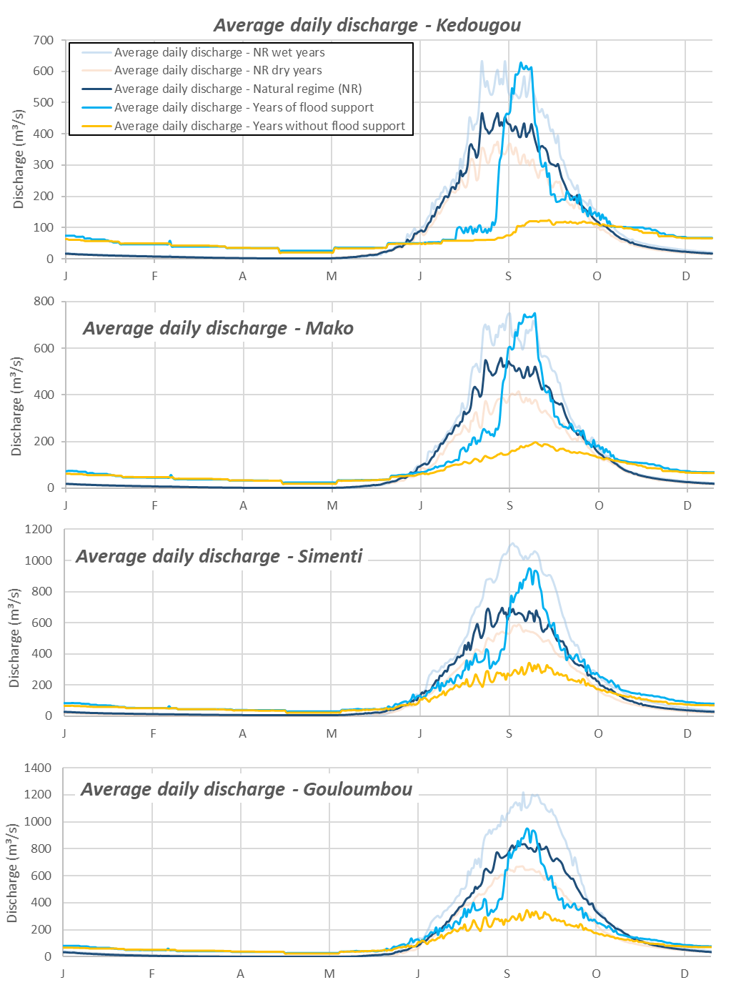
Figure 13. Comparison of the average daily flows under a natural regime and a regulated regime according to the environmental flow operating criteria at the Kédougou, Mako, Simenti, and Gouloumbou stations, respectively.

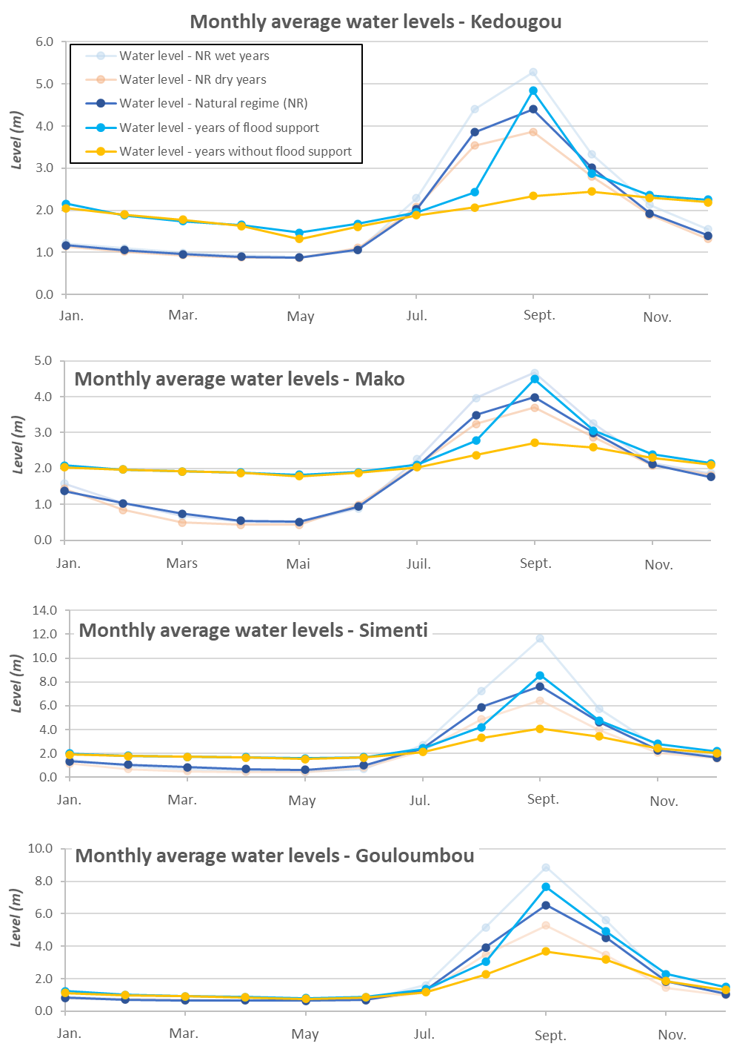
Figure 14. Comparison of the average monthly levels under a natural regime and a regulated regime according to the environmental flow operating criteria at the Kédougou, Mako, Simenti, and Gouloumbou stations, respectively.

5.2 Flood peaks and backswamp flooding
Annual statistics summarizing the impact of the environmental flow scenario during the high-water period are presented in this section by comparing them to the flood dynamics of the Gambia River under a natural regime. The annual details of flood amplitude, threshold overages, and river-backswamp connection times are presented in Appendix 7.
Table 9. Impacts of the water management environmental flow scenario on flood peaks and backswamp filling
Statistics | Natural (measured) | Natural (simulated) | Environmental flow (EF)
Maximum annual flow (1980–2019 period)
Sambangalou | 1,125.5.
Simenti | 1,991 | 1,886.7 | 1,600.2
Gouloumbou | 2,132 | 1,717.3 | 1,964.1
Maximum annual flow (average of the 1980–2019 period)
Sambangalou | 692.1 |  | 369.3
Simenti | 1,119 | 1,119 | 887.0
Gouloumbou | 1,158 | 1,156 | 1,140.5
Average flow during flood maintenance periods
Sambangalou | 470 |  | 700
Simenti | 1,138 | 871.0 | 854.4
Gouloumbou | 1,203 | 1,128 | 1,101.5
Average flow if above the backswamp flooding threshold
Simenti | 1,317 | 1,208 | 1,126.1
Gouloumbou | 1,324 | 1,267 | 1,278.2
Total years above the backswamp flooding threshold (over 39 years)
Simenti | 23 | 25 | 18
Gouloumbou | 25 | 26 | 23
Average number of days above the backswamp flooding threshold
Simenti | 17 | 9 | 8.8
Gouloumbou | 24 | 17 | 16.4
Total days above the backswamp flooding threshold (1980-2019 period)
Simenti | 500 | 209 | 154
Gouloumbou | 653 | 483 | 358
Number of years in which the volume of flooding maintenance discharge is lower than or equal to the volume of 700 m³/s of discharge released for 14 days (9,800 hm³)
Sambangalou | - | - | 10
Average volume of flooding maintenance discharge released (hm³)
Sambangalou | - | - | 738

5.3 Saltwater front displacement
Table 10 presents the impacts, on the natural saltwater front displacement in the estuary of the Gambia River, of dam water management and of the potential development of river water extraction for irrigation and other uses, as described in the proposed environmental flow scenario.
Table 10. Impacts of operating rules for compliance with the environmental flow on saltwater front displacements
 |  | Jan. | Feb. | Mar. | Apr. | May | June | July | Aug. | Sep. | Oct. | Nov. | Dec.
Environmental flow (EF) scenario | Average monthly position of the 1 gL⁻¹ saltwater front (KP) | 147 | 158 | 165 | 170 | 182 | 191 | 175 | 142 | 107 | 93 | 111 | 131
Environmental flow (EF) scenario | Recession compared to the natural position of the front (km) | -16 | -21 | -33 | -48 | -56 | -60 | -42 | 1 | 7 | 5 | -8 | -14
Environmental flow (EF) scenario | Average monthly position of the 5 gL⁻¹ saltwater front (KP) | 128 | 139 | 146 | 152 | 161 | 168 | 157 | 128 | 97 | 84 | 98 | 115
Environmental flow (EF) scenario | Recession compared to the natural position of the front (km) | -9 | -12 | -20 | -30 | -35 | -37 | -23 | 2 | 6 | 5 | -3 | -8
Environmental flow (EF) scenario | Maximum advancement (KP) of the 1 g/l saltwater front observed according to the EF | 260 |  |  | Limits of the area that experiences seasonal water salination (KP) |  |  |  |  | 93 to 191
Environmental flow (EF) scenario | Recession compared to maximum advancement under a natural regime (km) | 27 |  |  | Contraction of the area that experiences seasonal salination (km) |  |  |  |  | 62

5.4 Potential impacts on tidal range
The tidal range impacts of regulating the flow of the Gambia River according to the environmental flow criteria will be limited. This being said, the impacts will be more significant upstream of the estuary than towards the downstream portion of the river. In fact, at Kaur and Kuntaur stations, the influence of water regulation on the tidal range will be lower than natural variability. Instead, seasonal level stabilization will be observed. The impacts on tidal range observed at Bansang and Basse stations are especially observed during flood maintenance periods. Figure 15 illustrates the expected impact of regulation on the average monthly tidal range at Kaur, Kuntaur, Bansang, and Basse hydrometric stations.
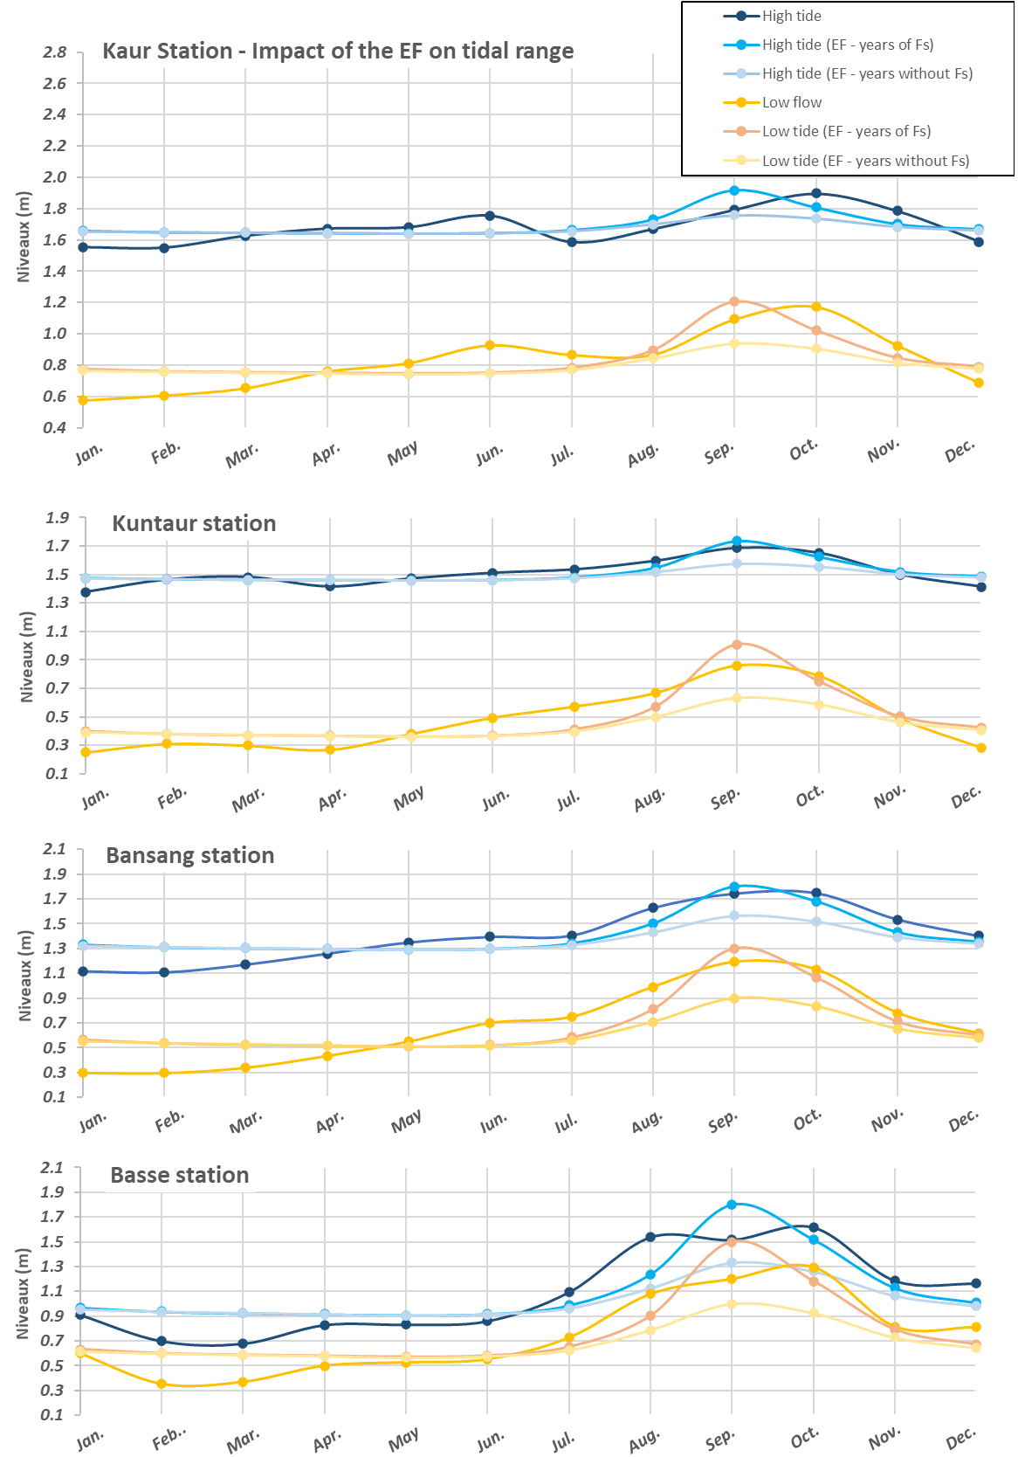
Figure 15. Impact of water regulation at the SHDP on tidal range in the estuary of the Gambia River

5.5 Output optimization
The application of environmental flow criteria requires optimization of the management of the Sambangalou dam, which should maximize power production under the constraint of compliance with all the environmental requirements laid out in this report. Compliance with socio-environmental procedures, also laid out in Chapter 4 of this report and to be added to the reservoir management plan, will result in fulfillment of all socio-environmental needs identified.
At the normal operating level (NOL = 196 m), the usable volume of the Sambangalou reservoir is 2,190 hm³, which is similar to the average annual inflow from the river to the Sambangalou site (2,523 hm³/year). Compared to the average inter-annual flow of the river (80.22 m³/s), the turbine-alternator equipment flow (200 m³/s) is very high, resulting in an equipment factor (EF) of 0.38 and a use factor (UF) of 0.34. Based on these characteristics, the Sambangalou Hydroelectric Development Project acts as a peaking power plant, the operation of which should be governed by clear and concise management rules, such as those presented in this AEFS report, to address the socio-environmental impacts.
However, given the need to apply strict management rules to limit the impacts on the various river water uses and natural dynamics, it could be difficult to combine output optimization with socio-environmental requirements, particularly during dry or low hydraulicity years. Since the AEFS allows for the incorporation of social and environmental dimensions to water management at the Sambangalou multipurpose dam, output optimization must be carried out hourly by incorporating all environmental flow rules presented in this report. Hourly simulations must also seek to better use the reservoir’s storage capacity.
To date, several output simulations have been carried out based on daily flows alone, which is perfectly appropriate for project profitability studies. However, to optimize production in a manner that accounts for socio-environmental constraints, it would have been necessary to complete energy simulations on an hourly basis by considering, within a given model, the following items:
- optimal group use taking into account the turbine hill charts, the varying pressure drops according to the drop and turbine flow (they are considered fixed in current studies) but also according to the limits of the turbine manufacturer warranties.
- an hourly energy and power demand curve; this hourly variation curve should be established according to a daily average that allows for optimal reservoir regulation, while remaining within the range of minimum and maximum flows authorized for each drop by the turbine manufacturer;
- and, as indicated above, all the environmental constraints presented in this report and can be summarized as compliance with the environmental flow rules by adopting the Adaptive Environmental Flow Strategy (AEFS). Among others, this strategy will be used to synchronize discharge released at the dam with the inflows of river tributaries in order to encourage backswamp filling, limit excessive come-and-go variations of the saltwater from, and meet riparian irrigation needs.
Bearing in mind that the environmental flow strategy is adaptive and that several measurement and monitoring instruments will be set up along the river and on its downstream tributaries, it would be risky to make projections on the value of the energy produced at this stage. It should constantly be maximized by taking advantage of the inflows of these tributaries as explained in Table 6 of Section 4.2.2. An environmental monitoring body within the OMVG is proposed in the AEFS in order to make sure that the environmental flow is properly implemented and to make sure that all needs, including energy and environment-related needs, are met.
Since implementation of the AEFS requires the consideration of tributary flows, and since these data are not available for hourly regimes, energy simulations using such a short interval represent a particularly arduous task. That is why these simulations will be used primarily to validate the use of turbine-alternator groups and to define the hourly pattern of operation.

AEFS implementation procedures
The environmental flow presented in this study, along with the related dam water management rules, will help avoid or reduce the amplitude of certain negative impacts of regulation of the water of the Gambia River. Even though feasibility of the management rules has been verified with the engineers and designers of the structure and with the OMVG, the application thereof still comes with significant technical and logistical challenges, [like] the monitoring of environmental criteria and the management rule reassessment procedures, other important components of the AEFS. This section describes the instruments and the technical and management tasks which should, according to the team of this study, be performed in order to implement the AEFS.

6.1 Technical instruments required
The AEFS was primarily drafted according to existing infrastructure in order to make implementation more realistic. This being said, certain measuring instruments, like a hydrometric station on the Koulountou and a water level recorder at the reservoir, must be set up prior to water management according to the rules of the EF. Other instruments must be closely monitored to make sure they are working properly. Table 11 describes all the instruments and the technical points to consider to implement or use them.

6.2 Tasks specific to monitoring and reassessment of the AEFS
Aside from certain technical tasks, like resuming operations at a hydrometric station on the Koulountou and setting up an automatic data transmission system, which are needed to implement the operating rules pertaining to the synchronization of flooding maintenance discharge, the most complex technical tasks are tasks connected to the environmental criteria monitoring process and the reassessment of environmental flow components. Figure 16 is a diagram of the structure of the main technical tasks to be carried out to implement the AEFS.
The technical tasks will be essential in (1) regularly applying the dam operating rules, (2) monitoring environmental criteria and the efficacy of the EF, or (3) reassessing the strategy or changing certain rules. These tasks are presented in detail in Table 12 according to the main environmental and social dynamics or issues added to the environmental flow and their application period.
It should be noted that, despite the experience of the resources in place at the OMVG or the OMVG’s partners, some tasks will require skill refreshing or shadowing phases or even outsourcing. The potential technical support needs for the performance of certain tasks are identified in the table presenting the technical tasks.

6.3 AEFS management procedures
The requirements for implementation of the AEFS, including the monitoring, control, and triennial reassessment thereof, will involve the collaboration of several stakeholders and the coordination of several technical or analytical activities, whether carried out jointly or not.
Table 13 details the management tasks required to implement the AEFS per technical component. However, at this stage of preparation of the AFES, the main stakeholders, groups, and collaborations to be set up before the Sambangalou hydroelectric dam’s operations can begin also need to be defined. Figure 17 shows the key stakeholders involved in the implementation of the AEFS. Hierarchical relationships, where they exist, were respected as much as possible, but the collaborations to be set up transcend the hierarchical relationships that may exist between some of these parties. Indeed, the

Table 11. Instruments required to implement the AEFS
Instrument set-up site | Instruments or systems to set up | Role | Further details
Synchronization (artificial flooding at the dam, synchronized with natural tributary flooding)
Water level recording station at the reservoir | • Water level recorder  • Automatic level recorder  • Real-time data transmission system | • Triggering of flooding maintenance discharge | • Should be implemented in all cases for regular SHDP operation
Hydrometric station on the Koulountou (PNNK ford) | • Water level recorder  • Automatic recorder  • Real-time and long-distance data transmission system | • Triggering of flooding maintenance discharge  • Determination of released discharge amplitude | • Difficult to access, but essential  • Instrument set-up further downstream of Koulountou impossible to consider because of the river eddy effect  • Some infrastructure is already in place, which simplifies instrument set-up at the station
Hydrometric stations on the Niokolo Koba and Diaguéri | • Automatic recorder  • Real-time data transmission system  (optional depending on the monitoring system) | • Triggering of flooding maintenance discharge  • Determination of released discharge amplitude | • Stations already in place and readings currently taken by readers on site  • Automatic monitoring could simplify data management and transmission
Level monitoring at the river and its tributaries
Hydrometric stations along the Gambia River | • Automatic recorder in Kédougou and Simenti (already set up in Gouloumbou)  • Real-time and long-distance data transmission system (optional depending on the monitoring system) | • Monitoring of compliance with EF operating rules and efficacy  • Use of data to reassess the EF | • Stations already in place and readings currently taken by readers on site  • Automatic monitoring could simplify data management and transmission
Hydrometric stations on tributaries | • Water level recorder at Diarha and Tiokoye stations (already in place on the Niokolo Koba and Diaguéri)  • Automatic recorder at all stations (optional depending on the monitoring system) | • Use of data to reassess the EF | • Stations were destroyed during renovation works on adjacent bridges  • Some infrastructure is already in makes, which will simplify instrument set-up at new stations
Level monitoring at backswamps
Monitoring station with a water level recorder at the Simenti, Faraba, and Djunda Bolon backswamps | • Water level recorders and automatic recorders already set up | • Monitoring of compliance with EF operating rules and efficacy | • Stations in good condition and automatic recorders still functional for another few years
Salinity monitoring in the estuary
Installation of a salinity probe at KP 190 | • Automatic salinity measurement probe (already in the possession of the Gambian DWR) | • Monitoring of compliance with EF operating rules and efficacy | • A probe is already set up in Kaur; an additional probe would improve data reliability
Monitoring of water needs
There are several possible ways of monitoring water needs, and they will depend on the monitoring methodologies proposed. The instrument set-up proposed for this monitoring exceeds the scope of this study and will be the responsibility of government bodies.
Monitoring of impacts in the PNNK
The potential instruments required to monitor impacts in the PNNK will be clarified, if needed, by the biodiversity study and LRP teams during their proposal of reduction or compensation measures to be implemented.

type of data reported from the field up to a specialized technical unit, for processing and analysis purposes, will involve various interim steps, ranging from field collection to data conversion for addition to the AEFS simulation models (dam operation models, SIMULGAM downstream flow model, and SALNSTAT saltwater front displacement model. The need for effective communication between all bodies in order to ensure implementation of the AEFS, according to the principles and rules mentioned in this report, implies that the usual protocol framework should be replaced with overt technical collaboration as required by the AEFS.
Despite the inactivity or near-inactivity to date of certain OMVG bodies, the Permanent Water Commission and the SOGESART in particular, the OMVG’s institutional structure, which is already well defined, can already be used to clarify the roles of bodies corresponding to certain tasks specific to the implementation, application, and coordination of technical tasks of the AEFS.
Under the hierarchical governance of the conference of the Heads of State and Government, the Council of Ministers, and the High Commissioner, the OMVG plays the central role of supervising the Energy Project and implementing the environmental and social management plan. Three potential stakeholders reporting directly to the OMVG or intervening with upper OMVG management were identified to play the key AEFS implementation roles.
1. Sambangalou Construction and Transportation Network Management Society (SOGESART, Société de Gestion des Ouvrages de Sambangalou et du Réseau de Transport): The SOGESART, whose roles were identified in the charter of the Sambangalou public works and OMVG electric power transportation network management agency, will see to the application of the operating rules drafted in this study to comply with the environmental flow. This society’s primary objective will be to manage the dam’s operations and power production. To do so, it will sign a contract with an independent professional operator to operate and manage the Sambangalou dam. It will need to make sure that the operator complies with the operating rules defined by the AEFS. To do so, the SOGESART will require data and feedback from the stakeholders on the field. The SOGESART will receive and manage such data with the help of a specialized technical unit. A detailed technical specifications document will be prepared in relation with the implementation of the AEFS. The SOGESART’s funding will come from income related to power production and transportation.
2. Permanent Water Commission; Similar to the role carried out by the Permanent Water Commission set up for the Manantali dam on the Senegal River, the Commission’s mandate will be to define the main uses of the water resource at the dam stemming from the policy-related impacts and decisions upstream and downstream of the dam. It will revise the triennial AEFS plans prepared by the specialized technical unit of the SOGESART and prepare an advisory opinion for the Council of Ministers. It will also represent a formal link for collaborations with Gambian entities.
3. Technical Unit of the AEFS (TU-AEFS): As indicated above, the AEFS implementation will require several technical tasks, pertaining to aspects such as regular dam operations, environmental criteria monitoring, and the triennial reassessment of the AEFS. The creation of a unit responsible for the technical management of the AEFS within the SOGESART should be prioritized. The AEFS’ technical tasks can be complex and, although they are likely carried out in collaboration with non-OMVG stakeholders specializing in the issues concerned, a technical unit within the SOGESART would simplify task management and the communication of information or findings and the analyses required for the Permanent Water Commission to implement the AEFS.
The main non-OMVG stakeholders identified are the Directorate of Water Resource Management and Planning (DGPRE) in Senegal, which is the key stakeholder for monitoring hydraulic conditions of the river and technical quantification of water needs required for the AEFS. In the Gambia, governmental stakeholders such as the Ministry of Fisheries and Water Resources, Ministry of Agriculture, or the Ministry of Environment, Climate Change, and Natural Resources would be involved with the TU-AEFS, via the Permanent Commission of Water and the SOGESART, in order to carry out the required AEFS monitoring or be involved in the interaction required to reassess river water uses. Finally, outside organizations like the International Union for Conservation of Nature (IUCN) and Niokolo Koba National Park (PNNK) are considered.
Table 14 summarizes the main responsibilities and collaborations required to adequately manage the AEFS. For each entity identified in Figure 17, its vision/mission, roles, and specific assignments as presented in its charter or available on its website were accounted for. The new tasks assigned to these entities as part of AEFS implementation are consequently done online for the most part with their usual roles.
OMVG entities will make the final decisions regarding the structures or stakeholders responsible for managing technical dam operation tasks according to the EF operating rules, monitoring environmental AEFS reassessment or environmental criteria. The OMVG is responsible for supervising the Energy Project and generally coordinating the implementation of the socio-environmental management plan. Some organizational strategies for the AEFS management tasks are presented here in order to propose an AEFS implementation strategy that is complete and consistent with its technical requirements.

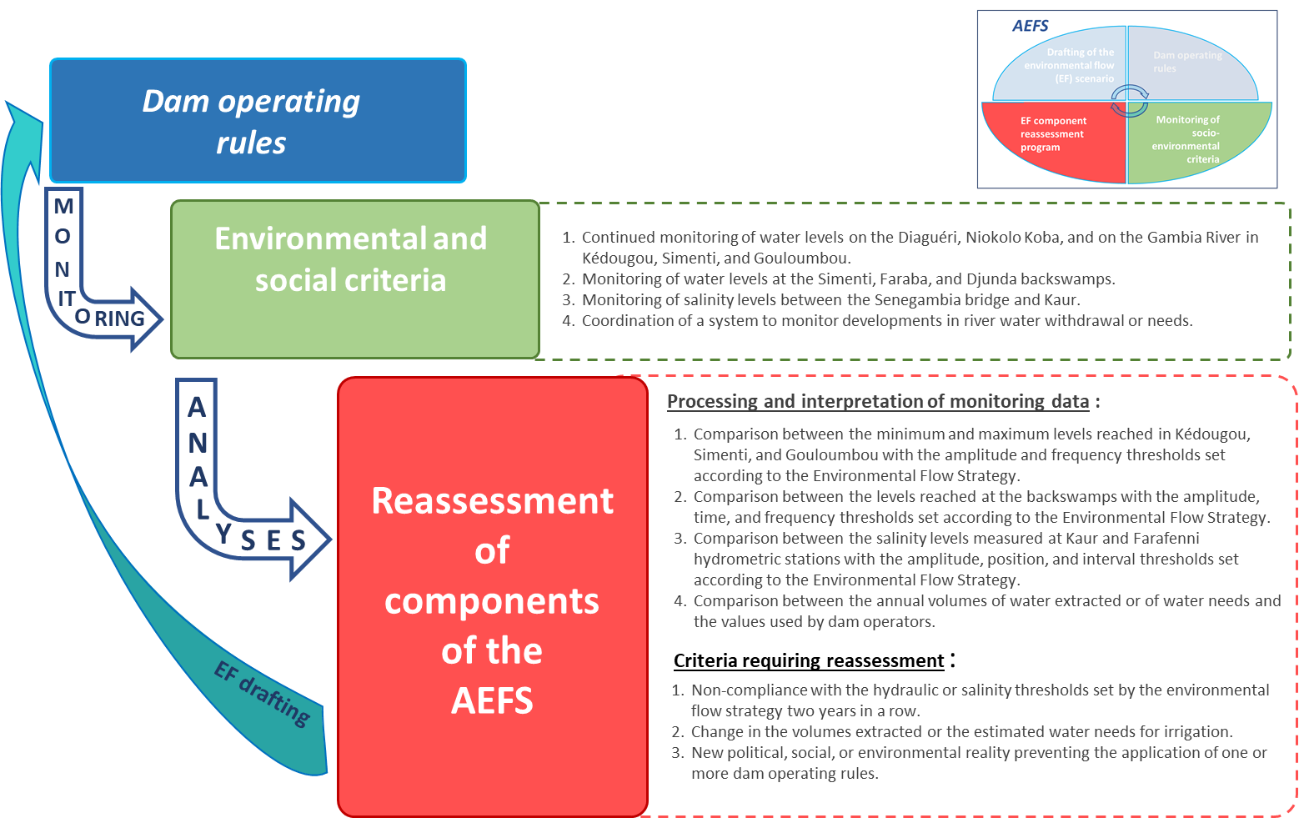
Figure 16. Technical tasks of AEFS monitoring and reassessment components

Table 12. Details of the technical tasks required to implement the AEFS
Specific technical task | Role | Effective period
Synchronization (artificial flooding at the dam synchronized with natural tributary flooding)
Instrument set-up on the Koulountou | Application of daily operating rules (synchronization) | Before implementation of the AEFS, then daily application
New gauging and georeferencing campaign for the new station compared to the existing instruments in place along the Koulountou | Application of daily operating rules (synchronization) | Before implementation of the AEFS, then daily application
Set-up of a system for rapidly transmitting data to the dam operator | Application of daily operating rules (synchronization) | Before implementation of the AEFS, then daily application
Level monitoring at the river and its tributaries
Continued station monitoring | Required to monitor compliance with EF operating rules and efficacy  Useful for reassessing the EF | Annual
Addition of new stations to the Hydraccess database |  | Annual
Set-up of a system for efficiently transmitting data to the stakeholders responsible for monitoring and reassessing the EF |  | Annual
Analysis of data regarding levels reached on the river according to the EF environmental criteria | Required for reassessing the EF | Triennial
Analysis of the EF reassessment criteria | Required for reassessing the EF | Triennial
Level monitoring at backswamps
Training on the use of the instruments set up | Required to monitor compliance with EF operating rules and efficacy | Occasional
Continued coordination of monitoring |  | Annual
Data retrieval |  | Annual
Analysis of backswamp level data according to the EF environmental criteria | Required for reassessing the EF | Triennial
Analysis of the EF reassessment criteria | Required for reassessing the EF | Triennial
Salinity monitoring in the estuary
Support for using and maintaining probes | Required to monitor compliance with EF operating rules and efficacy | Occasional
Continued coordination of monitoring |  | Annual
Data retrieval |  | Annual
Analysis of salinity data according to the EF environmental criteria | Required for reassessing the EF | Triennial
Analysis of the EF reassessment criteria | Required for reassessing the EF | Triennial
Monitoring of water needs
Monitoring of the possible changes in uses of the river water potentially affecting the reference values for the minimum water needs to be met downstream added to the EF | Application of annual operating rules | Annual
Quantitative reassessment of water needs to be met downstream | Required for reassessing the EF | Triennial
Analysis of the EF reassessment criteria | Required for reassessing the EF | Triennial
Monitoring of impacts in the PNNK
Studies of the efficacy of reduction and compensation measures | Required to monitor compliance with EF operating rules and efficacy | Triennial
Studies of the actual impacts on PNNK species |  | Triennial
Analysis of the need for EF reassessment | Required for reassessing the EF | Triennial

Environmental flow reassessment
Adaptation of structure operating rules | Required for reassessing the EF | Triennial
Use of dam operation models, SIMULGAM and SALNSTAT for redefining impacts | Required for reassessing the EF | Triennial
Conducting new studies if needed. | Required for reassessing the EF | Triennial
Training or support for using models to simulate impacts developed for the AEFS | Required for reassessing the EF | Occasional

Table 13. Details of the management tasks required to implement the AEFS
Specific coordination/management tasks | Role | Effective period
Synchronization (artificial flooding at the dam synchronized with natural tributary flooding)
Coordination of level readings with the rulers on the Diaguéri and Niokolo Koba (logistics, payment for readings) | Application of daily operating rules (synchronization) | Annual
Coordination of data transmission (training, monitoring) | Application of daily operating rules (synchronization) | Annual
Coordination of station maintenance | Application of daily operating rules (synchronization) | Triennial
Addition of new stations to the Hydraccess database | Useful for reassessing the EF | Annual
Level monitoring at the river and its tributaries
Coordination of data collection and transmission | Required to monitor compliance with EF operating rules and efficacy  Useful for reassessing the EF | Annual
Coordination of data analyses and communication of criteria assessment |  | Triennial
Level monitoring at backswamps
Coordination of data retrieval and transmission (mission, training, monitoring) | Required to monitor compliance with EF operating rules and efficacy  Useful for reassessing the EF | Annual
Coordination of station maintenance |  | Triennial
Coordination of data analyses and communication of criteria assessment |  | Triennial
Salinity monitoring in the estuary
Coordination of data retrieval and transmission (mission, training, monitoring) | Required to monitor compliance with EF operating rules and efficacy  Useful for reassessing the EF | Annual
Coordination of station maintenance |  | Triennial
Coordination of data analyses and communication of criteria assessment |  | Triennial

Monitoring of water needs
Coordination of studies required for quantifying and monitoring water needs (development of monitoring methods, mission logistics, data analysis) | Application of annual operating rules  Required for reassessing the EF | Annual
Management of data and administrative tasks with the governmental institutions concerned |  | Triennial
Coordination of data analyses, of communication of criteria assessment and reassessment needs |  | Triennial
Monitoring of impacts in the PNNK
Planning and management of studies needed to monitor impacts | Required to monitor compliance with EF operating rules and efficacy  Useful for reassessing the EF | Triennial
Coordination of data analyses, of communication of criteria assessment and reassessment needs |  | Triennial
Environmental flow reassessment
Planning and management of the environmental flow reassessment study and other studies if needed | Required for reassessing the EF | Triennial
Coordination of technical support to use simulation tools | Required for reassessing the EF | Triennial

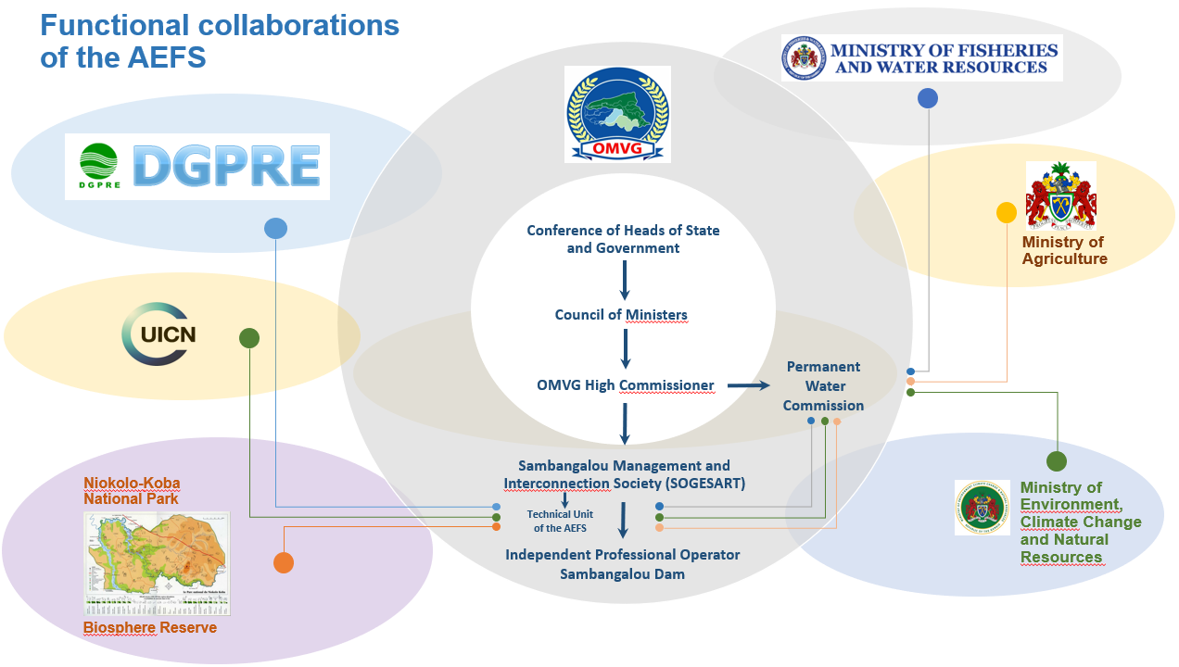
Figure 17. Key stakeholders collaborating on AEFS implementation

Table 14. AEFS management responsibilities and coordination matrix
Parties | Vision  Objective  Role | Specific AEFS-related responsibilities | Schedule  Frequency | Specific training need  (to be determined after workshops)
OMVG entities | - Applies the Agreement respecting the status of the Gambia River.  - Promotes and coordinates basin resource development studies and works.  - Fulfils its technical and financial missions assigned by Member States. | - Holds primary responsibility for AEFS implementation.  - Coordinates all related action.  - Ensures all related management. | - Continuously intervenes regarding the AEFS.
Conference of Heads of State and Government | - Supreme OMVG entity.  - Defines the organization’s cooperation and development policy.  - Makes decisions regarding the Organization’s general financial policy and all decisions regarding its jurisdiction. |  | - Meets for a regular session once a year.  - Meets for special sessions upon request of its Chairperson or a Member State.
Council of Ministers | - Creates policy for general basin construction, development of its resources, cooperation between Member States, and management of the Organization.  - Can create any body deemed necessary for the proper operation of the Organization.  - Defines river construction and resource development operations.  - Approves development programs involving one or several Member States.  - Defines the Organization’s work program and approves its budgets.  - Approves the Rules of Procedure of the High Commissioner. | - Approves the AEFS’ triennial plans prepared by the TU-AEFS and accompanied by the advisory opinion of the Permanent Water Commission. | - Meets for a regular session twice a year.  - Meets for a special session upon request of its Chairperson or a Member State.  - Intervenes regarding the AEFS’ triennial plans as needed.
High Commissioner | - Represents the Organization between sessions of the Council of Ministers.  - Represents the Organization’s implementing body.  - Reports on the implementation of its decision and any initiative it is required to make as directed by the Council of Ministers.  - Orders the Organization’s financial operations, namely regarding its budget and study and work budgets.  - Bears responsibility before the Council of Ministers for its management and the activities of the High Commissioner.  - Represents Member States in their relationships with international aid or bilateral cooperation associations with respect to the river.  - Authorized to negotiate and handle matters within the limits of the authority granted to it by the Council of Ministers.  - Collects baseline data involving the river.  - Submits study and works plans for the coordinated development and use of the river resources to the Council of Ministers.  - Reviews projects drafted by the States in view of river development. | - Sees to the proper application of the AEFS according to the triennial plan.  - Conducts the annual monitoring and triennial reassessment process for implementation of the AEFS.  - Sees to the triennial reassessment of the AEFS according to impacts and water needs.  - Sees to the reporting of data required by the TU-AEFS of the SOGESART for the seasonal/annual monitoring and triennial reassessment of the AEFS. | - Permanent body.  - Continuously intervenes regarding the AEFS.
Permanent Water Commission | - Defines principles and methods for river water distribution across States and sectors of water use: industry, agriculture, transportation.  - Issues advisory opinions to the Council of Ministers. | - Represents a formal connection for collaborations between the Gambia (see below) and the SOGESART which, through TU-AEFS, processes date received.  - Revises the AEFS’ triennial plans prepared by the TU-AEFS of SOGESART and prepares an advisory opinion for the Council of Ministers. | - Meets as needed upon request of the High Commissioner.  - Intervenes regarding the AEFS during its meetings.
Sambangalou Construction and Transportation Network Management Society (SOGESART) | - Agency responsible for completing the Energy Project.  - Sees to the operation, maintenance, and renewal of structures intended for producing and transporting electric power.  - Sees to the operation and renewal of structures intended for producing and transporting electric power (dam, plant, lines and posts, annexes, and accessories).  - Performs the missions entrusted to it in its Charter, whether alone or through any public or private legal person.  - Signs operations and management contracts with independent professional operators. | - Hosts the Technical Unit of the AEFS (TU-AEFS).  - Sees to compliance with dam water management rules in perfect conformity with the triennial management plan.  - Makes sure that the Independent Professional Operator for the Sambangalou dam strictly applies the water management rules.  - Participates in the annual monitoring and triennial reassessment process for AEFS implementation.  - Must report to the OMVG on compliance with its Technical Specifications Document where its specific responsibilities, with regard to the AEFS, will be specifically defined and specified at a level allowing the articulation of the functions of the TU-AEFS with the Gambian and Senegalese external stakeholders. | - Permanent body.  - Ongoing AEFS stakeholder.
Technical Unit of the AEFS (TU-AEFS) | - Technical unit for the implementation, monitoring, and triennial reassessment of the AEFS, within the SOGESART. | - Coordinates the annual monitoring and triennial reassessment process for AEFS implementation.  - Prepares the triennial AEFS implementation plans for the Permanent Water Commission  - Processes and analyses data regarding compliance with dam management rules.  - Operates the operation, flow, and salinity models regarding the river.  - Coordinates the reporting of data regarding the use of operation, flow, and salinity models.  - Processes and analyses all data for triennial AEFS reassessment. | - Permanent body  - Main technical stakeholder of the implementation, monitoring, and triennial reassessment of the AEFS.
Independent Professional Operator for the Sambangalou dam | - Under an operations and management contract with the SOGESART, sees to the operation of the Sambangalou Hydroelectric Development Project. | - Strictly applies the dam water management rules in perfect conformity with the triennial management plan of the AEFS.  - Participates in the annual monitoring and triennial reassessment process for AEFS implementation. | - Permanent body.  - Continuously intervenes regarding the AEFS.
Required coordinations
Senegal
Directorate of Water Resource Management and Planning (DGPRE) | - Conducts general studies regarding water resources, inventory, assessment, planning, and management of water resources.  - Develops and leads the blueprint and management plan for water resources.  - Implements and manages the measurement and observation networks on the various aquifers and rivers.  - Provides Department structures and other users with the databases and information required to mobilize and manage water resources.  - Sees to the promotion of integrated water resource management.  - Studies requests for authorization of construction and use of water intake and rejection structures.  - Sees to the planning of water needs for all uses and the mobilization thereof in connection with the departments of the ministries concerned.  - Forms the administrative office of the Technical Water Committee  - Prepares the meetings of the High Water Council and monitors the implementation of decisions.  - Sees to the monitoring of the implementation of legislative and regulatory texts, namely the provisions of the Water Code regarding water policy.  - Identifies new regulatory fields and proposes regular updates to legislative and regulatory texts.  - Controls the implementation of sector and pricing policy defined by the State with respect to hydraulics.  - On behalf of the Ministry, sees to the technical oversight of the Lakes and Rivers Bureau (OLAC, Office des Lacs et Cours d’eau), namely the monitoring and assessment of performance contracts.  - Monitors issues respecting international organizations falling under its areas of expertise. | - Participates in the annual monitoring and triennial reassessment process for AEFS implementation.  - Sees to the reporting of data from hydrometric stations required for the implementation, monitoring, and reassessment of the AEFS to the TU-AEFS.  - Sees to the operation and maintenance of hydrometric stations required for the AEFS.  - Sees to the reporting of the information required to seasonally/annually define water needs, particularly for irrigation, to the TU-AEFS. | - Permanent body.  - AEFS stakeholder on a periodic but frequent basis.
Niokolo-Koba National Park (PNNK) | - Manages the PNNK and conserves its plants and wildlife through its technical, legal, and material means.  - Preserves the regional, esthetic, tourism-related, and scientific ecological functions of the PNNK.  - Maintains the genetic heritage of plants and wildlife through ongoing standard conservation efforts.  - Reclaim affected areas of the PNNK by partially reconstituting biological diversity in places where it has worsened or disappeared.  - Regenerates and manages the game supply around the PNNK at an economically advantageous level, in order to respect the flow of local production systems and to correct destructive abuses thereof.  - Supervises all activity on its territory and intervenes to halt illegal activity or to end abuses.  - Monitors the PNNK through a paid body with equipment provided (radios, small trucks, weaponry, etc.).  - Maintains service roads to permanent stations.  - Maintains the fords required on the Gambia River for the migration and travel of certain animal species.  - Sees to signage at the Park boundaries.  - Finds funding to ensure the correct operation of biological research stations on its territory.  - Sets up areas to closely monitor rare and threatened species.  - Maintains public access to the PNNK and operates and maintains camps.  - Coordinates the activity of a PNNK Guide team and trains new members. | - Participates in the annual monitoring and triennial reassessment process for AEFS implementation.  - Reports data from hydrometric stations in PNNK territory, data required to implement, monitor, and reassess the AEFS, namely with respect to backswamp filling, to the TU-AEFS.  - Reports the information required to seasonally/annually defined water needs, particularly for backswamp filling, to the TU-AEFS.  - Maintains the fords required on the Gambia River for the migration and travel of certain animal species in the low-water period.  - Notifies the TU-AEFS of any unforeseen impact related to the new river regime following the construction of the Sambangalou dam. | - Permanent body.  - Periodic AEFS stakeholder.
The Gambia
Ministry of Environment, Climate Change and Natural Resources | - Is the leading institution with respect to environmental protection, adaptation to climate change and management/preservation of natural resources in the Gambia.  - Sees to the sustainable and coordinated management of the environment and natural resources in the Gambia for the benefit of all citizens.  - Makes sure that the environment and the natural resources in the Gambia are managed and conserved sustainably for the benefit of all (including future generations).  - Sees to increase the resilience of the Gambia to climate change.  - Works with other stakeholders to enable them to significantly contribute to global national efforts to protect and manage the country’s environment and natural resources.  - Is responsible for supervising and coordinating the development and implementation of policy and programs pertaining to the environment, climate change, and the management of natural resources in the Gambia.  - Promotes the well-being of Gambians thanks to integrated and socially responsible environmental management.  - Reinforces the factual management of natural resources and ecosystems.  - Confronts the causes of biodiversity losses with the establishment and reinforcement of a national protected area system (forests, wildlife reserves, marine parks, well capture areas).  - Reinforces institutional leadership capability in the strategic control of policy and program implementation.  - Reinforces the institutional coordination and environmental management framework at the local and national levels.  - Reinforces stakeholder participation in the management of natural resources by encouraging public-private partnerships.  - Mobilizes sufficient financial resources to implement the strategic plan.  - Implements programs and activities in partnership with other governmental ministries, departments, and agencies (MDAs) and with civic society, the private sector, and international development partners. | - Participates in the annual monitoring and triennial reassessment process for AEFS implementation.  - Notifies the TU-AEFS of any unanticipated impact on backswamp filling and the river’s saltwater fronts related to the new river regime following the construction of the Sambangalou dam. | - Permanent body.  - Periodic AEFS stakeholder.
Ministry of Fisheries and Water Resources | - Maintains the vision of sustainable development in the fishing, climate, and water sectors, the resulting economic benefits, and the well-being of its stakeholders.  - Drafts policy frameworks that recognize that responsible resource management is key to sustainable development, both now and in the future.  - Manages, develops, conserves, and protects the country’s fishing and water resources and provides for the guaranteed and sustainable use of such resources for domestic, commercial, agricultural, and other purposes in order to sustain current and future quality of life and meet the economic development needs of current and future generations of Gambian citizens.  - Provides accurate weather and climate data and information in due time to protect the population and promote food security.  - Regulates and manages, through its Department of Water Resources (DWR), the sustainable management of water resources and coordinates related policy.  - Operates a sustainable water resource, time, and climate management system.  - Sees to the implementation of a manageable and inclusive water resource framework based on IWRM principles.  - Involves people and centers them in the process, consults all stakeholders to reach the policy’s objects, and establishes a consensus.  - Defines the administrative structures required and defines the procedures required to implement IWRM.  - Establishes a solid technical rationale for the management of water resources, supported by verifiable information and solid and quantifiable hydrometeorological and hydrogeological data.  - Recommends a set of IWRM instruments to assess and quantify the yield available at the hydrographic basin (surface and sub-surface) for a variety of climate scenarios.  - Requires transparency and responsibility from the people responsible for preserving the country’s water resources.  - Is responsible, through its Department of Fisheries, for the management, development, and conservation of fishing resources.  - Among others, sees to the conservation and assessment of the supply of fish, collects statistics on fishing and aquaculture, periodically prepares and reviews fishery management and development plans in accordance with the Law, issues, suspends, and revokes permits or other authorizations for fishing or any other activity for which permits or authorizations are required by Law, monitors, controls, and oversees fishing operations. | - Participates in the annual monitoring and triennial reassessment process for AEFS implementation.  - Reports data from Gambian hydrometric river stations, data required to implement, monitor, and reassess the AEFS, namely with respect to backswamp filling and the seasonal position of saltwater fronts, to the TU-AEFS.  - Notifies the TU-AEFS of any unforeseen impact related to the new river regime following the construction of the Sambangalou dam on backswamp filling and the river’s saltwater fronts.  - Notifies the TU-AEFS on any possible impact observed on fishing resources, the cause of which could be related to the new river regime following the construction of the Sambangalou dam. | - Permanent body.  - AEFS stakeholder on a periodic but frequent basis.
Ministry of Agriculture | - Upholds a vision of reducing poverty and improving food security, income, and nutrition thanks to optimal use of resources in the sector compatible with preserving the integrity of the environment.  - Achieves a higher level of production of productivity of basic products through the rehabilitation, intensification, and expansion of sustainable production systems and processes.  - Emphasizes crop development, especially horticulture (olive crops, pomology, and floriculture), upland and deep-water rice crops, fishing, forestry, and animal production, whose import replacement potential must be maximized and promoted to grow the crops’ export markets.  - Guides the growth of cereal production, particularly secondary cereals cultivated intensively for the domestic market, which includes intensive animal production.  - Stimulates agricultural development by synergizing plant and animal production systems on a greater and broader scale.  - Sees to the sustainable development of water resources thanks to investments to explore the potential of renewal energies and technologies for irrigation and drainage.  - Improves the degree of expansion and development of the sub-sector of the food industry.  - Must see to broader and more effective participation and representation of farmers/operators, particularly women and youth, as part of a more modern, commercial, and agro-industrial production.  - Coordinates development efforts between the agricultural sector and other sectors of the economy.  - Reinforces the economic and structural integration of the agricultural sector with other sectors of the economy, particularly the manufacturing industry, tourism, and the hotel industry. | - Participates in the annual monitoring and triennial reassessment process for AEFS implementation.  - Reports the information required to seasonally/annually define water needs for irrigation to the TU-AEFS. | - Permanent body.  - Periodic/seasonal AEFS stakeholder.
International
International Union for Conservation of Nature | - Upholds a vision of an equitable world that understands and preserves the value of nature.  - Influences, encourages, and helps companies preserve the integrity and diversity of nature.  - Makes sure that natural resources are used equitably and sustainably.  - Aims to transform how businesses value, manage, and invest in nature, while promoting the possibilities and benefits of a sustainable approach.  - Takes part in multilateral processes and international forms on the environment by providing policy-related and technical advice to the main stakeholders and by combining its broad field experience and scientific expertise.  - Efficiently handles and incorporates key social problems into its conservation programs.  - Values nature and the capacity of healthy ecosystems to protect people, improve infrastructure, and see to the richness and stability of biodiversity in the future.  - Fights to save species, for humans and nature, as part of its World Species Program, with its partners and the IUCN Species Survival Commission. | - Participates in the annual monitoring and triennial reassessment process for AEFS implementation.  - Notifies the TU-AEFS of any unexpected impact of which it should have been notified on natural environments of the Gambie River and the biological diversity thereof related to the new river regime following the construction of the Sambangalou dam. | - Permanent body.  - Periodic AEFS stakeholder.

Estimated investments required to implement the AEFS
This section presents an estimate of the investments required to implement the AEFS according to the instruments and technical and management tasks presented in the previous sections. Investments are described based on one-time, annual, or triennial costs. Also note that management costs are not estimated because they depend on internal OMVG decisions and exceed the scope of this study. However, an estimate of (daily) management efforts has been drawn up in order to guide the policy decisions to be taken based on this report. External technical support costs for AEFS reassessment are estimated according to ongoing support for all reassessment periods; higher costs for the organization of permanent resource training at the OMVG might also be considered. Table 16 lists the estimated investments. Note that these investment costs exclude the training costs required to prepare all resource-persons for their new responsibilities in the implementation of the AEFS. These costs vary according to the training and skills of the resources considered at baseline.
Table 15. Estimated costs for implementation of the AEFS
Main category | Description of costs | Instruments (CFAF) | Effort (days) | Total cost (CFAF)
One-time costs prior to start-up of the SHDP
Synchronization | Technical instrument set-up (Reservoir, Koulountou)
Synchronization | • Water level recorders (Koulountou) | 200,500.00 | - | 200,500.00
Synchronization | • Automatic level recorders (3, essential only on the Koulountou, readers can take measurements at the other 2 stations) | 12,030,000.00 | - | 12,030,000.00
Synchronization | • Real-time data transmission system (3) | 6,015,000.00 | - | 6,015,000.00
Synchronization | • Probe and water level recorder installation (3) | - | 5 | 6,015,000.00
Synchronization | Update to the Koulountou station
Synchronization | • Gauging campaign | - | 10 | 4,010,000.00
Synchronization | • Ruler and level recorder georeferencing | - | 1 | 1,203,000.00
Monitoring of the hydraulic conditions of the river and tributaries (non-essential for the AEFS) | Technical instruments
 | • Automatic recorders in Kédougou, Mako, Simenti, and on the main tributaries (2) | 20,050,000.00 | - | 20,050,000.00
 | • Installation | - | 10 | 8,020,000.00
 | Update to the Diarha and Tiokoye stations
 | • Gauging campaign | - | 10 | 4,010,000.00
 | • Equipment georeferencing | - | 2 | 1,203,000.00
Salinity monitoring in the estuary | Technical instruments
Salinity monitoring in the estuary | • Automatic salinity measurement probe (already in the possession of the Gambian DWR) | 2,005,000.00 | - | 2,005,000.00
Salinity monitoring in the estuary | • Installation | 2,005,000.00 |  | 2,807,000.00
Monitoring of impacts in the PNNK | • Implementation of impact reduction or compensation measures | - | - | -
Total estimated one-time investments |  | 42,305,500.00 | 38 | 67,568,500.00
Annual operating and monitoring costs
Synchronization | • Reading and transmitting data (September) | - | 30 | 1,203,000.00
Synchronization | • Coordination of measures and addition of data to the Hydraccess database | - | 2 | Internal Management
Level monitoring at the river and its tributaries | • Data monitoring and retrieval mission | - | 2 | 1,604,000.00
Level monitoring at the river and its tributaries | • Coordination of monitoring | - | 1 | Internal Management
Level monitoring at backswamps | • Coordination of monitoring | - | 2 | Internal Management
Salinity monitoring in the estuary | • Data monitoring and retrieval mission | - | 2 | 802,000.00
Salinity monitoring in the estuary | • Coordination of monitoring | - | 1 | Internal Management
Monitoring of water needs | • Technical tasks to monitor needs and significant changes in uses | Methodology to be determined
Total estimated annual costs |  | 0 | 40 | 3,609,000.00
Triennial AEFS reassessment costs
Level monitoring at the river and its tributaries | • Data analysis according to the EF reassessment criteria | - | 2 | 2,005,000.00
Level monitoring at the river and its tributaries | • Recurring equipment maintenance | 401,000.00 | 1 | 401,000.00
Level monitoring at the river and its tributaries | • Coordination of analyses | - | 1 | Internal Management
Level monitoring at backswamps | • Data monitoring and retrieval mission | - | 2 | 2,005,000.00
Level monitoring at backswamps | • Recurring equipment maintenance | 401,000.00 | 1 | 401,000.00
Level monitoring at backswamps | • Data analysis according to the EF reassessment criteria | - | 1 | 2,005,000.00
Level monitoring at backswamps | • Coordination of analyses | - | 1 | Internal Management
Salinity monitoring in the estuary | • Data analysis according to the EF reassessment criteria | - | 2 | 2,005,000.00
Salinity monitoring in the estuary | • Recurring equipment maintenance | 401,000.00 | 1 | 401,000.00
Salinity monitoring in the estuary | • Coordination of analyses | - | 1 | Internal Management
Monitoring of water needs | • Detailed analysis to quantify needs and according to use changes | - | 20 | 8,020,000.00
Monitoring of water needs | • Data analysis according to the estimates using in the EF | - | 2 | 2,005,000.00
Monitoring of water needs | • Coordination of Studies | - | 5 | Internal Management
Monitoring of impacts in the PNNK | • Mission to monitor the efficacy of the measures implemented | * To be determined by the biodiversity study
Monitoring of impacts in the PNNK | • Infrastructure maintenance or other measures implemented
Monitoring of impacts in the PNNK | • Coordination of Studies | - | 5 | Internal Management
Environmental flow reassessment | • Technical studies for EF changes | - | 20 | 8,020,000.00
Environmental flow reassessment | • Technical support | - | 10 | 6,015,000.00
Environmental flow reassessment | • Coordination of Studies | - | 10 | Internal Management
Total estimated triennial costs |  | 1,203,000.00 | 85 | 33,283,000.00

Findings

8.1 Key components of the environmental flow
- Backswamps - Issues related to flood backswamps located on the shores of the Gambia River between Simenti and Bansang were identified using studies previously conducted by AECOM and the preliminary recommendations of the environmental and social studies. The management criteria drafted to ensure backswamp filling in line with natural dynamics are based on the synchronization of flooding maintenance discharge with:
  - water contributions to the reservoir
  - the water flows or levels observed on the Koulountou, Diaguéri, and Niokolo Koba.
Only synchronization allows for filling at a frequency and with a river-backswamp connection time similar to those observed under a natural regime. These criteria are also drafted from a perspective of relatively straightforward implementation, thanks to clear water management instructions to be added to the future structure operating manual.
- Irrigation - The regulated flow of the Gambia River will offer investment opportunities for the irrigated agriculture sector, both in terms of more consistent freshwater inflows and of relative stabilization of the river levels and of less significant flooding of the land during the high-water period. Its possible advantages depend, however on a guarantee for downstream producers of a river flow able to cover their seasonal water needs. This guarantee is especially important for the riparian irrigated agriculture sector, as the survival of irrigated crops depends on it, and, consequently, so does the profitability irrigation investments.
- Low-water period - Socio-environmental issues during the low-water period are especially related to the rise in water levels upstream of Gouloumbou and to the significant downstream recession of the maximum intrusion of saltwater in the river. Based on the findings of all of AECOM’s studies, the environmental strategy proposed is designed to limit the amplitude of these impacts. However, this strategy cannot be considered without the implementation of compensation measures to be proposed by RAP/LRP and Biodiversity studies.
- Output optimization - The application of environmental flow criteria requires optimization of the management of the Sambangalou dam, which must maximize power production under the constraint of compliance with all the environmental requirements laid out in this report. Such optimization should account for:
  - optimal use by groups, taking into account turbine hill charts, pressure drops, and the limits of turbine manufacturer warranties;
  - the hourly energy and power demand curve;
  - the environmental constraints related to the rules of the environmental flow and Adaptive Environmental Flow Strategy (AEFS);
  - SAMVA’s discarding of hydrological series reconstructed by linear interpolation which tends, in the high-water period, to slightly underestimate potential output.

8.2 Implementation challenges
- The AEFS’ end goal is to see to the implementation of an environmental flow that limits the social and environmental impacts of the construction and operation of the Sambangalou dam. Based on the amplitude, period, and recurrence requirements of this environmental flow, dam operating rules were defined. Although some of these rules can be easily applied by the future dam operator, others will require the transmission of data to the entities involved in implementation so that they may take the appropriate action. Of the information or data required to apply certain rules, the following should be provided:
  - Real-time transmission in September of the water levels observed on the Koulountou, Diaguéri, and Niokolo Koba.
  - Meanwhile, the values of water needs to be met by discharge released downstream (turbine flow or evacuated by the sluices) will need to be reassessed every three years and amended in the structure operating manual.
  - Management rules that allow for daily turbine optimization, which better meets peak power demands, remain to be determined. However, it should be noted that these rules may change over time as a result of variations in power demand.
- Estimating the water needs downstream of the dam, which are used to adjust the structure management rules, both seasonally and over the years, represents a sizeable challenge. Naturally, a rough estimate was done for this study, but it relies solely on the interpretation of future irrigation developments and the related water needs. The institutions responsible for coordinating uses of the river water will therefore need to set up a system to quantify and monitor irrigation water needs along the Gambia River. From an optimistic point of view and a perspective of hydroelectric output optimization, the development and growth of irrigated agriculture, accompanied by a better capacity to estimate increasing water needs, will allow for more flexible dam water management and potentially for a review of the management rules.
- Aside from the application of dam water management rules associated with the environmental flow, the AEFS also puts forth monitoring procedures used to validate the implementation and efficacy of the management rules. It also defines the periodic reassessment phases of this environmental flow strategy. To do so, these monitoring and reassessment activities will require the collection of lots of field data, and, although the monitoring of certain required data is already carried out by certain stakeholders from the government or elsewhere, the monitoring of other data should be adjusted to the needs of the AEFS or implemented if it does not exist. The main issue related to the implementation of monitoring activities concerns the coordination and collaboration of the various stakeholders, along with the management and analysis of the compiled data required for the reassessment of the AEFS. To simplify implementation, this study recommends the creation of a Technical Unit (TU-AEFS) within the SOGESART, whose main role will be to coordinate and reassess components of the AEFS. SOGESART's technical specifications document must be explicit in this regard.
- The AEFS’ triennial assessment procedures consist of meeting socio-environmental criteria in order to determine whether the environmental flow scenario needs to be corrected or redrafted. Certain aspects, such as a change in the river water uses or a new political, social, or environmental reality, may compromise the implementation of the dam operating rules. This new reality may require reassessment of the environmental flow scenario and, where applicable, amendments to its management rules. The first AEFS criterion requiring a correction to the environmental flow or the drafting of new management rules is non-compliance with the socio-environmental criteria defined therein. Since an amendment to the environmental flow strategy will also require the updating of certain management rules with reassessment of the downstream river dynamics and salinity, the models developed or updated in this study will be indispensable. Using these tools might require a training phase or occasional outside support.
- Clearly, the issues pertaining to the environmental flow of the Gambia River contain physical, biological, social, economic, and political dimensions. In this respect, usage or management decisions made upstream of the river, particularly at the Sambangalou dam, will always have consequences downstream of the river. The OMVG’s institutions or joint institutions under the governance of the Council of Ministers, such as the Permanent Water Commission (PWC), aim to ensure the coordinated management of river water uses and the resulting impacts. The issues related to coordinated management between the upstream and downstream portions of the Gambia River and between all parties involved with the reality of the river and its banks are especially important, since certain aspects of the Sambangalou dam’s operations remain to be defined by the constructors and the operator.

References
Bader, J.-C. (2003). Digital modelling to assess certain benefits and impacts of the future Sambangalou dam on the Gambia River (p. 83). IRD.

Bader, J.-C., Vauchel, P., & Lamagat, J.-P. (1998a). Study of the hydraulic diagram of the Gambia River: Chapter regarding the Sambangalou dam management scenarios (p. 48). ORSTOM.

Bader, J.-C., Vauchel, P., & Lamagat, J.-P. (1998b). Summary of the Sambangalou dam management scenarios: Calculations used for the study of the hydraulic diagram of the Gambia River (p. 14). ORSTOM.

BRLi, & Nodalis. (2015). Supplemental financial study for the Sambangalou Hydroelectric Development Project on the Gambia River (p. 93). BRL Ingéniérie and Nodalis Conseil.

Charter of the Sambangalou Public Works and OMVG Electric Power Transportation Network Management Agency, Pub. L. No. 2018‑27 (2016).

DEEC. (2010). Second national communication at the United Nations Framework Convention on Climate Change. Ministry of Environment and Nature Protection, Directorate of Environment and Classified Institutions (DEEC).

Study of flood backswamps of the Gambia River - Step 2 - Monitoring of the hydraulic operation of the backswamps Annual summary report - Year 2 (2019–2020) (EX-00474). (2020). AECOM Consultant Inc.

Lamagat, J.-P., Albergel, J., Bouchez, J.-M., & Descroix, L. (1987). Hydrological monograph of the Gambia River. 256.

Presentation brochure of the Management Unit of the OMVG Energy Project. (2019). Energy Project Management Unit / OMVG PMU

Sambangalou Hydropower Project, Senegal Environmental and Social Due Diligence Final report (phase 2) (No. 0520262). (2020). ERM.

Savenije, H. H. G. (1988). Influence of rain and evaporation on salt intrusion in estuaries. Journal of Hydrology, 114(12), 1509‑1524.

Third national communication at the United Nations Framework Convention on Climate Change. (2015). Ministry of Environment and Nature Protection, Directorate of Environment and Classified Institutions (DEEC).

Verkerk, M. P., & van Rens, C. P. M. (2005). Saline intrusion in Gambia River after dam construction (p. 66). Twente University.

VINCI. (2018). Flood hydrology study. Vinci Construction.

VINCI. (2019). Review of the hydrology of inflows and estimation of output. Vinci Construction.

VINCI. (2020a). Overflow spillway devices. Vinci Construction.

VINCI. (2020b). Estimated output during operation and filling. Vinci Construction.

Vozhehova, R. A., Lavrynenko, Y. O., Kokovikhin, S. V., Lykhovyd, P. V., Biliaieva, I. M., Drobitko, A. V.,

APPENDIX 1
Estimate of irrigation water needs

Appendix 1: Methodological process used to reassess water needs for irrigation
The recommended approach to reassess current and future water needs for irrigation relies on five major steps with the end goal of estimating as accurately as possible the monthly volumes of water required to meet the irrigation water needs of the current irrigated crops on riverside land, but also for land with short and medium-term irrigated agriculture development potential. This appendix describes the methodological process proposed to obtain these estimates.
1. Delimitation of the types of land use using satellite images
The first step of the reassessment of irrigation water needs consisted of the creation of a land use map that identifies the agricultural plots currently irrigated along with other land uses with potential for irrigation development. Note that land use mapping was initially done to meet the objectives of the biodiversity and LRP studies; however, some analyses specific to the environmental flow study related namely to unit typology, geomorphology, and the potential for use of the river water were added.
1.1 Land use mapping
Mapping the land use downstream of the dam first consisted of delimiting the flood backswamps according to Sentinel images taken during the maximum high-water period (spatial resolution of 10 x 10 m). Beforehand, a “false color infrared” combination was generated using bands 8 (near infrared), 4 (red) and 3 (green) for these images in order to increase the contrast between the wet and dry areas. As shown in the example presented in Figure 1A, flooded areas stand out by their black color or fuchsia to blueish tints, according to the water depth and plant types present. Occasionally, the digital SRTM (Shuttle Radar Topography Mission) elevation model (with 30 m pixels) was consulted to better determine the relief and confirm the backswamp boundaries (Figure 1B).
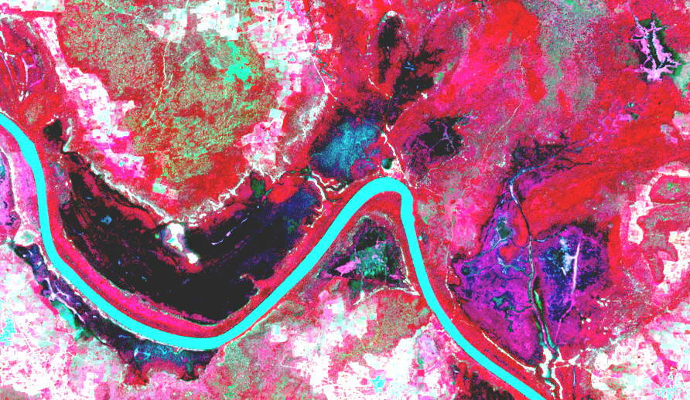
Figure 1A. Portion of a Sentinel image in which the flood backswamps are clearly visible

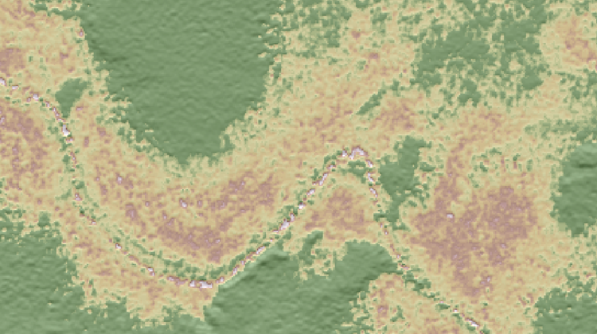
Figure 1B: Relief as observed in the digital SRTM elevation model
The land use layer was produced by manual delimitation and visual photointerpretation of spatial units directly in ArcMap, using high-resolution ESRI and Bing (via the Basemap interface) images and WorldView-2 images acquired in January 2019 and May 2020 for the upstream portion of the mangrove area.
Given the high resolution of these images (Figure 1C), interpretation was carried out at the very detailed scale of 1:3,000 to 1:5,000. First, the georeferencing was compared to the Sentinel images used to delimit the boundaries of the flooded areas. To supplement the high-resolution ESRI and WorldView-2 images, a second series of Sentinel images taken during the dry season (April 2016) were consulted to confirm the permanence of wet conditions for the sites identified as bodies of water, marshes, and wet meadows. These Sentinel images were also used to ensure the contemporary nature of the agricultural land.
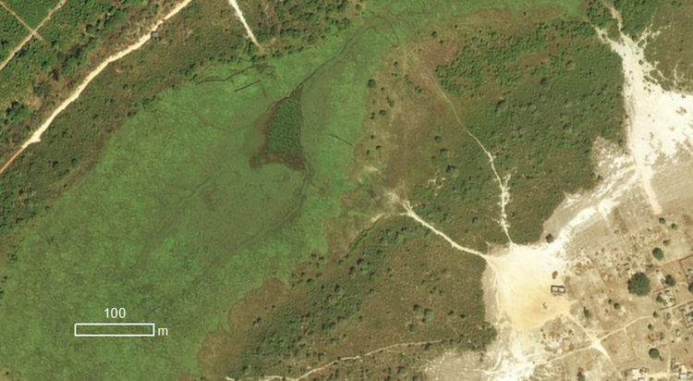
Figure 1C. Portion of a high-resolution satellite image available in ArcMap.

1.2 Typology of the land use downstream of the dam
Before delimiting and identifying the land use categories, a reference typology was drafted using the Yangambi classification, to which were added types that are more specific to the conditions observed on the field and to the issue covered by the project. Approximately thirty main categories were mapped within the reservoir area, as presented in Table 1A below. Variants are added to this list according to the frequency of periodic flooding, the size of human settlements, and the substrate of riverbeds
Table 1A. Description of the land use categories in the reservoir area
Name | Description | Image
Agricultural land | This category includes land cultivated arbitrarily or intensively, as well as recent fallow land. In general, subsistence crops aim to produce cassava, corn, rice, cereal grasses, or pulses. The north-west segment of the interconnection crosses the Senegal groundnut basin. | 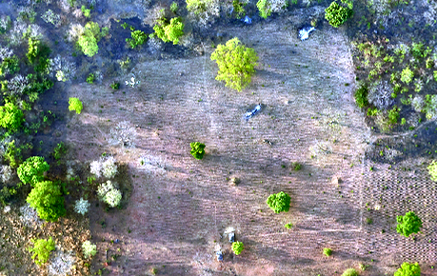
Flood recession agricultural land | This category includes land cultivated in the floodable plain of rivers. | 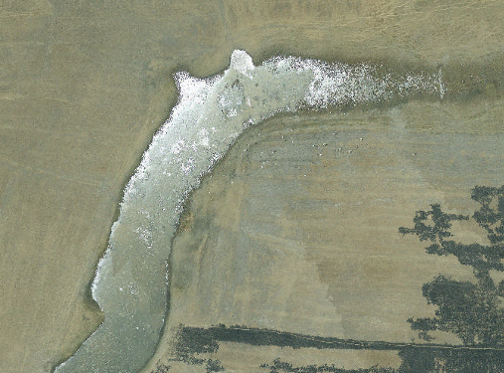
Market crops | Area of vegetable production in small sections. | 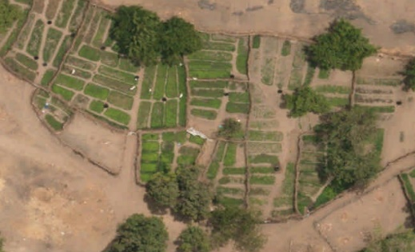
Irrigation scheme | Space composed of various cultivated sections, usually, for rice production and supplied with water through a channel system | 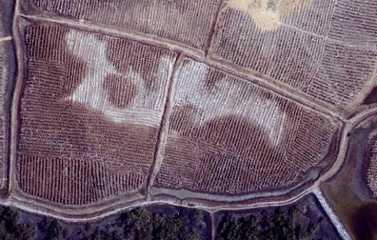
Fallow land | Formerly cultivated land in which grasses and shrubs have predominantly reclaimed the land. | 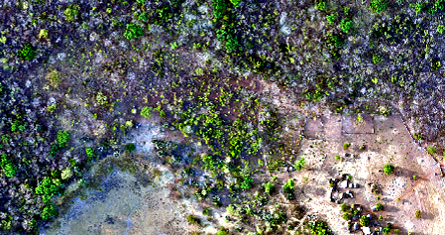
Grassland | This stratum is made up almost exclusively of a grassy floor. A few shrubs are sometimes observed, but their presence remains highly sporadic. Grasslands commonly border iron-rich duricrust areas. | 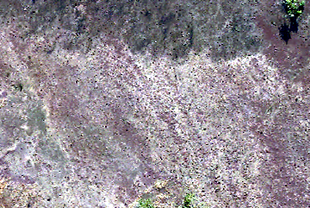
Shrub savanna | Shrub savanna is a formation made up of a more or less dense grassy floor across which are scattered shrubs with trunks that are often twisted. Shrub cover is greater than 15%, while the tree stratum is absent or extremely sparse. | 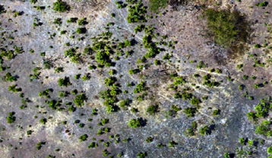
Tree savanna | Tree savanna is made up of trees and shrubs scattered across the grassy floor. Shrub cover is greater than 15%, while tree cover covers approximately 15% of the land. | 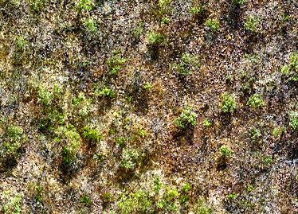
Wooded savanna | Wooded savanna is made up of trees and shrubs forming a clear cover that lets through a lot of light. Shrub cover is usually greater than 40%, while tree cover varies between 15 and 40%. | 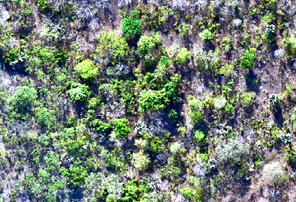
Palm grove | Group of palm trees (probably fan palms), typically located near anthropized or formerly anthropized sites. Density varies significantly, ranging from sparse to dense categories. | 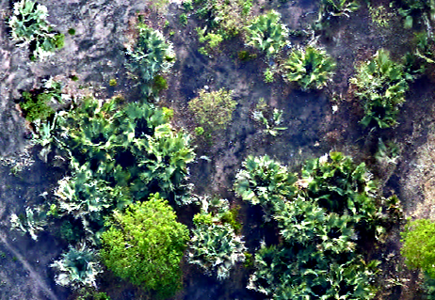
Wet meadow | The plant stratum is made up of grasses on soils that are more or less permanently waterlogged. As such, this type of plant colonizes wet depressions and experiences long-lasting seasonal flooding periods. | 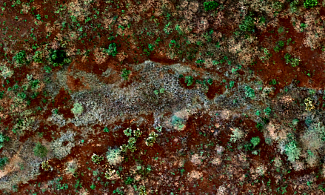
Grassy saline semi-desert (halophyte marsh) | Low grassy plants, composed of halophytes (Sesuvium portulacastrum, Paspalum vaginatum, Scirpus maritimus, Philoxerus vermicularis, Eleocharis mutata, etc.) and located in the river-marine plain that is periodically flooded by the tides. | 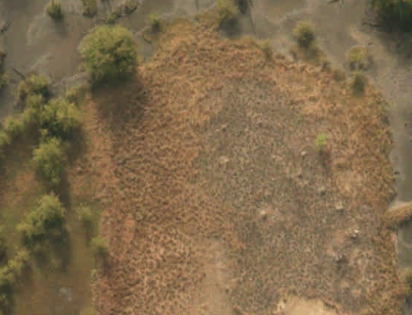
Bare saline semi-desert | Area of bare, hypersaline soil periodically flooded by the tides. | 
Open woodland | Population made up of relatively tightly knit trees, the tops of which are more or less connected and cover over 50% of the land. The population includes several semi-deciduous to deciduous forest species. The entire cover lets through a lot of light, to the point that grasses are mild in abundance and may be mixed in with other suffrutescent or grassy plants. The tree structure gives a clear impression of a forest, while the wooded savanna consists of a highly irregular mix of trees and especially shrubs. | 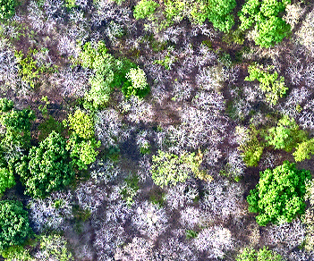
Wet forest | Population made up of relatively tightly knit trees, the tops of which are more or less connected and cover over 50% of the land. The population includes few semi-deciduous to deciduous forest species. The entire cover lets through a lot of light, to the point that grasses are mild in abundance and may be mixed in with other suffrutescent or grassy plants. | 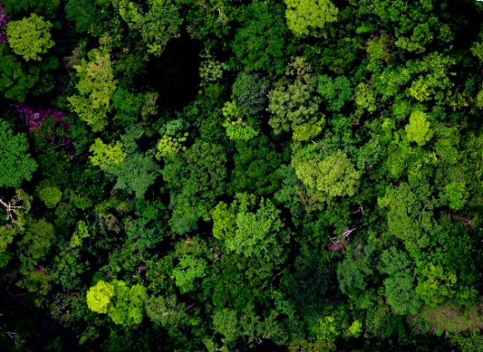
Riparian forest (or gallery forest) | Riparian forests or “gallery forests” are also dense forest formations at the heart of tree savanna. They border the banks of the headwaters of rivers and streams. | 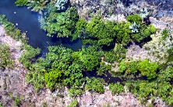
Rhizophora mangrove | Forest population made up of mangroves, Rhizophora racemosa and R. mangle, located on the shores of the Gambia River and bolongs, in the area immediately affected by the tides. | 
Avicennia mangrove | Mangrove made up of Avicennia nitida and, sometimes, Laguncularia racemosa, in the high-tide flooded area, between the covered area of Rhizophora spp. and the saline semi-deserts. | 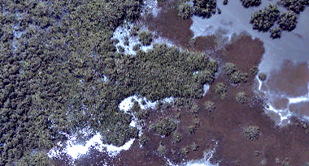
Cashew crop | Cashew cash crop | 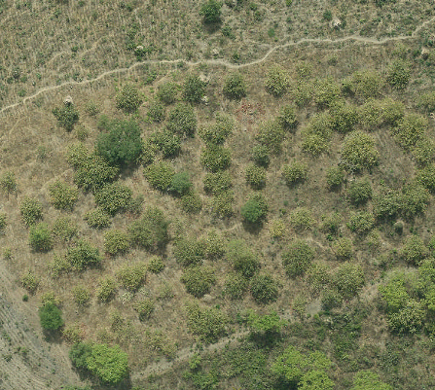
Palm crop | Palm cash crop | 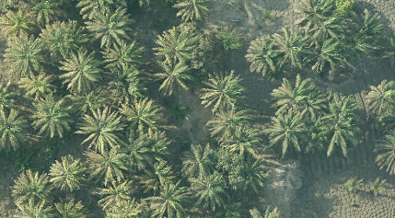
Fruit plantation or cash crop | Fruit plantation or cash crop, typically close to human settlements. | 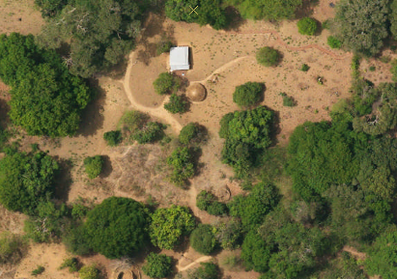
Escarpment | Rocky cliffs of varying height. | 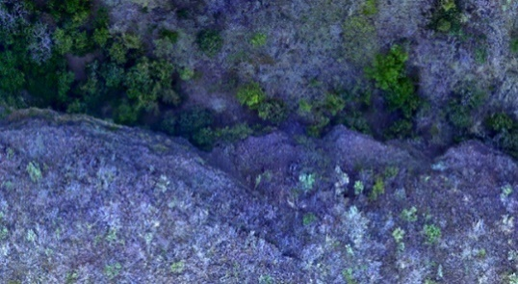
Rocky outcrop | Visible exposed part of the rocky substrate, usually near an escarpment. | 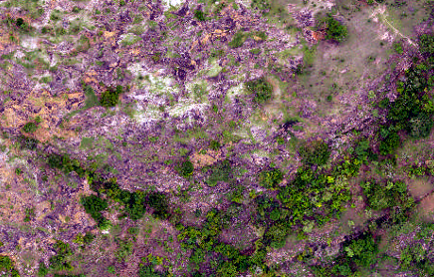
Iron-rich duricrust and bare soil | This category includes plant-free areas on an iron-rich duricrust or on degraded soil. | 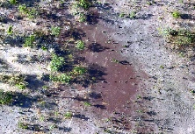
Gambia River and tributaries | Scope of the water of the Gambia River and major tributaries in the low-water period. | 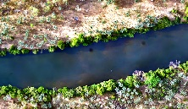
Asphalt road | Resurfaced road communication line. | 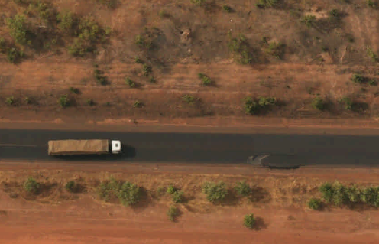
Road | Non-resurfaced road communication line. | 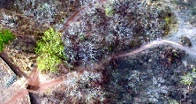
Human settlement | This category includes areas occupied by buildings, dwellings and other structures. | 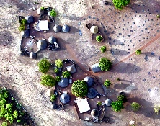

1.3 Geomorphology and landscape unit mapping
The map of geomorphological units/landscapes was largely derived from plant polygons, namely for seasonal flooding areas, undercut bank slopes, the iron-rich duricrusts, bare soil, and bodies of water. Next, the digital SRTM elevation model was analyzed to establish the boundary between the valleys and plateaus. This model was also used to map alluvial levees and meander cutoffs. These units were described and clarified according to the geological, geomorphological, and pedological data available in the literature. Figure 1D illustrates a portion of this map created for the Study.
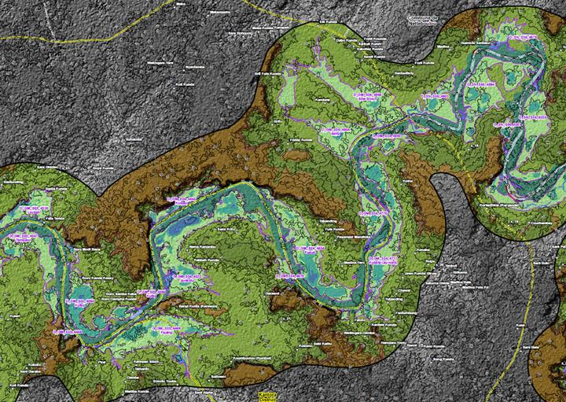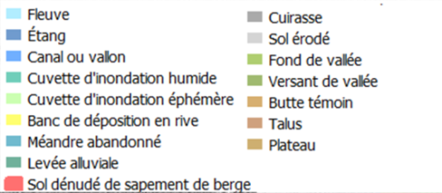
Figure 1D. Portion of the geomorphology map.

2. Classification of the land use types according to their current and future agricultural potential
Based on the general classification of land use types, units were recategorized in order to only distinguish the land use types associated with a current irrigation water need or with reasonable potential for irrigated agricultural development on the plot.
The land use types were then grouped together in order to characterize, respectively, (1) the current potential for irrigation, (2) the short-term potential for irrigation water needs taking into account the development of irrigated agriculture on plots previously used for this purpose or (3) taking into account more general, medium-term irrigation development.
Moreover, in order to refine the analysis of plots subject to irrigated agriculture development, the plots retained on the map of land use types were again categorized according to the following criteria (note that some plots were rejected for only part of the year according to the average position of the 1 g/l saltwater front in the off-season or rainy season);
- All plots upstream of the Sambangalou hydro power plant were automatically rejected from this analysis, since the main objective of this reassessment of irrigation water needs is to refine the environmental flow scenario according to the current and future volumes of water pumped;
- All plots located downstream of the maximum annual recession of the 1 g/l saltwater front were rejected, since pumping of the river water for irrigation cannot be considered because of its salinity;
- All plots or portions of plots overlapping with a protected natural area were rejected, since protected areas must be prioritized over agricultural development;
- All plots or portions of plots associated with steep slopes, areas of significant erosion, inliers and outliers, or high terraces were rejected because of their agricultural development potential that was too weak or too risky;
- All plots or portions of plots identified as “complex of mangroves and saline semi-deserts” and found to be Avicennia mangrove-dominant were also rejected in order to prioritize the conservation of this resource;
- All plots or portions of plots for which land use needs to be maintained, whether for use by the populations or for the ecological functions it accomplishes, were rejected;
- All plots or portions of plots located downstream of KP 200, i.e., 10 km upstream of the limit targeted by the environmental flow for the recession of the 1 g/l saltwater front during the off-season (June), were rejected for this period, because the river water cannot be harnessed for irrigation at this location. In the rainy season, plots or portions of plots located downstream of KP 100 were rejected;
- Finally, all plots or portions of plots located more than 2 km from the river were rejected because of the complexity associated with irrigation using the river water from this distance.
These restrictive criteria allow for a very conservative estimate of the area potentially subject to the development of irrigated agriculture. The plots retained were categorized once last time in order to associate a realistic type of water supply for irrigation to each plot. The potential water supply categories retained were (1) tidal or channel irrigation, (2) irrigation by river water pumping, and, finally, (3) rainfed irrigation.
The methodological process used to identify the areas well-suited to the various types of irrigation relies on the elevation differences between each pixel of a plot compared to the river. To determine these elevation differences, a model of hydrological consistency or potential drainage derived from the SRTM was used. This model aims to determine the shortest route from each SRTM pixel to a pixel associated with the river. The elevation differences between each pixel along this shortest route were calculated. This results in a matrix that presents, for each cell, the elevation difference according to the shortest route with respect to the river. This type of model, inspired by the topographical “Depth-to-Water” hydrological consistency model is much more consistent that the use of an elevation difference with respect to the Euclidean distance to the river. The SRTM resolution (30 m) makes it difficult to define a consistent hydraulic connectivity model. However, there is very good consistency between the landscape units (irrigation, floodable plains, backswamps) and the elevation categories derived from the model (see Figure 1E.) Classification of the elevation differences was then carried out and associated with potential irrigation types.
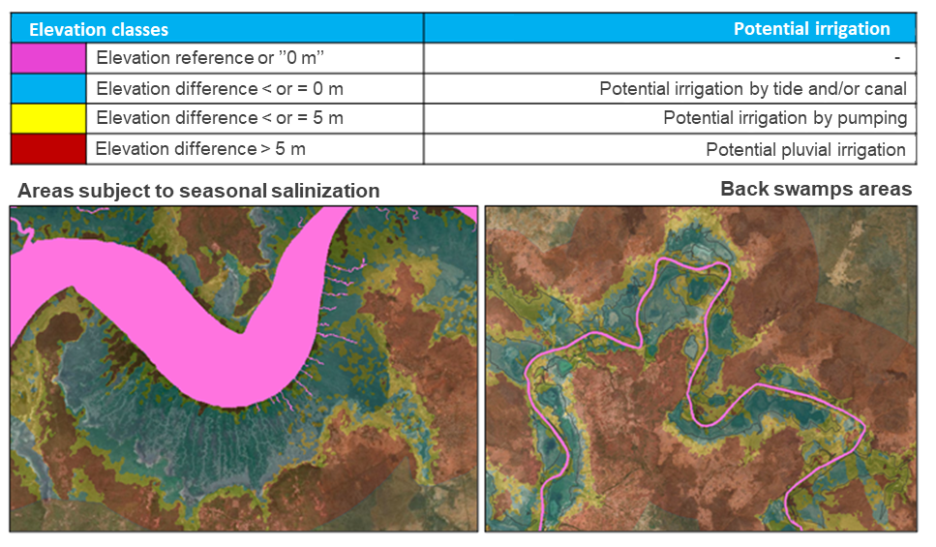
Figure 1E. Potential irrigation types associated with elevation differences derived from the Depth-to-Water model and example of application for two areas of the river.
This additional classification is used to distinguish certain plots or areas which, even if subject to irrigated agricultural development, would not be suited to the development of irrigated agriculture using the river water.
The main land use units resulting from this classification and the potentially irrigable areas, depending on the season (off-season or rainy season) and the types of irrigation considered are detailed in Table 1B. The main land use units are also grouped under the main crop areas described in Figure 16 of the report titled “Additional economic study for the Sambangalou Hydroelectric Development Project on the Gambia River” by BRLi and Nodalis (2015).
Table 1B. Details of the potentially irrigable areas according to the season and types of irrigation and main crop areas.
Potential for irrigable crops according to the environmental flow scenario
Types of land use and irrigation | Off-season (Dec.–June) - ha | Rainy season (Jul.–Nov.) - ha | Irrigation potential
1 - Tidal or channel irrigation
Areas 6–7
Existing crop | 1,521.3 | 3,269.2 | Medium term
Existing crop (currently irrigated) | 242.7 | 250.3 | Current
Fruit plantation (banana crop) | N/A | 6.4 | Current
Small vegetables | N/A | N/A | Current
Abandoned crops | 421.9 | 2,992.3 | Short term
Mangroves | 9,754.0 | 22,680.6 | Long term
Meadows | 330.7 | 330.7 | Long term
Potentially usable savanna | 480.7 | 727.9 | Long term
Potentially usable bare soil | 606.4 | 714.3 | Long term
Area 5
Existing crop | 1,103.0 | 1,313.2 | Medium term
Existing crop (currently irrigated) | 2,091.4 | 2,091.4 | Current
Fruit plantation (banana crop) | 15.7 | 16.5 | Current
Small vegetables | N/A | N/A | Current
Rapid crop potential | 385.9 | 446.3 | Short term
Mangroves | N/A | N/A | Long term
Meadows | 1,084.4 | 1,084.4 | Long term
Potentially usable savanna | 4,247.5 | 4,247.5 | Long term
Potentially usable bare soil | N/A | N/A | Long term
Area 4
Existing crop | 3,471.6 | 3,772.7 | Medium term
Existing crop (currently irrigated) | 311.9 | 311.9 | Current
Fruit plantation (banana crop) | 96.1 | 101.1 | Current
Small vegetables | 29.1 | 36.4 | Current
Rapid crop potential | 1,258.2 | 1,545.1 | Short term
Mangroves | N/A | N/A | Long term
Meadows | 4,155.1 | 4,155.1 | Long term
Potentially usable savanna | 19,720.0 | 19,720.0 | Long term
Potentially usable bare soil | 32.6 | 32.6 | Long term
Areas 2–3
Existing crop | 764.4 | 764.4 | Medium term
Existing crop (currently irrigated) | N/A | N/A | Current
Fruit plantation (banana crop) | 155.0 | 155.0 | Current
Small vegetables | N/A | N/A | Current
Rapid crop potential | 153.2 | 153.2 | Short term
Mangroves | N/A | N/A | Long term
Meadows | 788.1 | 788.1 | Long term
Potentially usable savanna | 7,228.9 | 7,228.9 | Long term
Potentially usable bare soil | 18.9 | 18.9 | Long term

Potential for irrigable crops according to the environmental flow scenario
Types of land use and irrigation | Off-season (Dec.–June) - ha |  | Rainy season (Jul.–Nov.) - ha |  | Irrigation potential
2 - Irrigation by pumping
Areas 6–7
Existing crop |  | 965.3 |  | 1,465.7 |  | Medium term
Existing crop (currently irrigated) |  | 14.0 |  | 14.0 |  | Current
Fruit plantation (banana crop) |  | 1.4 |  | 30.4 |  | Current
Small vegetables |  | N/A |  | N/A |  | Current
Rapid crop potential |  | 299.9 |  | 428.6 |  | Short term
Mangroves |  | 703.7 |  | 711.4 |  | Long term
Meadows |  | 30.1 |  | 30.1 |  | Long term
Potentially usable savanna |  | 1,783.5 |  | 2,078.9 |  | Long term
Potentially usable bare soil |  | 565.8 |  | 651.9 |  | Long term
Area 5
Existing crop |  | 1,425.0 |  | 1,425.0 |  | Medium term
Existing crop (currently irrigated) |  | 194.4 |  | 194.4 |  | Current
Fruit plantation (banana crop) |  | 7.9 |  | 7.9 |  | Current
Small vegetables |  | N/A |  | N/A |  | Current
Rapid crop potential |  | 391.9 |  | 391.9 |  | Short term
Mangroves |  | N/A |  | N/A |  | Long term
Meadows |  | 10.9 |  | 10.9 |  | Long term
Potentially usable savanna |  | 4,816.7 |  | 4,816.7 |  | Long term
Potentially usable bare soil |  | 1.2 |  | 1.2 |  | Long term
Area 4
Existing crop |  | 4,305.0 |  | 4,305.0 |  | Medium term
Existing crop (currently irrigated) |  | 21.6 |  | 21.6 |  | Current
Fruit plantation (banana crop) |  | 101.9 |  | 101.9 |  | Current
Small vegetables |  | N/A |  | N/A |  | Current
Rapid crop potential |  | 286.3 |  | 286.3 |  | Short term
Mangroves |  | N/A |  | N/A |  | Long term
Meadows |  | 64.5 |  | 64.5 |  | Long term
Potentially usable savanna |  | 8,001.2 |  | 8,001.2 |  | Long term
Potentially usable bare soil |  | 8.9 |  | 8.9 |  | Long term
Areas 2–3
Existing crop |  | 3,078.7 |  | 3,245.6 |  | Medium term
Existing crop (currently irrigated) |  | 3.1 |  | 3.1 |  | Current
Fruit plantation (banana crop) |  | 1,171.5 |  | 1,233.2 |  | Current
Small vegetables |  | 0.4 |  | 0.5 |  | Current
Rapid crop potential |  | 192.3 |  | 235.9 |  | Short term
Mangroves |  | N/A |  | N/A |  | Long term
Meadows |  | 96.6 |  | 96.6 |  | Long term
Potentially usable savanna |  | 13,074.7 |  | 13,074.7 |  | Long term
Potentially usable bare soil |  | 15.8 |  | 15.8 |  | Long term

Potential for irrigable crops according to the environmental flow scenario
Types of land use and irrigation | Off-season (Dec.–June) - ha |  | Rainy season (Jul.–Nov.) - ha |  | Irrigation potential
3 - Rainfed irrigation
Areas 6–7
Existing crop |  | 1,855.6 |  | 1,855.6 |  | Medium term
Existing crop (currently irrigated) |  | N/A |  | N/A |  | Current
Fruit plantation (banana crop) |  | 194.5 |  | 194.5 |  | Current
Small vegetables |  | N/A |  | N/A |  | Current
Rapid crop potential |  | 280.5 |  | 280.5 |  | Short term
Mangroves |  | 1.4 |  | 1.4 |  | Long term
Meadows |  | 3.3 |  | 3.3 |  | Long term
Potentially usable savanna |  | 2,441.4 |  | 2,441.4 |  | Long term
Potentially usable bare soil |  | 20.9 |  | 20.9 |  | Long term
Area 5
Existing crop |  | 838.6 |  | 838.6 |  | Medium term
Existing crop (currently irrigated) |  | 6.5 |  | 6.5 |  | Current
Fruit plantation (banana crop) |  | 1.7 |  | 1.7 |  | Current
Small vegetables |  | N/A |  | N/A |  | Current
Rapid crop potential |  | 122.6 |  | 122.6 |  | Short term
Mangroves |  | N/A |  | N/A |  | Long term
Meadows |  | N/A |  | N/A |  | Long term
Potentially usable savanna |  | 2,640.5 |  | 2,640.5 |  | Long term
Potentially usable bare soil |  | N/A |  | N/A |  | Long term
Area 4
Existing crop |  | 1,983.6 |  | 1,983.6 |  | Medium term
Existing crop (currently irrigated) |  | 0.0 |  | 0.0 |  | Current
Fruit plantation (banana crop) |  | 17.2 |  | 17.2 |  | Current
Small vegetables |  | N/A |  | N/A |  | Current
Rapid crop potential |  | 35.3 |  | 35.3 |  | Short term
Mangroves |  | N/A |  | N/A |  | Long term
Meadows |  | 0.2 |  | 0.2 |  | Long term
Potentially usable savanna |  | 6,730.2 |  | 6,730.2 |  | Long term
Potentially usable bare soil |  | N/A |  | N/A |  | Long term
Areas 2–3
Existing crop |  | 2,400.1 |  | 2,400.1 |  | Medium term
Existing crop (currently irrigated) |  | N/A |  | N/A |  | Current
Fruit plantation (banana crop) |  | 181.4 |  | 181.4 |  | Current
Small vegetables |  | N/A |  | N/A |  | Current
Rapid crop potential |  | 109.6 |  | 109.6 |  | Short term
Mangroves |  | N/A |  | N/A |  | Long term
Meadows |  | 1.0 |  | 1.0 |  | Long term
Potentially usable savanna |  | 15,175.2 |  | 15,175.2 |  | Long term
Potentially usable bare soil |  | 6.7 |  | 6.7 |  | Long term

3. Study of agricultural trends for the Senegalese and Gambian region bordering the Gambia River
In their report, BRLi and Nodalis (2015) highlight crops along the Senegalese reach (area 2 and 3), and crops along the Gambian reach (areas 4 to 7). The proportion (%) of dominant crop types is given for each of these reaches. Without providing significant details on the proportion of each crop type, the FAO identifies more or less the same crop types for the “Central and South-East” area of Senegal and the Sudan area of the Gambia, which includes the Central River, North Bank, South Bank, and Upper River regions. For each main land use area identified as currently irrigated or with irrigation development potential, but for which the type of crop could not be identified, the proportions of the main crop types detailed in the study by BRLi and Nodalis (2015) and confirmed by the data available were used. Table 1C details these proportions of crops according to the main crop areas.
Table 1C. Proportions of the dominant crop types associated with the Senegalese and Gambian reaches.
 |  | Area 2–3 (Senegalese reach) |  |  | Area 4–7 (Gambian reach) |  |  | All areas
Types | Main land use types | Cereal | Rice | Peanut | Cereal | Rice | Peanut | Market garden | Fruit
Existing crop | Flood recession crop (75%) | 64% | 1% | 35% | 50% | 17% | 33% | - | -
Existing crop | Floodable crop (80%)
Existing crop | Non-floodable rainfed crop
Existing crop | Occasionally flooded rainfed crop (90%)
Existing crop (currently irrigated) | Irrigation scheme | 64% | 1% | 35% | 50% | 17% | 33% | - | -
Existing crop (currently irrigated) | Occasionally flooded irrigated area
Fruit plantation (banana crop) | Fruit plantation or cash crop | - | - | - | - | - | - | - | 100%
Fruit plantation (banana crop) | Irrigated fruit plantation or cash crop
Fruit plantation (banana crop) | Occasionally flooded fruit plantation or cash crop
Small vegetables | Floodable market garden | - | - | - | - | - | - | 100% | -

For the main crop types identified, the planting periods defined in the FAO’s “Crop Calendar” (https://cropcalendar.apps.fao.org/#/home) were used. Table 1D presents the planting periods used in the CropWat simulations to estimate the gross water needs associated with the various crops.
Table 1D. Crop calendar used to estimate water needs for irrigation in the study area.
Area | Type of crop | Seeding/planting date
Area | Type of crop | Season | Off-season
Senegal (ZC 2-3) | Grain | 15 May | -
Senegal (ZC 2-3) | Peanut | 01 May | -
Senegal (ZC 2-3) | Rice | 10 May | -
Senegal (ZC 2-3) | Market garden | - | 01-Jan.
Senegal (ZC 2-3) | Fruit (Banana) | 01 Jan.–31 Dec.
The Gambia (ZC 4-7) | Grain | 15 June | -
The Gambia (ZC 4-7) | Peanut | 15 May | -
The Gambia (ZC 4-7) | Rice | 15 June | 01 Feb.
The Gambia (ZC 4-7) | Market garden | 15 May | 15 Oct.
The Gambia (ZC 4-7) | Fruit (Banana) | 01 Jan.–31 Dec.

4. Calculation of water requirements for irrigation with respect to the various crop types and climate conditions
For the main crop types presented in the previous section, the gross water needs, i.e., the amount of water required by a plant to optimize its growth season, were estimated using the CropWat model. The CropWat model, developed by the division of water and land development of the FAO, is used to estimate regional climate conditions, crop types, soil types, and the crop calendars, gross water requirements needed for a specific type of crop. Water needs are described quarterly and take into account the water needs before a crop is planted (ex.: puddling of a rice crop) and climate conditions (ex.: temperature, radiation, rainfall) to estimate the volumes of water required until the crop harvest period.
Tables 1E and 1F describe the climate settings used for the CropWat simulations carried out for the Senegalese (2 and 3) and Gambian (4–7) areas, respectively. Table 1G illustrates the monthly water volumes (L/w/ha) required for each main crop type, taking into account an irrigation efficacy of 50%.
Table 1E. Climate trends in Tambacounda, used for the CropWat simulations for the Senegalese reach.
Tambacounda
Variables | Jan. | Feb. | Mar. | Apr. | May | June | July | Aug. | Sep. | Oct. | Nov. | Dec.
Average temperature (°C) | 24.4 | 25.3 | 26.3 | 26.1 | 26.1 | 27 | 27.3 | 26.9 | 27.2 | 28 | 27.6 | 25.5
Average minimum temperature (°C) | 19 | 19.6 | 20.4 | 20.9 | 21.9 | 24.1 | 25.1 | 25 | 25.1 | 25.4 | 23.2 | 20.4
Maximum temperature (°C) | 31.4 | 32.7 | 34.2 | 33.4 | 32.2 | 31.3 | 30.3 | 29.4 | 29.9 | 31.4 | 33.2 | 32.1
Precipitation (mm) | 2 | 1 | 0 | 0 | 0 | 10 | 107 | 247 | 170 | 53 | 1 | 1
Humidity (%) | 32% | 31% | 38% | 50% | 61% | 72% | 77% | 83% | 84% | 78% | 53% | 39%
Days of rain (days) | 0 | 0 | 0 | 0 | 0 | 1 | 10 | 17 | 14 | 5 | 0 | 0
Hours of sun (h/day) | 10.3 | 10.5 | 10.8 | 11.1 | 11.2 | 10.2 | 7.6 | 6.7 | 7.1 | 9.1 | 10.3 | 10.2
Hours of sun (h) | 319.3 | 294 | 334.8 | 333 | 347.2 | 306 | 235.6 | 207.7 | 213 | 282.1 | 309 | 316.2
Wind (km/h) | 14.5 | 15.7 | 12.5 | 13.4 | 13 | 13.7 | 12.5 | 11.6 | 9.7 | 8.5 | 9.1 | 14.8
Wind (km/day) | 348 | 376.8 | 300 | 321.6 | 312 | 328.8 | 300 | 278.4 | 232.8 | 204 | 218.4 | 355.2

Table 1F. Climate trends in Georgetown, used for the CropWat simulations for the Gambian reach.
Georgetown
Variables | Jan. | Feb. | Mar. | Apr. | May | June | July | Aug. | Sep. | Oct. | Nov. | Dec.
Average temperature (°C) | 28 | 29 | 30.5 | 32.5 | 33 | 33 | 31 | 28.5 | 29 | 31 | 30.5 | 28.5
Average minimum temperature (°C) | 20 | 20 | 21 | 23 | 24 | 26 | 26 | 24 | 24 | 25 | 23 | 21
Maximum temperature (°C) | 36 | 38 | 40 | 42 | 42 | 40 | 36 | 33 | 34 | 37 | 38 | 36
Precipitation (mm) | 0 | 0 | 0 | 0 | 5.4 | 32.7 | 145.5 | 260.9 | 207.8 | 43.2 | 3.1 | 0
Humidity (%) | 15 | 13 | 18 | 23 | 33 | 46 | 68 | 78 | 80 | 63 | 43 | 16
Days of rain (days)
Hours of sun (h) | 365 | 336 | 371 | 359 | 371 | 356 | 351 | 330 | 327 | 367 | 356 | 365
Wind (km/h) | 14.5 | 15.7 | 12.5 | 13.4 | 13 | 13.7 | 12.5 | 11.6 | 9.7 | 8.5 | 9.1 | 14.8
Wind (km/day) | 348 | 376.8 | 300 | 321.6 | 312 | 328.8 | 300 | 278.4 | 232.8 | 204 | 218.4 | 355.2

Table 1G. Monthly volumes of water required to irrigate one hectare of the main crop types in the Senegalese and Gambian reaches.

Water needs (L/w/ha) - Overall irrigation efficiency 50%
Reaches and crop types |  | Off-season (OS) |  |  |  | Rainy season (RS) |  |  |  |  | Off-season (OS)
 |  | Jan. | Feb. | Mar. | Apr. | May | June | July | Aug. | Sep. | Oct. | Nov. | Dec.
Senegal (ZC 2-3) | Grain | 0.0 | 0.0 | 0.0 | 0.0 | 0.3 | 0.7 | 0.6 | 0.1 | 0.0 | 0.0 | 0.0 | 0.0
Senegal (ZC 2-3) | Peanut | 0.0 | 0.0 | 0.0 | 0.0 | 0.4 | 0.8 | 0.6 | 0.0 | 0.0 | 0.0 | 0.0 | 0.0
Senegal (ZC 2-3) | Rice | 0.0 | 0.0 | 0.0 | 1.1 | 4.3 | 1.8 | 0.7 | 0.1 | 0.0 | 0.0 | 0.0 | 0.0
Senegal (ZC 2-3) | Market garden | 1.3 | 1.9 | 2.0 | 0.3 | 0.0 | 0.0 | 0.0 | 0.0 | 0.0 | 0.0 | 0.0 | 0.0
Senegal (ZC 2-3) | Fruit (Banana) | 0.9 | 1.0 | 0.9 | 1.0 | 1.0 | 0.9 | 0.3 | 0.0 | 0.1 | 0.8 | 1.1 | 0.9
The Gambia (ZC 4-7) | Grain | 0.0 | 0.0 | 0.0 | 0.0 | 0.0 | 0.2 | 0.2 | 0.1 | 0.1 | 0.3 | 0.0 | 0.0
The Gambia (ZC 4-7) | Peanut | 0.0 | 0.0 | 0.0 | 0.0 | 0.0 | 0.4 | 0.1 | 0.0 | 0.2 | 0.7 | 0.0 | 0.0
The Gambia (ZC 4-7) | Rice | 2.7 | 1.1 | 0.0 | 0.0 | 0.1 | 0.8 | 4.9 | 1.0 | 0.1 | 3.7 | 1.9 | 2.7
The Gambia (ZC 4-7) | Market garden | 1.2 | 0.0 | 0.0 | 0.0 | 0.0 | 0.7 | 0.5 | 0.0 | 0.0 | 0.5 | 1.4 | 2.3
The Gambia (ZC 4-7) | Fruit (Banana) | 1.1 | 1.2 | 1.1 | 1.4 | 1.5 | 1.5 | 0.6 | 0.0 | 0.2 | 1.4 | 1.4 | 1.1

5. Calculation of water requirements for irrigation according to irrigated or potential areas.
The total monthly water volumes required for irrigation, which would currently be pumped from the river and which could potentially be pumped from the river following water regulation and in the event of irrigated agricultural development are calculated according to Tables 1B, 1C, and 1G. The surface areas of each crop plot currently irrigated or showing short/medium-term potential for irrigation are calculated, fractionated according to the proportions of the main crop types and multiplied according to the volume of water required for the various crop types and areas. Note that, like the rough work of delimiting the plots with real potential for use of the river water for irrigation (results presented in Table 1B), the volumes estimated using this methodology resemble the water volumes that could be extracted from the river for irrigation. Table 1H therefore details the average monthly volume estimates (m³/s) of river water required for irrigation currently and according to short and medium-term irrigated agricultural development perspectives.
Table 1H. Average monthly river water volumes needed to irrigate currently irrigated plots with short and medium-term development potential.
 | Average monthly flows (m³/s) to fulfill water requirements
 | Jan. | Feb. | Mar. | Apr. | May | June | July | Aug. | Sep. | Oct. | Nov. | Dec.
Current (Irrigated + Fruit + Market garden) | 1.7 | 0.9 | 0.4 | 0.5 | 0.6 | 2.6 | 5.6 | 1.1 | 0.9 | 3.3 | 1.4 | 1.8
Short-term potential (-5 years) with 1 g/l saltwater front recession | 3.1 | 1.5 | 0.4 | 0.5 | 0.8 | 4.9 | 11.1 | 2.1 | 1.7 | 6.3 | 2.4 | 3.2
Medium-term potential (-10 years) with 1 g/l saltwater front recession | 8.8 | 3.8 | 0.4 | 0.5 | 2.4 | 13.4 | 27.8 | 5.1 | 3.8 | 18.9 | 6.3 | 8.9

APPENDIX 2
Structure of the dam water operating model

Appendix 2: Structure of the model used to simulate operation of the Sambangalou dam
The dam water management simulation model complies with i) the dam characteristics and ii) the water management rules. These data come from reports produced by SAMVA: Estimated output during operation and filling (2019), Review of the hydrology of inflows and estimation of output (2019), Floodwater evacuation devices (2020), Estimation of output during operation and filling (revised in November 2020), and from direct transmission of the missing data by the engineers responsible for output evaluation. The model developed by AECOM was validated by comparisons with data series sent by SAMVA for various water management scenarios at the dam. The differences between the average annual output determined by SAMVA’s model and by AECOM’s model were, for the three scenarios studied by AECOM, 6, 4, and 1 GWh, respectively, or a maximum difference of 1.5%.
1. Dam characteristics
The elevation-volume curve of the reservoir generated comes from relational data between the operating level, reservoir surface area and operating volume calculated by SAMVA according to the analysis of the reservoir’s LiDAR model. As no curve equation was provided, the elevation-volume curve was generated according to two logarithmic relationships with a point of intersection at 1,150 hm³ of storage volume. Figure 2A illustrates the very high adequacy between the curve generated by AECOM and the data provided by VINCI.
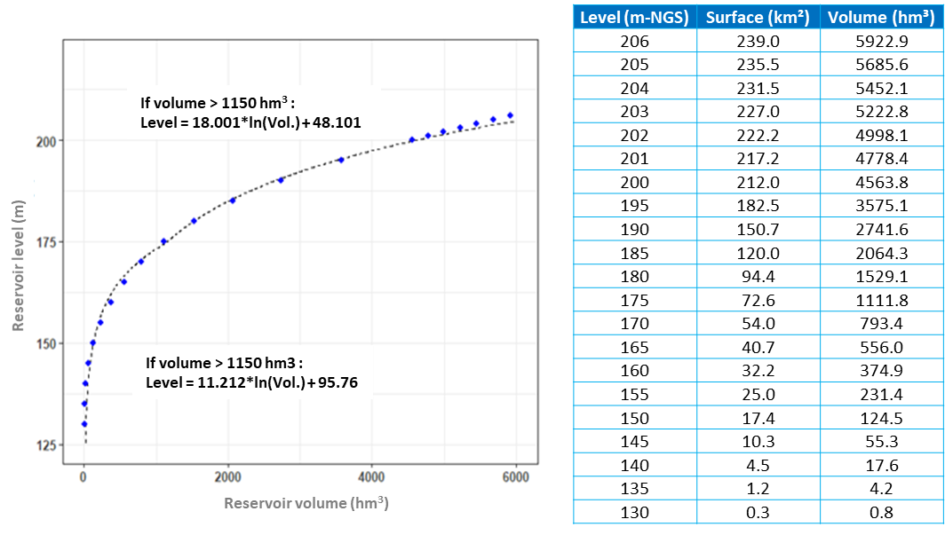
Figure 2A. Elevation-volume curve of the Sambangalou dam reservoir.
Note that the reservoir volumes may be affected by evaporation, which is, among others, a function of the reservoir surface area. In its report on hydrology and output, SAMVA provides average monthly evaporation rates for the region. These rates are summarized per day in Table 1A.
Table 1A. Average daily evaporation rate per month.
 | Jan. | Feb. | Mar. | Apr. | May | June | July | Aug. | Sep. | Oct. | Nov. | Dec.
Average daily evapotranspiration rate (mm/d) | 7.0 | 7.9 | 10.0 | 10.2 | 10.1 | 7.5 | 6.4 | 5.6 | 5.7 | 6.0 | 5.8 | 6.1

The dam’s turbine use capacity depends on its three groups, each with an equipment flow of 66.67 m³/s for a total equipment flow of 200 m³/s. Based on the dam operation statistics projected by the most recent management scenario provided by SAMVA, the minimum flow required for turbine use is 30 m³/s. To account for pressure drops over long periods of time, SAMVA mentions that it used an average weighted production of 91.68% per group for their annual output simulations. The downstream rating curve used to calculate output is illustrated in Figure 2B. Note that according to recent communications, the minimum flow required for turbine use was 35 m³/s. This value will be considered for future simulations, but contradicts the values provided for simulations carried out to date.
Since no rating curve equation was provided, the downstream rating curve was generated according to statistics (total flow released, downstream side) provided for the projected operation of the dam. The downstream rating curve must account for the stripping planned at the downstream foot of the dam, since the current simulations of dam operations and estimated output presented in various reports account for possible stripping. The rating curve is determined by two linear and logarithmic relationships with a point of intersection at 100 m³/s released downstream.
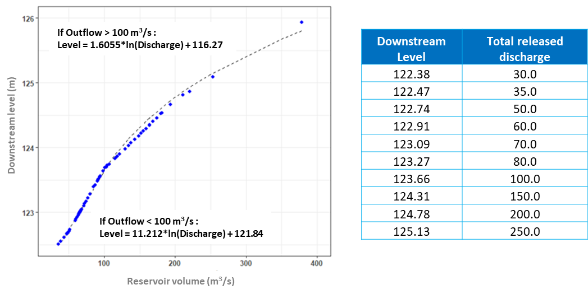
Figure 2B. Rating curve downstream of the Sambangalou dam.

As regards the dam’s water discharge capacity, only the sluices and the Creager spillway will be implemented in the simulation model, given the simulation objectives of normal annual dam operation. Consequently, the secondary spillway placed on a neck dike (level 204.2 m NGS) is not considered here. According to the current design plans, the Sambangalou dam will have two sluices. The sluice flow (Q) is calculated using the following formula:
$$Q=C*S*{(2*g*H)}^{0.5}$$
In which C is the flow coefficient (0.68), S is the surface area or opening of the sluices, g is gravitational acceleration, and H is the hydraulic height between the operating level and the sluice axis (128.025 m NGS). Consequently, for an operating level of 200 m (normal operating level), the total capacity of a sluice (surface area of 12.96 m²) is 331 m³/s and that of two sluices is 662 m³/s.
Where the operating level of the reservoir exceeds 196 m NGS, the Creager spillway automatically engages. The spillway flow (Q) is determined by the following equation:
$$Q= C_{d} b \sqrt{2 g} H^{\frac{3}{2}}$$
In which C_{d} is the threshold coefficient, b is the threshold width (80 m), g is the gravitational constant, and H is the hydraulic height upstream of the spillway. Meanwhile, the threshold coefficient is influenced by the hydraulic height and is determined by the following equation:
$$\frac{C_{d}}{C_{dD}} = {\left(\frac{H}{H_{D}}\right)}^{0.12}$$
In which C_{dD} is the threshold coefficient of the hydraulic height for dimensioning, i.e., 0.494, H is the hydraulic height, and H_{D} is the hydraulic height for dimensioning (3.6).
2. Dam operating rules

Dam water management rules are essential to determine the quantities of water passed through the turbines or stored at the dam during dam operation simulations. Dam water management rules must be determined according to i) natural dam water inflows, ii) output optimization and compliance with electrical production demand scenarios, and ii) compliance with certain natural river dynamics, such as the amplitude or the volume of floodwaters and flows of low waters. In its reports, SAMVA provides some of these management rules, which lay the foundations for a simulation of dam water use. Below are the basic management rules used to implement the dam water management model:
The normal operating level is 196 m NGS.
The turbine stoppage level is 176.5 m NGS. In the event of drought, a flow of zero downstream of the reservoir will be observed when this level is reached.
The data retained for low water maintenance (or minimum turbine flow) are as follows:
Table 2B. Monthly values of minimum turbine flows
 | Jan. | Feb. | Mar. | Apr. | May | June | July | Aug. | Sep. | Oct. | Nov. | Dec.
Low water maintenance flow (m³/s) | 90.0 | 60.0 | 45.0 | 35.0 | 35.0 | 45.0 | 90.0 | 60.0 | 60.0 | 60.0 | 60.0 | 90.0
Turbine flows are optimized according to the reservoir’s monthly limit levels. If the reservoir level is above or below the baseline levels, an optimization flow is passed through the turbines to supplement the low water maintenance flow. Details of the optimization rules are provided in Figure 2C;
The sluices release an additional flow to make sure that the reservoir level remains below the level of 196 m.
The dam water operations model was imported into Excel using daily intervals. The model calculated several dam water management statistics, such as the reservoir level, the total evacuated flow (turbine + evacuated flow), the evacuated flow not passed through the turbines (m³/s), evaporation losses (hm³), the fall height (m) and the power produced (GWh), on a daily basis.
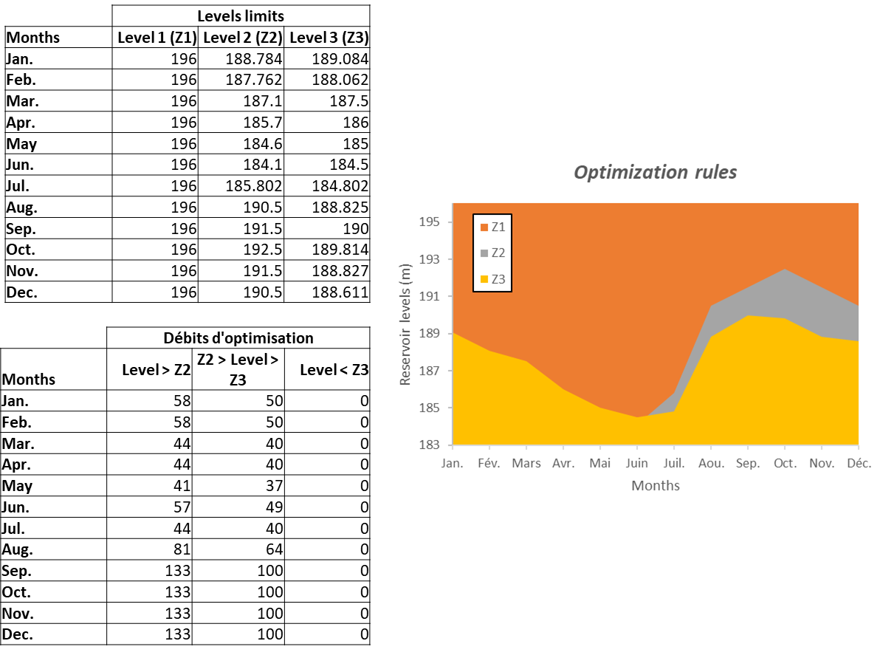
Figure 2C. Optimization rules for turbine flows presented by SAMVA.

APPENDIX 3
SIMULGAM model

Appendix 3: Methodological description of the SIMULGAM model
The SIMULGAM model was developed by Mr. Jean-Claude Bader of the Development Research Institute (IRD). This software is derived from the SIMULSEN software used to simulate the management of the Manantali dam, implanted on the upper Senegal basin. Operating at a daily frequency, it is used to calculate, according to the flows in Sambangalou (natural or simulated according to water regulation), the resulting flows at the stations located along the river downstream of operations (until Gouloumbou). The model first requires flow entry with no omissions for the period to be simulated, which consequently requires a systematic reconstruction phase for the missing data periods.
The model uses travel or offset times and linear correlations between stations on the river and certain tributaries in order to determine the amplitude of the flows reached at the hydrometric stations. The flow data at the following hydrometric stations are required for use of the SIMULGAM model:
- Stations on the Gambia River: Kédougou, Mako, Simenti, Downstream Wassadou. And Gouloumbou
- Stations on tributaries: Tiokoye, Diarha, Niokolo Koba, and Koulountou (at the PNNK ford)
The same correlation and offset equations between the stations presented in the latest study available on the digital modelling of the operation of the future Sambangalou dam (Bader, 2003, p.13–14 and Appendix Figure 6) were used to implement the SIMULGAM model. However, compared to this study, here, simulations concerned the 1970–2019 period thanks to the updating of all flow series needed.

1. Reconstruction of hydrological series
River and tributary data are generally reconstructed during the low-water period using drying-up models and during the flooding period using regression models. The regression models used to reconstruct hydrological series are established by forward selection. Explanatory variables are extracted from flow series in adjacent tributaries or at neighboring hydrometric stations along the river. Table 3A summarizes the corrections made to fill in the missing data periods.
Table 3A. Methods used to fill in the missing data periods for the flow series required by the SIMULGAM model.
Station | Missing data estimation methods | Equations
Sambangalou
Entire series | Linear correlation | 0.953Kedougou _{d}
Kédougou (K)
Entire series | Multiple linear regression | (if M < 50 m³/s): 1.37736M - 0.36418M_{d-1} + 0.5689
Entire series | Multiple linear regression | (if M < 50 m³/s): 1.058M_{d} - 0.3885M_{d-1} + 0.088M_{d-3} + 37.055
Mako (M)
General period | Multiple linear regression | 1.5349S_{d} - 29.1318Nk_{d} + 0.522S_{d-1} - 4.8
Drought | Drying-up model | Dry(0.977)
Simenti (S)
General period | Multiple linear regression | 0.965753M_{d-2} + 0.493921M_{d} - 0.649442
Drought | Drying-up model | Dry(0.974)
Downstream Wassadou (W)
General period | Multiple linear regression | (if S > 25 m³/s): 1.31191S_{d} - 0.35047S_{d-1} - 0.64176
Drought | Drying-up model | Dry(0.975)
Gouloumbou (G)
General period | Multiple linear regression | (if W > 100 m³/s): 2.09417 W_{d} - 0.98519W_{d-1} + 28.30399
Drought | Drying-up model* | Dry(0.975)
Tiokoye (T)
Entire series | Multiple linear regression | 0.082442S_{d-2} - 0.025970M_{d+1} + 1.311402
Diarha (D)
Entire series | Multiple linear regression | 0.048627S_{d-2} - 0.019095M_{d+1} - 0.022212M_{d+2} + 0.036322S_{d-1} + 0.07539
Niokolo Koba (Nk)
Entire series | Multiple linear regression | (0.041015S_{d+1} - 0.011714M_{d+2} + 0.026092S_{d-1} - 0.016034M_{d} - 0.532698
Koulountou (PNNK)
General period | Multiple linear regression | (if W > 10 m³/s): (0.214745G_{d-1} - 0.062683W_{d+1} + 13.575436
Drought | Drying-up model | Dry(0.945)
* Note that due to the effect of the tides during drought in Gouloumbou, a mobile average was also used to eliminate the fluctuations observed in the flow series.
All corrected series and raw data series may be viewed via the links to interactive charts provided in Appendix 5.

2. Validation of hydrological series
Validation of the flow series simulated by the SIMULGAM model at the Mako, Simenti, and Gouloumbou hydrometric stations is based on comparisons between the simulated series and reconstructed series of flows recorded at the stations. Nash coefficients were used as a similarity metric between series (see details on coefficients below). Figure 3A illustrates the comparisons between measured and simulated hydrological series. Though some differences are observed at the flood peaks, visual comparisons show good consistency across the series for the other periods (rise, flood recession and drought). The Nash coefficients show an excellent relationship for all stations. Finally, as regards the differences between the flood peaks, the analysis of the series as a whole and not specifically at the peak suggests that the periods in which the peaks are estimated to fall compensate for the periods in which the peaks are estimated to rise.

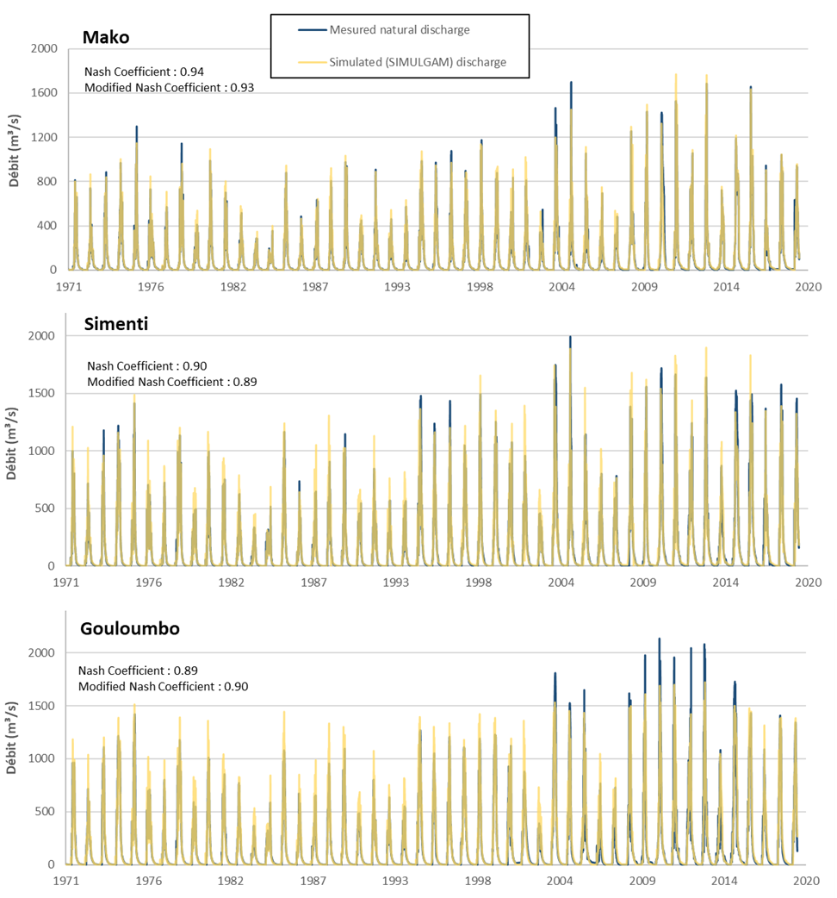
Figure 3A. Validation of hydrological series simulated by the SIMULGAM model.

3. Nash coefficient calculation
The numerical criteria used to assess the results of hydrological series reconstructions or SIMULGAM model simulations are: the Nash criterion (NC) and the modified Nash criterion (MNC). The criteria are defined by the following equations:

$$CN=1- \frac{\sum_{i=1}^{n}{\left[{\left(Q_{obs,i}- Q_{sim,i}\right)}^{2}\right]}}{\sum_{i=1}^{n}{\left[{\left(Q_{obs,i}- \overline{Q_{obs}}\right)}^{2}\right]}} CMN=1- \frac{\sum_{i=1}^{n}{\left[Q_{obs,i}* {\left(Q_{obs,i}- Q_{sim,i}\right)}^{2}\right]}}{\sum_{i=1}^{n}{\left[{Q_{obs,i}* \left(Q_{obs,i}- \overline{Q_{obs}}\right)}^{2}\right]}}$$

In which Q_(obs,i) corresponds to the flow observed on day i, Q_(sim,i) corresponds to the flow simulated on day i, and (Q_obs) ̅ is the average daily flow for the benchmark year. The two criteria assess the quality of the simulation according to the variation between observed and simulated flows. The Nash criterion is commonly used. The modified Nash criterion more severely penalizes the variation on peak flows and is therefore a good indicator of the quality of the simulation during high-water periods. The closer the Nash criterion or the modified Nash criterion gets to 1, the more the simulated flows accurately reflect the flows observed. In their article on the performance of various quality assessment methods of environmental models, Moriasi et al. (Ref. 23) propose the following classification of Nash criteria: >0.8 = excellent relationship, 0.7 to 0.8 = good relationship, 0.5 to 0.7 = adequate relationship, and <0.5 = inadequate relationship.

APPENDIX 4
SALNSTAT model

Appendix 4: Methodological description of the SALNSTAT model
The SALNSTAT model simulates saltwater front displacements in the estuarine part of the river. The one-dimensional model was developed by M. Savenije (Savenije, 1986) and subsequently adjusted to the physical, hydrological and climate characteristics of the Gambia River (Savenije, 1988). The model was developed in Fortran programming language and implements the following processes: river flow, precipitation, evaporation, tide, water requirements for irrigation, and the morphology of cross-sections of the river. The SALNSTAT model was previously updated in 2003 (IRD, 2003), so the saltwater front displacement was simulated for the 1970–2001 period and validated according to salinity measurements collected between 1974 and 1996. Moreover, performance validation of the model was only performed for displacement of the 1 g/l saltwater front.
Here, saltwater front displacements are simulated according to the reconstructed flows in Gouloumbou for the 1970–2019 period and for average monthly water needs for irrigation, updated according to AECOM’s latest studies on water needs for irrigation presented later in this report. Compared to the values simulated by the IRD (2003), the monthly position has receded approximately 10 km downstream, which may be attributed to the period of much higher hydraulicity observed from the early 2000s to present.
Table 4A. Simulated average monthly saltwater front positions for the 1970–2019 period.
Average monthly position under a natural regime (KP) | 1 gL⁻¹ | Jan. | Feb. | Mar. | Apr. | May | June | July | Aug. | Sep. | Oct. | Nov. | Dec.
Average monthly position under a natural regime (KP) | 1 gL⁻¹ | 162 | 178 | 198 | 218 | 236 | 247 | 214 | 139 | 100 | 87 | 118 | 144
Average monthly position under a natural regime (KP) | 5 gL⁻¹ | 136 | 150 | 166 | 181 | 196 | 203 | 177 | 125 | 90 | 78 | 100 | 122
Average monthly position under a natural regime (KP) | 15 gL⁻¹ | 96 | 109 | 122 | 136 | 149 | 154 | 137 | 99 | 70 | 60 | 72 | 84
Water requirements for irrigation (m³/s) |  | 1.7 | 0.9 | 0.4 | 0.46 | 0.6 | 2.6 | 5.6 | 1.1 | 0.9 | 3.3 | 1.4 | 1.8
Average monthly flows in Gouloumbou (m³/s) |  | 25 | 12 | 6 | 3 | 2 | 6 | 93 | 473 | 819 | 494 | 132 | 53

The first mission of study 3 - Environmental flow consisted of compiling physical-chemical longitudinal measurements and installing continuous salinity measurement probes on the downstream portion of the Gambia River, which experiences seasonal water salinity variations. These measurements or instruments aimed to allow for (1) spatial and (2) chronological validation of the simulation of saltwater front displacements using the SALNSTAT model.
Bimonthly simulation of saltwater front displacement according to the Gouloumbou flow data obtained until June 2021, in addition to the monthly river water volumes required for irrigation, was consequently carried out. The data collected during the two salinity measurement missions were subsequently compared to the results of the SALNSTAT model. Figure 4A illustrates the intermittent validation of the SALNSTAT model according to longitudinal salinity measurements taken on December 12, 2020 (river flood recession conditions) and on June 16–17, 2021 (maximum drought).

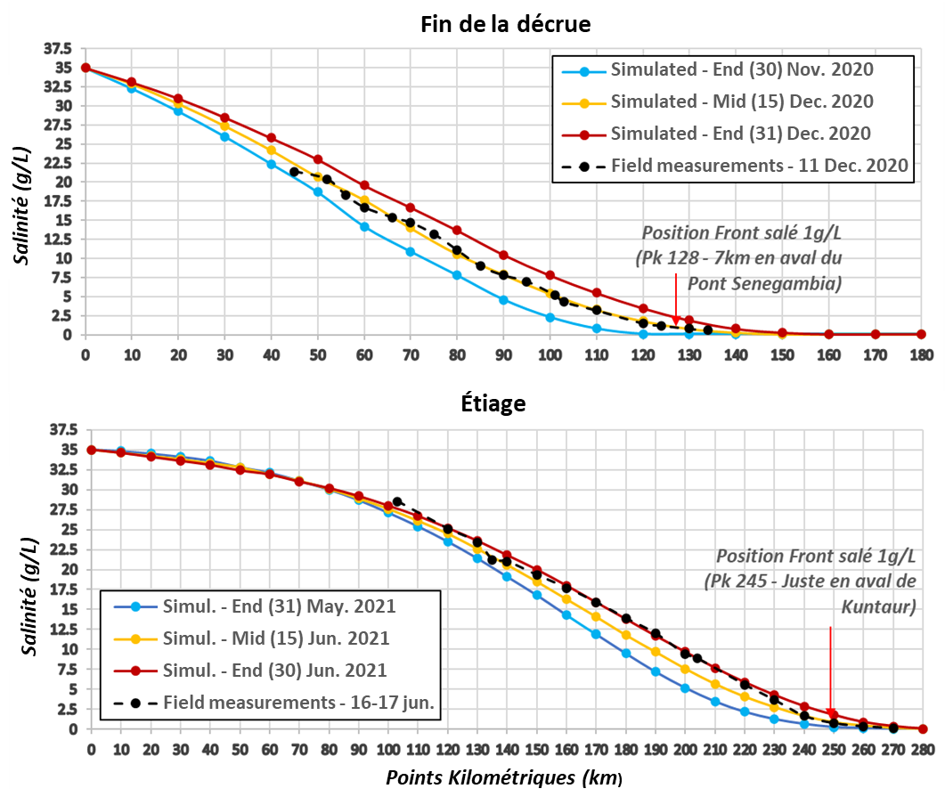
Figure 4A. Spatial validation of the SALNSTAT model carried out during flood recession of the Gambia River and at maximum drought.
The salinity levels simulated and measured during flood recession were found to be very similar. The salinity levels measured on the field in June 2021 are slightly below the salinity levels simulated for the same date, but only from KP 160–200 or at concentrations from 5 to 17.5 g/l. This validation shows that the model simulates the position of saline concentrations below 5 g/l very accurately. The model performs slightly less well during drought for saline concentrations above 5 g/l, but the errors are nevertheless acceptable for the needs of this study.
Figure 4B below illustrates the validation of the SALNSTAT model for the database of salinity data compiled from the probes at the Senegambia bridge and in Kaur. The other probe data could not be used because of, respectively, salinity above the limit of the probe in Tendaba over nearly the entire validation period and an incorrect recording interval used in Kuntaur. Comparisons continue to show good consistency between the salinity levels simulated and measured for the lowest salt concentrations. Deviations of approximately 5 g/l between the simulated and measured salinity levels are observed between March and June on the Senegambia bridge probe; however, part of this deviation could be attributable to the accuracy of the probe used. It should also be noted that, as the salinity levels were too high (for the probe limits) at the time of data retrieval, the data measured in Kaur could not be replaced for the possible deviation effect and should consequently be interpreted with greater caution.
With the exemption of the updated flows in Gouloumbou and the estimated water volumes extracted from the river, none of the primary inflows in the SALNSTAT model were changed with respect to the settings used during the IRD study (Bader, 2003). The accuracy of the saltwater front displacements of the SALNSTAT model was deemed appropriate for the needs of the study.

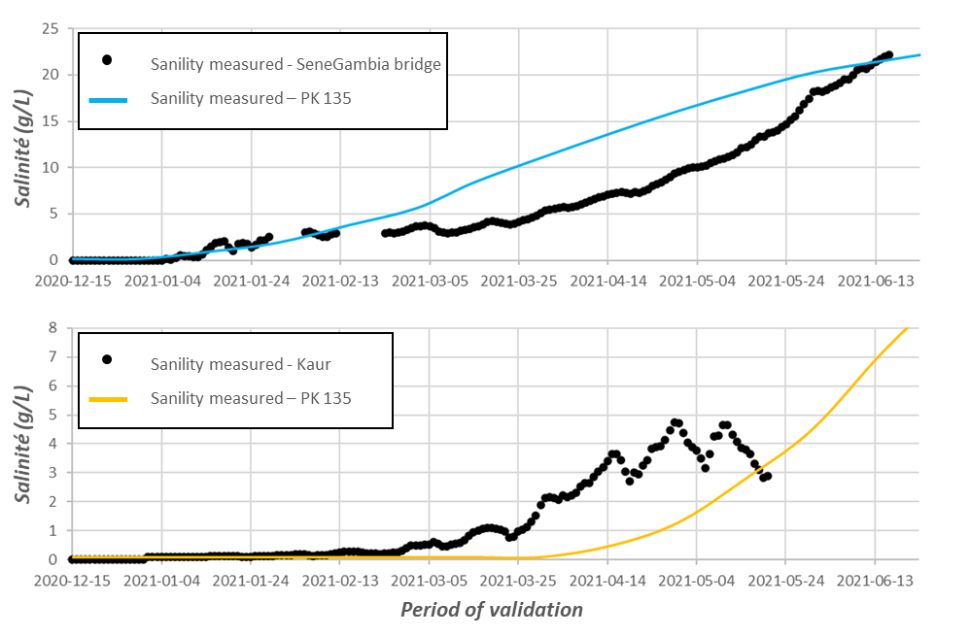
Figure 4B. Chronological validation of the SALNSTAT model using the salinity levels measured at the Senegambia bridge and in Kaur.

APPENDIX 5
Details of the hydrological series used

Appendix 5: Hydrological series used
1. Revision of rating curves

AECOM’s first task consisted of reconstituting the rating curves thanks to data available via the Hydraccess database. Two main objectives justified this task, instead of directly using the flows available in the database: (1) the levels corresponding to the flows observed on the river were required to assess certain issues related to the environmental flow, but also (2) the chronological level series available via the Hydraccess database contain fewer data omissions than the chronological flow series.

The rating curves established at the hydrometric stations on the Gambia River are illustrated in Figure 5A below.

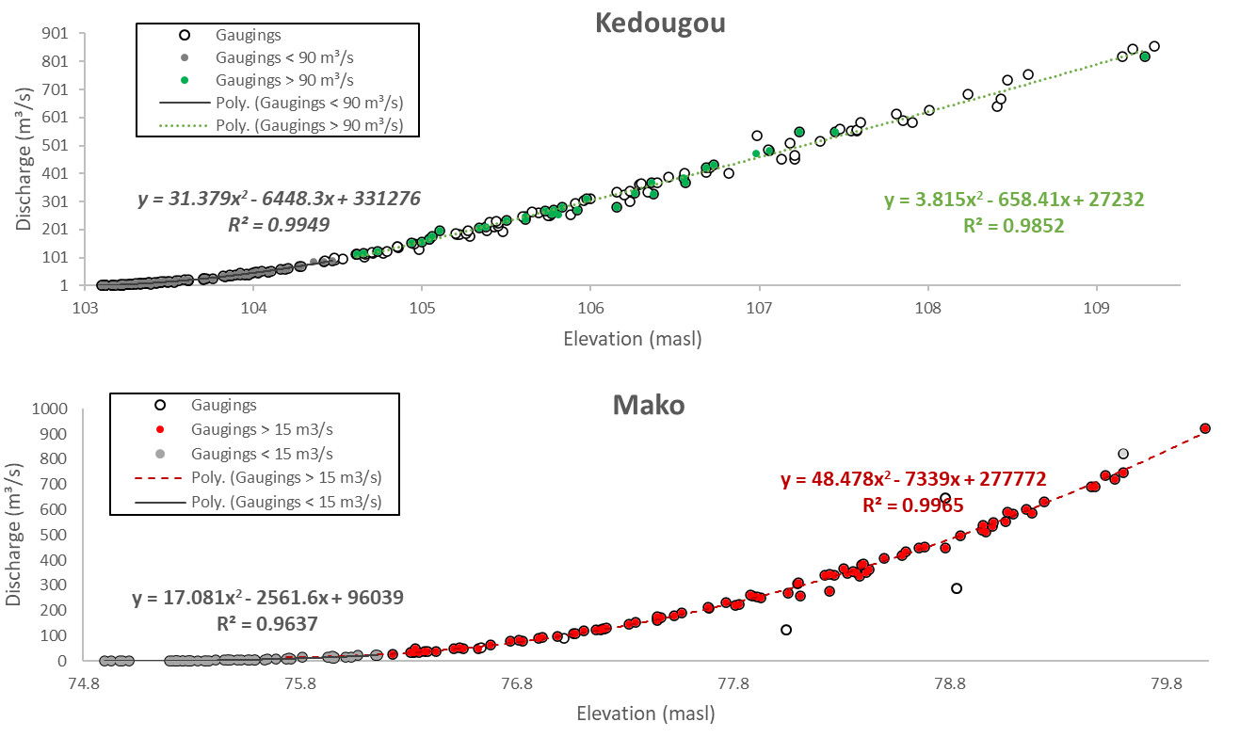
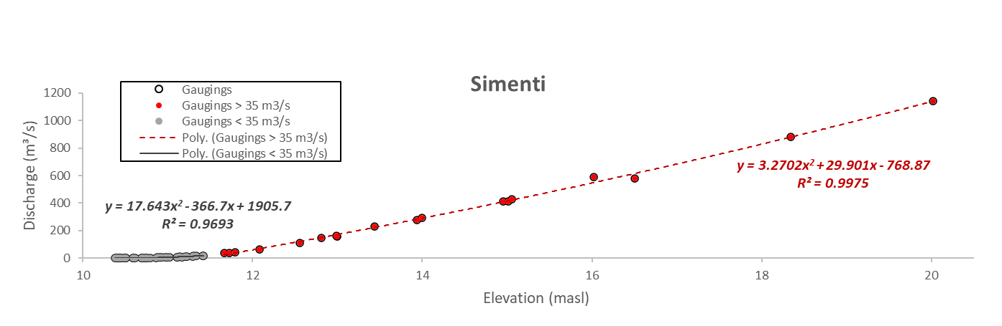

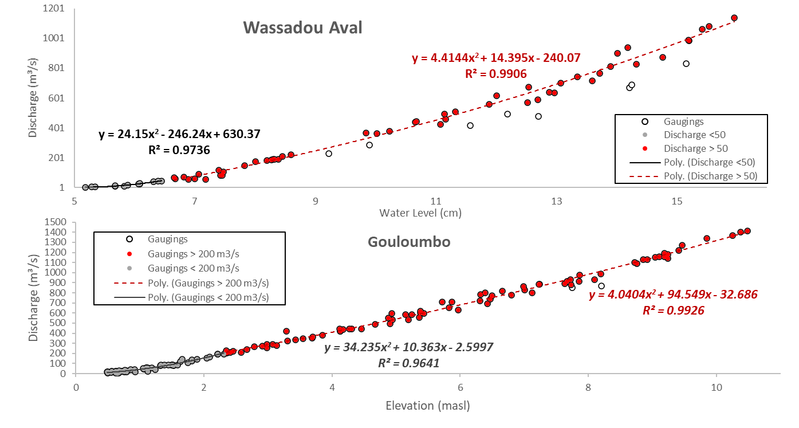
Figure 5A. Revision of rating curves at the hydrometric stations on the Gambia River.

2. Comparisons of reconstructed flow series and available data

The links in Table 5A below show the flow series reconstructed using the methods presented in Table 3A, compared to the level data available in the Hydraccess database.

Hydrometric stations | Links to interactive charts
Kédougou | Kédougou chart
Mako | Mako chart
Simenti | Simenti chart
Gouloumbou | Gouloumbou chart
Diaguéri | Diaguéri chart
Tiokoye | Tiokoye chart
Diarha | Diarha chart
Niokolo Koba | Niokolo Koba chart
Koulountou - PNNK | Koulountou chart

APPENDIX 6
Diagram of synchronization levels at the hydrometric stations

Appendix 6: Diagram of synchronization levels at the hydrometric stations
Diagram of synchronization levels for Diaguéri hydrometric station

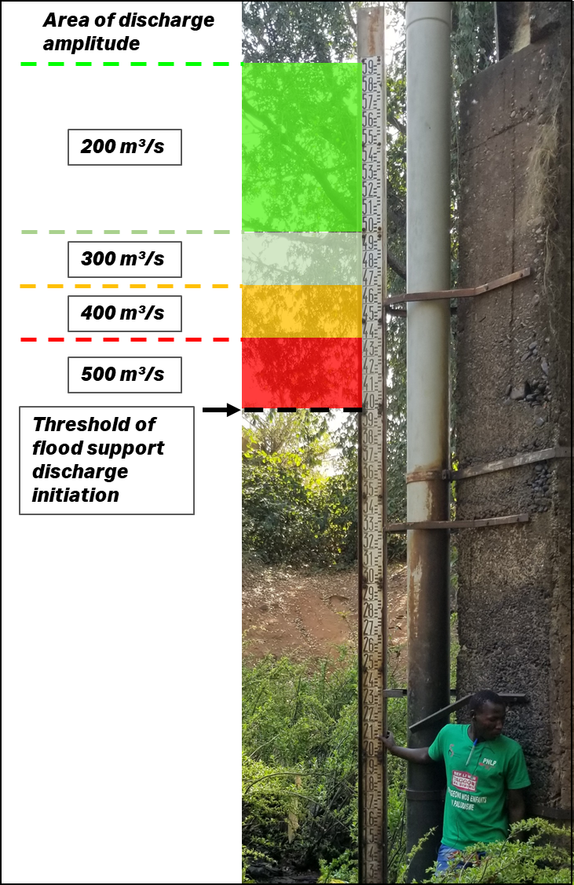

Rating of levels and flows at Diaguéri station

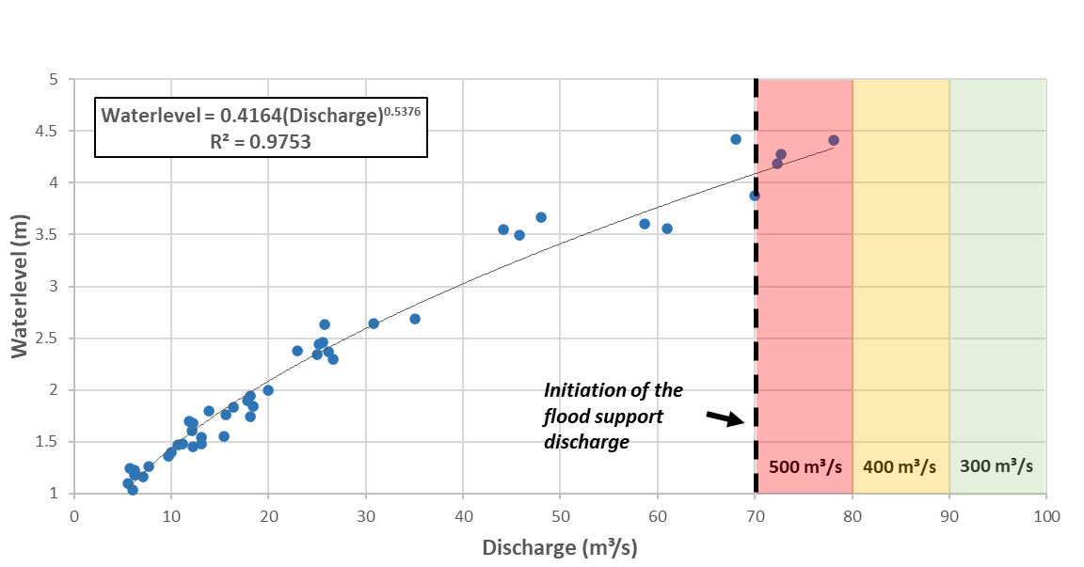

Diagram of synchronization levels for Niokolo Koba hydrometric station

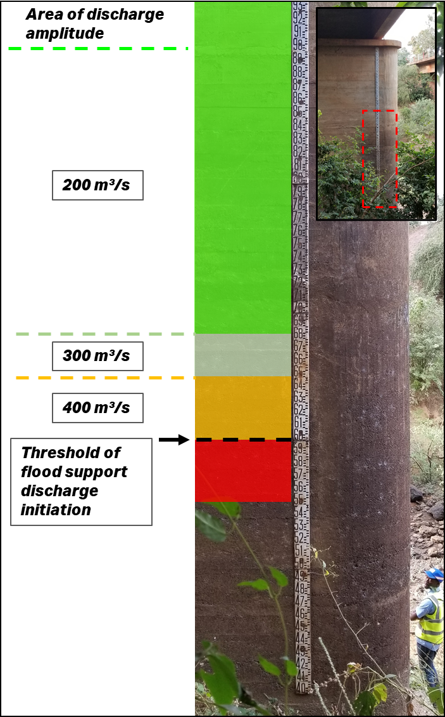

Rating of levels and flows at Niokolo Koba station

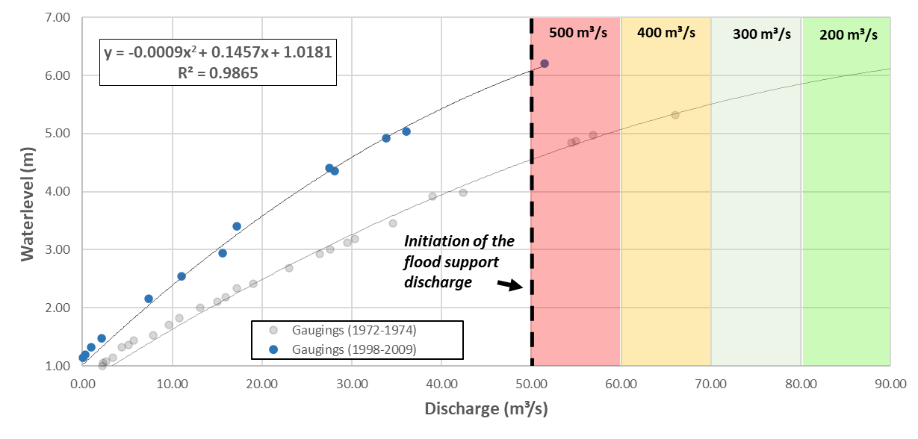

Characteristics of the site of the former hydrometric station in Koulountou (PNNK)

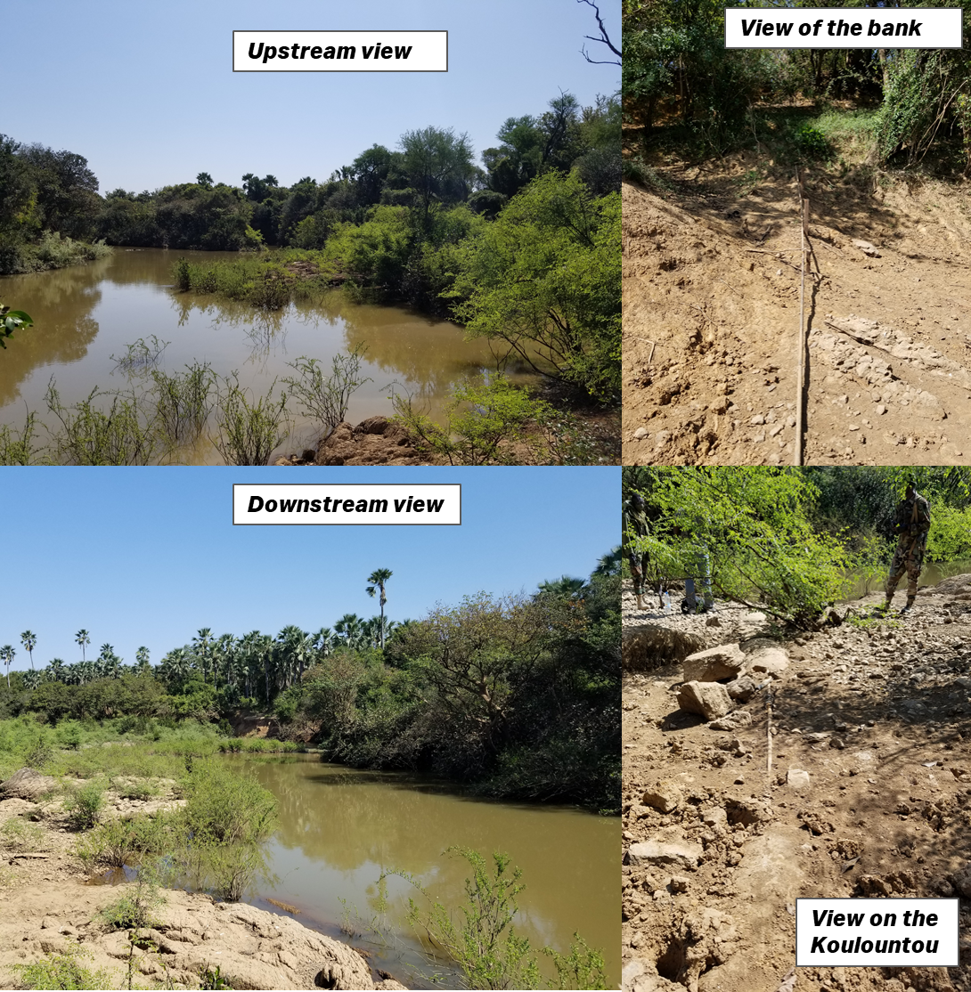

Rating of levels and flows according to the data available at Koulountou station (PNNK)

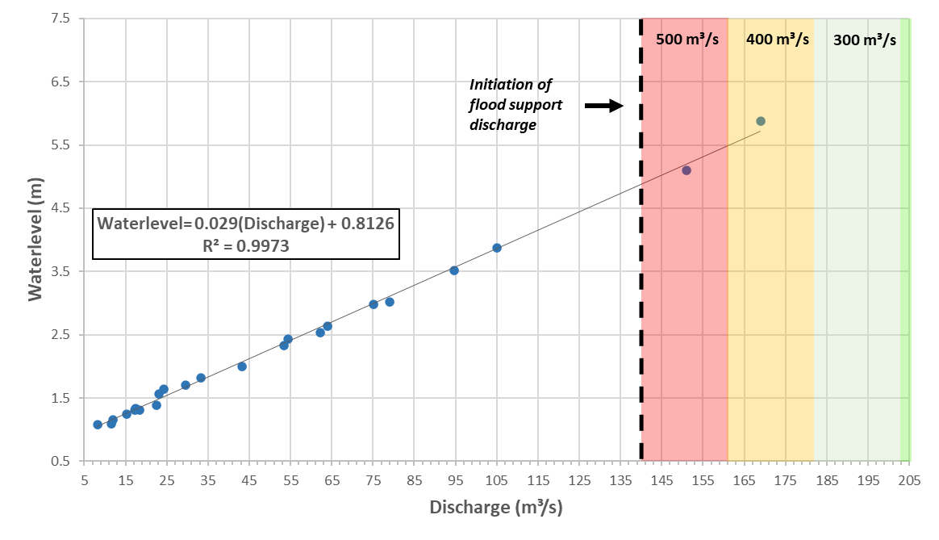

APPENDIX 7
Annual statistics on backswamp filling

Appendix 7: Annual statistics on backswamp filling
Annual statistics on backswamp filling according to the environmental flow scenario

Year | Flooding maintenance | Simenti max. flow | Gouloumbou max. flow | Av. flow during backswamp maintenance periods - Simenti | Av. flow during backswamp maintenance periods - Gouloumbou | Number of days over - Simenti | Number of days over - Gouloumbou | Volume of released discharge (hm³)
1980 |  | 670 | 1,128 | 0 | 0 | 0 | 1 | 0
1981 |  | 659 | 890 | 0 | 0 | 0 | 0 | 0
1982 |  | 414 | 598 | 0 | 0 | 0 | 0 | 0
1983 |  | 319 | 414 | 0 | 0 | 0 | 0 | 0
1984 |  | 477 | 762 | 0 | 0 | 0 | 0 | 0
1985 | X | 1,279 | 1,762 | 1,115 | 1,395 | 10 | 15 | 982
1986 |  | 479 | 758 | 0 | 0 | 0 | 0 | 0
1987 |  | 781 | 761 | 0 | 0 | 0 | 0 | 0
1988 |  | 631 | 919 | 0 | 0 | 0 | 0 | 0
1989 | X | 1,084 | 1,277 | 1,034 | 1,096 | 5 | 8 | 870.9984
1990 |  | 477 | 547 | 0 | 0 | 0 | 0 | 0
1991 |  | 537 | 754 | 0 | 0 | 0 | 0 | 0
1992 |  | 400 | 509 | 0 | 0 | 0 | 0 | 0
1993 |  | 524 | 515 | 0 | 0 | 0 | 0 | 0
1994 | X | 1,140 | 1,574 | 1,054 | 1,272 | 8 | 21 | 829
1995 | X | 1,117 | 1,547 | 1,025 | 1,214 | 12 | 19 | 864
1996 | X | 1,282 | 1,589 | 1,141 | 1,250 | 4 | 18 | 864
1997 |  | 740 | 889 | 0 | 0 | 0 | 0 | 0
1998 |  | 859 | 1,174 | 0 | 0 | 0 | 4 | 0
1999 |  | 873 | 1,230 | 0 | 0 | 0 | 3 | 0
2000 |  | 1,004 | 1,080 | 0 | 0 | 1 | 2 | 0
2001 |  | 661 | 1,183 | 0 | 0 | 0 | 2 | 0
2002 |  | 518 | 584 | 0 | 0 | 0 | 0 | 0
2003 | X | 1,276 | 1,401 | 1,146 | 1,177 | 5 | 29 | 458
2004 | X | 1,168 | 1,657 | 1,085 | 1,407 | 14 | 20 | 847
2005 | X | 1,131 | 1,521 | 1,061 | 1,318 | 11 | 20 | 864
2006 |  | 615 | 785 | 0 | 0 | 0 | 0 | 0
2007 |  | 559 | 598 | 0 | 0 | 0 | 0 | 0
2008 |  | 783 | 1,259 | 0 | 0 | 0 | 3 | 0
2009 | X | 1,237 | 1,636 | 1,153 | 1,254 | 9 | 11 | 605
2010 | X | 1,174 | 1,478 | 1,093 | 1,311 | 2 | 17 | 432
2011 | X | 1,600 | 1,669 | 1,146 | 1,284 | 10 | 19 | 855
2012 | X | 1,313 | 1,551 | 1,143 | 1,222 | 16 | 23 | 821
2013 | X | 1,453 | 1,964 | 1,193 | 1,405 | 12 | 19 | 648
2014 |  | 744 | 810 | 0 | 0 | 0 | 0 | 0
2015 | X | 1,189 | 1,594 | 1,088 | 1,227 | 11 | 38 | 622
2016 | X | 1,173 | 1,365 | 1,046 | 1,225 | 15 | 22 | 683
2017 |  | 702 | 896 | 0 | 0 | 0 | 0 | 0
2018 | X | 1,230 | 1,519 | 1,073 | 1,267 | 6 | 22 | 804
2019 | X | 1,068 | 1,443 | 1,049 | 1,280 | 3 | 20 | 743

Green cells are associated with the achievement of backswamp filling objectives or criteria. Meanwhile, yellow cells indicate the years for which the volume of flooding maintenance discharge is below the released discharge of 700 m³/s for 14 days.

APPENDIX 8
Turbine shut-down and fulfillment of water needs for irrigation

Appendix 8: Turbine shut-down and fulfillment of water needs for irrigation

Turbine shut-down periods due to levels below the MEF

Number of days of turbine shut-down
 | Jan. | Feb. | Mar. | Apr. | May | June | July | Aug. | Sep. | Oct. | Nov. | Dec.
1980 | 0 | 0 | 0 | 7 | 31 | 0 | 0 | 0 | 0 | 0 | 0 | 0
1981 | 0 | 0 | 0 | 7 | 31 | 0 | 0 | 0 | 0 | 0 | 0 | 0
1982 | 0 | 0 | 0 | 7 | 31 | 0 | 0 | 0 | 0 | 0 | 0 | 0
1983 | 0 | 0 | 0 | 7 | 31 | 0 | 0 | 0 | 0 | 0 | 0 | 0
1984 | 0 | 0 | 0 | 7 | 31 | 25 | 0 | 0 | 0 | 0 | 0 | 0
1985 | 17 | 28 | 31 | 30 | 31 | 30 | 21 | 0 | 0 | 0 | 0 | 0
1986 | 0 | 0 | 4 | 30 | 31 | 30 | 18 | 0 | 0 | 0 | 0 | 0
1987 | 0 | 0 | 0 | 16 | 31 | 30 | 26 | 0 | 0 | 0 | 0 | 0
1988 | 0 | 0 | 0 | 7 | 31 | 0 | 0 | 0 | 0 | 0 | 0 | 0
1989 | 0 | 0 | 0 | 7 | 31 | 0 | 0 | 0 | 0 | 0 | 0 | 0
1990 | 0 | 0 | 0 | 0 | 4 | 30 | 6 | 0 | 0 | 0 | 0 | 0
1991 | 0 | 0 | 0 | 0 | 0 | 0 | 0 | 0 | 0 | 0 | 0 | 0
1992 | 0 | 0 | 0 | 0 | 0 | 0 | 0 | 0 | 0 | 0 | 0 | 0
1993 | 0 | 0 | 0 | 0 | 0 | 9 | 2 | 0 | 0 | 0 | 0 | 0
1994 | 0 | 0 | 0 | 0 | 0 | 0 | 0 | 0 | 0 | 0 | 0 | 0
1995 | 0 | 0 | 0 | 0 | 0 | 0 | 0 | 0 | 0 | 0 | 0 | 0
1996 | 0 | 0 | 0 | 0 | 0 | 0 | 0 | 0 | 0 | 0 | 0 | 0
1997 | 0 | 0 | 22 | 30 | 31 | 27 | 0 | 0 | 0 | 0 | 0 | 0
1998 | 0 | 0 | 0 | 0 | 0 | 0 | 0 | 0 | 0 | 0 | 0 | 0
1999 | 0 | 0 | 0 | 0 | 0 | 0 | 0 | 0 | 0 | 0 | 0 | 0
2000 | 0 | 0 | 0 | 0 | 0 | 0 | 0 | 0 | 0 | 0 | 0 | 0
2001 | 0 | 0 | 0 | 0 | 0 | 0 | 0 | 0 | 0 | 0 | 0 | 0
2002 | 0 | 0 | 0 | 0 | 0 | 0 | 0 | 0 | 0 | 0 | 0 | 0
2003 | 0 | 0 | 0 | 0 | 0 | 16 | 0 | 0 | 0 | 0 | 0 | 0
2004 | 0 | 0 | 0 | 0 | 0 | 0 | 0 | 0 | 0 | 0 | 0 | 0
2005 | 0 | 0 | 0 | 0 | 0 | 0 | 0 | 0 | 0 | 0 | 0 | 0
2006 | 0 | 0 | 0 | 0 | 0 | 0 | 0 | 0 | 0 | 0 | 0 | 0
2007 | 0 | 0 | 0 | 0 | 0 | 0 | 0 | 0 | 0 | 0 | 0 | 0
2008 | 0 | 0 | 0 | 0 | 0 | 0 | 0 | 0 | 0 | 0 | 0 | 0
2009 | 0 | 0 | 0 | 0 | 0 | 0 | 0 | 0 | 0 | 0 | 0 | 0
2010 | 0 | 0 | 0 | 0 | 0 | 0 | 0 | 0 | 0 | 0 | 0 | 0
2011 | 0 | 0 | 0 | 0 | 0 | 0 | 0 | 0 | 0 | 0 | 0 | 0
2012 | 0 | 0 | 0 | 0 | 0 | 0 | 0 | 0 | 0 | 0 | 0 | 0
2013 | 0 | 0 | 0 | 0 | 0 | 0 | 0 | 0 | 0 | 0 | 0 | 0
2014 | 0 | 0 | 0 | 0 | 0 | 0 | 0 | 0 | 0 | 0 | 0 | 0
2015 | 0 | 0 | 0 | 0 | 0 | 0 | 0 | 0 | 0 | 0 | 0 | 0
2016 | 0 | 0 | 0 | 0 | 0 | 0 | 0 | 0 | 0 | 0 | 0 | 0
2017 | 0 | 0 | 0 | 0 | 0 | 0 | 0 | 0 | 0 | 0 | 0 | 0
2018 | 0 | 0 | 0 | 0 | 0 | 0 | 0 | 0 | 0 | 0 | 0 | 0
2019 | 0 | 0 | 0 | 0 | 0 | 0 | 0 | 0 | 0 | 0 | 0 | 0
* Note that, during the first ten years of turbine shut-down in April and May, to limit saltwater front recession, discharge is released through the sluices to fulfill irrigation water needs.
Assessment of the fulfillment of irrigation water requirements according to scenario 1

Irrigation scenarios | Minimum monthly flows (m³/s) to fulfill water requirements
Irrigation scenarios | Jan. | Feb. | Mar. | Apr. | May | June | July | Aug. | Sep. | Oct. | Nov. | Dec.
Current (Irrigated + Fruit + Market garden) | 1.7 | 0.9 | 0.4 | 0.4 | 0.6 | 2.6 | 5.6 | 1.0 | 0.8 | 3.3 | 1.4 | 1.7
Short-term potential (-5 years) | 3.0 | 1.4 | 0.4 | 0.4 | 0.8 | 4.9 | 11.1 | 2.1 | 1.6 | 6.3 | 2.3 | 3.1
Medium-term potential (-10 years) | 8.7 | 3.7 | 0.4 | 0.5 | 2.4 | 13.4 | 27.8 | 5.1 | 3.8 | 18.8 | 6.3 | 8.9
1980 | 100% | 100% | 100% | 97% | 97% | 100% | 100% | 100% | 100% | 100% | 100% | 100%
1981 | 100% | 97% | 100% | 97% | 97% | 100% | 100% | 100% | 100% | 100% | 100% | 100%
1982 | 100% | 97% | 100% | 97% | 97% | 100% | 100% | 100% | 100% | 100% | 100% | 100%
1983 | 100% | 97% | 100% | 97% | 97% | 100% | 100% | 100% | 100% | 100% | 100% | 100%
1984 | 100% | 100% | 100% | 97% | 97% | 93% | 100% | 100% | 100% | 100% | 100% | 100%
1985 | 97% | 97% | 3% | 97% | 97% | 97% | 100% | 100% | 100% | 100% | 100% | 100%
1986 | 100% | 97% | 87% | 97% | 97% | 97% | 100% | 100% | 100% | 100% | 100% | 100%
1987 | 100% | 97% | 100% | 97% | 97% | 97% | 100% | 100% | 100% | 100% | 100% | 100%
1988 | 100% | 100% | 100% | 97% | 97% | 100% | 100% | 100% | 100% | 100% | 100% | 100%
1989 | 100% | 97% | 100% | 97% | 97% | 100% | 100% | 100% | 100% | 100% | 100% | 100%
1990 | 100% | 97% | 100% | 100% | 97% | 97% | 97% | 100% | 100% | 100% | 100% | 100%
1991 | 100% | 97% | 100% | 100% | 100% | 100% | 100% | 100% | 100% | 100% | 100% | 100%
1992 | 100% | 100% | 100% | 100% | 100% | 100% | 100% | 100% | 100% | 100% | 100% | 100%
1993 | 100% | 97% | 100% | 100% | 100% | 70% | 94% | 100% | 100% | 100% | 100% | 100%
1994 | 100% | 97% | 100% | 100% | 100% | 100% | 100% | 100% | 100% | 100% | 100% | 100%
1995 | 100% | 97% | 100% | 100% | 100% | 100% | 100% | 100% | 100% | 100% | 100% | 100%
1996 | 100% | 100% | 100% | 100% | 100% | 100% | 100% | 100% | 100% | 100% | 100% | 100%
1997 | 100% | 97% | 29% | 0% | 0% | 10% | 100% | 100% | 100% | 100% | 100% | 100%
1998 | 100% | 97% | 100% | 100% | 100% | 100% | 100% | 100% | 100% | 100% | 100% | 100%
1999 | 100% | 97% | 100% | 100% | 100% | 100% | 100% | 100% | 100% | 100% | 100% | 100%
2000 | 100% | 100% | 100% | 100% | 100% | 100% | 100% | 100% | 100% | 100% | 100% | 100%
2001 | 100% | 97% | 100% | 100% | 100% | 100% | 100% | 100% | 100% | 100% | 100% | 100%
2002 | 100% | 97% | 100% | 100% | 100% | 100% | 100% | 100% | 100% | 100% | 100% | 100%
2003 | 100% | 97% | 100% | 100% | 100% | 47% | 100% | 100% | 100% | 100% | 100% | 100%
2004 | 100% | 100% | 100% | 100% | 100% | 100% | 100% | 100% | 100% | 100% | 100% | 100%
2005 | 100% | 97% | 100% | 100% | 100% | 100% | 100% | 100% | 100% | 100% | 100% | 100%
2006 | 100% | 97% | 100% | 100% | 100% | 100% | 100% | 100% | 100% | 100% | 100% | 100%
2007 | 100% | 97% | 100% | 100% | 100% | 100% | 100% | 100% | 100% | 100% | 100% | 100%
2008 | 100% | 100% | 100% | 100% | 100% | 100% | 100% | 100% | 100% | 100% | 100% | 100%
2009 | 100% | 97% | 100% | 100% | 100% | 100% | 100% | 100% | 100% | 100% | 100% | 100%
2010 | 100% | 97% | 100% | 100% | 100% | 100% | 100% | 100% | 100% | 100% | 100% | 100%
2011 | 100% | 97% | 100% | 100% | 100% | 100% | 100% | 100% | 100% | 100% | 100% | 100%
2012 | 100% | 100% | 100% | 100% | 100% | 100% | 100% | 100% | 100% | 100% | 100% | 100%
2013 | 100% | 97% | 100% | 100% | 100% | 100% | 100% | 100% | 100% | 100% | 100% | 100%
2014 | 100% | 97% | 100% | 100% | 100% | 100% | 100% | 100% | 100% | 100% | 100% | 100%
2015 | 100% | 97% | 100% | 100% | 100% | 100% | 100% | 100% | 100% | 100% | 100% | 100%
2016 | 100% | 100% | 100% | 100% | 100% | 100% | 100% | 100% | 100% | 100% | 100% | 100%
2017 | 100% | 97% | 100% | 100% | 100% | 100% | 100% | 100% | 100% | 100% | 100% | 100%
2018 | 100% | 97% | 100% | 100% | 100% | 100% | 100% | 100% | 100% | 100% | 100% | 100%
2019 | 100% | 97% | 100% | 100% | 100% | 100% | 100% | 100% | 100% | 100% | 100% | 100%

Despite being associated with Nash coefficients greater than 0.9, which suggests excellent hydrological series simulation, the results of the SIMULGAM model typically underestimated the duration of peak flow periods of the Gambia River. Since the assessment of management scenarios were based on the SIMULGAM model, it was more appropriate to compare the results to the statistics of simulations of the natural hydrological regime carried out by SIMULGAM than to make comparisons with statistics taken directly from chronological series of measured flows.
Area 1, corresponding to the reach upstream of the Sambangalou hydroelectric structure, was not considered for this study.
The data respecting the types of crops and the crop calendar of the Gambia were available via the platform https://cropcalendar.apps.fao.org/#/home of the FAO at the time of the study and were therefore downloaded. Data for the Gambia are no longer available on this platform, but can be provided upon request.
For the Gambian area, see the footnote on the previous page.
The threshold value of 30 m³/s has been used to date in all reports on output; this value had been used to date by the EF team in order to allow for comparison with previous studies. This value was changed to a minimum turbine flow of 35 m³/s for this version of the environmental flow scenario because of the indications concerning the minimum equipment flow, received by the consulting engineer responsible for revising design studies.
Idem.

